NC Private Protective

Services Firearms Training

STUDENT MANUAL



INTRODUCTION

TITLE: NC PPS FIREARMS TRAINING - Course Abstract (Student Manual)

Lesson Purpose:

Training Objectives:

To provide the student with the knowledge and skills to safely handle firearms and to deliver accurate fire during shooting situations.

At the end of this block of instruction, the student will be able to achieve the following objectives in accordance with information received during the instructional period:

1. Discuss the provisions of North Carolina General Statute 74C as it pertains to the armed security officer.

2. Describe in writing and demonstrate the proper methods for cleaning and inspecting the service handgun.

3. Demonstrate the ability to quickly but safely draw a handgun and/or "shoulder" a shotgun.

1. Attain a qualifying score of at least 80 percent accuracy on the approved courses of fire.
2. Demonstrate two methods of utilizing the flashlight while firing the handgun.

*6.* Describe in writing the difference between cover and concealment.

7. Describe in writing sight alignment and sight picture.

8. List the four functional tasks that the security officer must be able to perform under low light conditions.

1. Demonstrate how to combat load the shotgun.
2. Explain the color code system of Mental Conditioning. ·
3. Demonstrate how to safely secure a handgun.

Hours:

Module I: *Legal (Four hours)

Module II: *Safety (One hour)

Module III: *Handgun Operation and Maintenance (Three (+) hours)

Module IV: *Marksmanship Fundamentals

(Eight (+) hours)

Module V: *Night Firing (Four (+) hours)

Module VI: Shotgun Operation (Four hours)

Module VII: Encounter Techniques (Two hours

classroom plus additional range time. Approximately eight hours)

Qualification: *Hours contingent on number of

weapons with which to qualify, number of relays, etc.

Instructional Methods: Lecture/Demonstration/Practical Exercises

Materials Required: Lesson Outline

Pen/Pencil/Paper

Training Aids: Chalkboard/Chalk or Whiteboard/Markers

Overhead or LCD Projector

Multi-Media Slides Screen

VCR or DVD Player Revolver

Shotgun Semiautomatic Pistol Dummy Ammunition Cleaning Equipment

Range Materials and Equipment

References: Adams, Ronald J.; McTernan, Thomas M.; and Remsberg, Charles. Street Survival: Tactics for Armed Encounters. Evanston, IL: Calibre Press, 1980.

Awerbuck, Louis. The Defensive Shotgun. Techniques and Tactics. El Dorado, AR: Desert Publications, 1989.

Clede, Bill. Police Shotgun Manual. Harrisburg, PA: Stackpole Books, 1986.

Cooper, Jeff. Fireworks. A Gunsite Anthology. Rogue River, OR: The Janus Press, 1980.

Felter, Brian A. Police Defensive Handgun Use and Encounter Techniques. Englewood Cliffs, NJ: Pren­ tice-Hall, Inc., 1988.

Felter, Brian A. Police Shotguns and Carbines. Engle­ wood Cliffs, NJ: Prentice-Hall, Inc., 1991.

International Association of Law Enforcement Firearms Instructors. IALEFI Standards and Practices Guide.

Laconia, NH: International Association of Law Enforce­ ment Firearms Instructors, 1995.

North Carolina Administrative Code. Title 12, Department of Justice, Subchapter 7D, 2014:

North Carolina Criminal Law and Procedure. Charlottesville, VA: Michie, 2014.

Parts List Manual. Smith & Wesson, Springfield, MA: n.d.

Roberts, Duke and Bristow, Allen P. An Introduction to Modern Police Firearms. Beverly Hills, CA: Glencoe Press, 1974.

Siddle, Bruce K. Sharpening the Warrior's Edge. Millstadt, IL: PPCT Research Publications, 1995.

Skillen, Charles R. and Williams, Mason. American Police Handgun Training. Springfield, IL: Charles C. Thomas Publisher, 1977.

The Basics of Pistol Shooting. Washington DC: NRA, 1991.

Trimmer, L. Reece. Laws Governing Concealed Handgun and Use of Deadly Force. Salemburg, NC: North Carolina Justice Academy, 1995.

Laws Governing Concealed Handgun and Use of Deadly Force. Salemburg, NC: North Carolina Justice

Academy, 2013.

Prepared by: R. Steven Johnson Instructor/Coordinator

North Carolina Justice Academy

Date Prepared: Summer 1998

Revised by: R. Steven Johnson Instructor/Coordinator

North Carolina Justice Academy

Date Revised: August 2000

Revised by: R. Steven Johnson Instructor/Coordinator

North Carolina Justice Academy

Date Revised: July 2003 November 2011

Revised by: R. Steven Johnson Adjunct Instructor

North Carolina Justice Academy

Jeffrey P. Gray Attorney

* 1. Private Protective Services Board

Darrell Wayne Ayers Deputy Director

North Carolina Justice Academy

Date Revised: February 2014

Revised by: R. Steven Johnson

Adjunct Instructor

N.C. Justice Academy

Date Revised: December 2017

##### NC Private Protective

Services Firearms Training



MODULE I LEGAL ISSUES

Title: Legal Issues

Lesson Purposes: To familiarize the participant with the use of deadly force, the provisions of law regarding carrying a deadly weapon, and the provisions of North Carolina General Statutes Chapter 74C as it pertains to the armed security officer.

Training Objectives: At the end of this block of instruction, the student will be able to achieve the following objectives in accordance with information received during this instructional period:

1. Define “Justified Self Defense.”

2. Describe a situation when an armed security guard or armed licensee may use deadly force.

3. List five areas where the carrying of a concealed weapon is prohibited.

4. Discuss the provisions of North Carolina General Statutes 74C as it pertains to an armed security officer.

5. List the training requirements of an armed security guard and armed licensee.

Hours: Four (4)

Materials Required: PowerPoint Projector

Pen/Pencil

Chalkboard or Easel with Pad

References: See Bibliography

Prepared By: R. Steven Johnson, North Carolina Justice Academy

Date Prepared: July 2000

Revised by: Jeffrey P. Gray

Date Revised: November 2008

Revised by: Jeffrey P. Gray

R. Steven Johnson

Date Revised: October 2011

Revised by: Jeffrey P. Gray

Date Revised: August 2013

Revised by: Jeffrey P. Gray

R. Steven Johnson

Date Revised: January 2014

Revised by: Jeffrey P. Gray

Date Revised: March 2015

Revised by: Jeffrey P. Gray

Date Revised: August 2015

Revised by: Jeffrey P. Gray

Date Revised: August 2016

Revised by: Jeffrey P. Gray

Date Revised: March 2020

Revised by: Jeffrey P. Gray

Date Revised: August 2021

Revised by: Jeffrey P. Gray

Date Revised: August 2021

Revised by: Jeffrey P. Gray

Date Revised: May 2023

Revised by: Jeffrey P. Gray

Date Revised: November 2023

Revised by: Jeffrey P. Gray

R. Steven Johnson

Date Revised: October 2024

Title: Legal Issues

I. Introduction

1. Opening Statement

The legal aspects of carrying a weapon and understanding the provisions of law that allow an armed security guard or armed licensee to use deadly force are critical to the performance of the armed security guard or licensee’s job. Understanding where one can carry a firearm and when that firearm can be used is of paramount importance and a great personal responsibility to the armed security guard or licensee.

1. Student Performance Objectives
2. Reasons

Given the responsibility of carrying a weapon and possibly utilizing that weapon while in performance of one’s duties, it is important that the armed security officer understand all the provisions of not only carrying the weapon but the provisions of law that allow for the use of that firearm.

II. Body

1. Legal Issues for the Armed Security Officer
   1. Use of deadly force

a. If the shooting of a person or thing does not meet legal guidelines, the security officer could face criminal charges, and the officer and employer could face civil liability as well. The officer could also face administrative action, and the employer could face action from the Private Protective Services Board.

b. The use of deadly force by a security officer is the same as it is for a private citizen in North Carolina. A person is justified in using deadly force only when it appears to be reasonably necessary to defend himself or a third person from what he reasonably believes to be the use or imminent use of deadly physical force.

As used in this material, “deadly force” means force that is likely to kill or inflict life-threatening injury. A “deadly weapon” is any object capable of being used in a manner that causes death or life-threatening injury. Note: In North Carolina a firearm is a deadly weapon and any use of a firearm against a person is the use of deadly force.

The dangerousness of the conduct determines the authority to use deadly force.

Failure to use the proper level of force for the situation constitutes “negligence.” For purposes of these materials, “negligence” means a failure to use that degree of care a reasonable and prudent person would use under like circumstances.

The use of force – deadly or non-deadly – is an intentional act but an intentional act can nonetheless be negligent.

The use of force is a “strict liability” situation, which means the armed security officer can be held responsible no matter the circumstances or the intent.

An armed security guard or armed licensee must, therefore, use reasonable care to avoid injury to others.

c. Statutory Embodiment of Case Law

North Carolina law recognizes various circumstances in which a person may lawfully use force against the threat of harm. Through decades of decisions, North Carolina’s appellate courts have recognized the right to defend oneself, other persons, and one’s home and property, among other interests, and have developed rules on when those rights apply and amount to a defense to criminal charges.

In 2011, the North Carolina General Assembly enacted G.S. 14-51.2, 14.51.3, and 14-51.4 to address several of the circumstances in which a person may use defensive force. These latest statutory changes restated the law in some respects and broadened it in others. North Carolina already had an existing “intruder law” governing use of deadly force in a home, but this statute, generally, did not apply to instances where an armed security guard might have to use deadly force. The law was effective for offenses occurring on or after December 1, 2011.

For example, the 2011 changes to the defensive-force statutes recognize the right to use deadly force against a forcible, unlawful intrusion into a motor vehicle. If faced with such a threat, a person often would have the right to use deadly force under existing doctrines as well – namely, the right to defend oneself and any other vehicle occupants and to prevent the commission of a dangerous felony. A person would have the right to raise these defenses and have the jury instructed on them, in addition to the new defense of motor vehicle rights, in light of the general principle that a person may rely on multiple defenses that arise from the evidence and the statement in G.S. 14-51.2(g) that the statute “is not intended to repeal or limit any other defense that may exist under the common law.”

As another example, the courts now must incorporate the statutory presumption of lawfulness, applicable to the use of deadly force against a forcible intrusion into a home, motor vehicle, or workplace. The 2011 modifications of the law allow a person to use deadly force against a forcible intrusion into a home, motor vehicle, or workplace. The law has always allowed a person to use deadly force against such intrusions, but the courts will have to consider the new presumption in evaluating whether the State has offered sufficient evidence to withstand a motion to dismiss by the defendant and, in cases that go to the jury, will have to give appropriate instructions explaining the presumption.

G.S. 14.51.2 modifies defense of habitation (called “defense of home” in the statute), explicitly recognizes a comparable defense for the workplace, and adopts a new defense involving motor vehicles. All involve defending against forcible intrusions into those areas under the circumstances described in the statute. Most important, the statute creates a presumption of lawfulness in the sense that if a lawful occupant of a home, motor vehicle, or workplace uses deadly force against an intruder and meets the other conditions in the statute, the occupant is presumed to have held a reasonable fear of imminent death or serious bodily harm to himself, herself, or a third person. The statute states that the new presumption is rebuttable and does not apply in five detailed instances, as when “the person against whom the defensive force is used has the right to be in or is a lawful resident of the home, motor vehicle, or workplace, such as an owner or lessee, and there is not an injunction for protection from domestic violence or a written pretrial supervision order of no contact against that person.”

G.S. 14.51.3 addresses the right to use deadly and non-deadly force to defend oneself and others. The statute tracks the courts’ traditional approach to these rights in most respects, but it may introduce new principles or at least clarify existing ones. For example, the statute states that a person is justified in using deadly force and does not have a duty to retreat in any place he or she has the lawful right to be if the person reasonably believes that such force is necessary to prevent imminent death or great bodily harm to himself, herself, or a third person. The statute does not limit this principle to cases involving a home, motor vehicle, or workplace. Under current law, a person has no duty to retreat in comparable circumstances (that is, when a person is faced with a felonious assault), but the statute’s express statement of the principle requires the court to instruct the jury about it in all cases.

G.S. 14.51.4 describes the circumstances in which a person is not entitled to rely on the defenses in G.S. 14.51.2 and G.S. 14.51.3. For example, when a person is the aggressor by initially provoking the

use of force against himself or herself. Again, these circumstances are similar in many respects to those traditionally recognized under the law, but differences exist, which will require close comparison of the statute to existing doctrines by our courts.

d. Justified Self-Defense

A citizen is legally justified in using deadly force against another ***IF AND ONLY IF:***

(1) The citizen believes deadly force is necessary to prevent an imminent threat of death, or great bodily harm, and

(2) The facts and circumstances prompting that belief would cause a person of ordinary firmness to believe deadly force was necessary to prevent an imminent threat of death, or great bodily harm, and

(3) The citizen using deadly force was not an instigator or aggressor who voluntarily provoked, entered, or continued the conflict leading to deadly force, and

(4) Force used was not excessive, i.e. it was not greater than reasonably needed to overcome the threat posed by a hostile aggressor.

For a citizen to have a “perfect self-defense”, the questions must be answered as follows:

* Was I in imminent threat of death, great bodily harm, or serious sexual assault? \****Yes***
* Would a person of ordinary firmness agree with me? ***Yes***
* Was I the instigator or aggressor who provoked the conflict? ***No***
* Was force used excessive? ***No***

If any of the questions were answered incorrectly, the individual would then have an “imperfect self-defense” and could be charged with a crime.

For an armed security guard, the answer to question three should

always be “**No.**” Confronting a person in a lawful, official manner does not make a security officer the “instigator” or “aggressor” in a situation.

***\*Not all sexual assaults justify the use of deadly force.*** Much of the law on justified self-defense in North Carolina was written before the Legislature redefined sexual offenses in this state. Basically, there are two categories of sexual offenses: 1) “rape”, and 2) “sexual assaults”. Therefore, if it is not rape it, is sexual assault. Many sexual assault offenses do not meet the standard for inclusion in the justified self-defense formula. ONLY sexual assaults that have a risk of death or great bodily harm should be included.

e. There are also instances where moral judgment dictates that an officer holds his fire even though the use of deadly force is legally justified.

f. In essence, the decision of when to shoot depends on a multitude of facts, i.e., the threat, available cover, and bystanders. There is no absolute formula that can be applied.

* 1. Deadly force NOT ALLOWED

Deadly force is not allowed in the following instances:

Protection of Property

Under **NO** circumstances can deadly force be used to protect property. **Deadly force CANNOT be used to stop a thief BEFORE, DURING or AFTER the theft.**

1. Trespassers

Trespassers may be in violation of the law, but the law **DOES NOT ALLOW DEADLY FORCE TO END THE TRESPASS**.

c. Arresting a Criminal or Preventing a Criminal’s Escape

Security guards have no power of arrest.

Security guards do have the right to detain in certain situations. The right to detain is not the right to arrest. Reasonable non-deadly force may be used if lawful according to N.C.G.S. 15A-404(c). **Deadly force to detain is NOT lawful**.

However, if any of these three instances escalate into a situation justifying deadly force, force may be used.

* 1. Understanding the use of force.

Three factors must be shown for an officer to be legally justified in using deadly force or justified self-defense:

a. Ability

b. Opportunity

c. Jeopardy

A person must have true present **ability** to physically harm the armed security officer or other person. For example, the person has a gun, vehicle, axe, baseball bat, etc.

The armed security guard must also reasonably believe that the “weapon” is capable of killing or inflicting serious bodily injury.

The **opportunity** for the person to cause death or serious bodily injury to the armed security officer or other person must be present.

The armed security officer or other person must be in actual **jeopardy** of death or serious bodily injury. For example, threats accompanied by some type of aggressive action would indicate jeopardy.

The armed security guard will have the burden of proving that the force used against him/her was deadly in nature!

What is “excessive force”? It is more force than is (was) necessary to accomplish a result.

For example:

- Using a firearm when other means appropriate or available

- Excessive gunfire

- Deadly force after suspect down

- Deadly force against a fleeing suspect not actively using deadly force

What is “negligent force?” Negligent force is the use of force in a manner that endangers others.

For example:

- Firing in a crowded area

- Firing “randomly”/” blindly”

Also, (instruct your students to) never fire a “warning shot” unless the armed security guard has the right to use deadly force and agency policy allows the firing of a warning shot.

A firearm is an inherently dangerous instrumentality which requires a high degree of care in its use.

There are rarely incidents of an “accidental discharge”; however, there are “unintentional discharges or negligent discharges” because of human error (even in manufacturing.)

* 1. Use of Force Continuum

Use of force is often portrayed in a continuum. The “Use of Force Continuum” defines levels of force from minimum to maximum. The continuum is as follows:

1. **Presence:** Psychological force established through the guard’s arrival or presence and the symbols of authority often represented by a uniform, badge, etc. Officer positioning, stance, posture and demeanor often serve to prevent problems.

b. **Verbal:** Conversation, advice, commands, or instructions utilized by the guard to control or de-escalate a confrontation.

c. **Soft Hand Control:** Techniques that have a low probability of injury such as joint locks or pressure points.

d**. Hard Hand Control:** Techniques that have a higher probability of injury such as punches, kicks or stuns.

e. **Chemical:** Use of aerosols such as Mace, CN, OC, etc.

f. **Impact Weapons:** Use of such items as batons, ASP, etc.

g. **Deadly Force:** CANNOT BE USED FOR DETENTION unless the person presents an imminent threat of death or serious physical injury to the officer or others.

To use the techniques beyond Presence and Verbal, the guard should receive additional training in defensive techniques, use of impact weapons or the use of aerosols such as OC, etc.

There may be employee and client policies that may dictate the guard’s options. There are several laws and statutes in North Carolina that regulate the actions of Security Guards. Guards should be acquainted with these laws.

A Security Guard, like any citizen, must witness the crime through one or more of the senses of sight, hearing, smell, touch or taste.

5. Use of Force During Detention

In every detention situation, the Security Guard must be firm and be

prepared to protect himself as well as others. Security guards must consider every detention to be dangerous. The unpredictability of human behavior makes all detentions serious business. Common sense demands that the Security Guard always remain alert. Never make a detention alone if it can be avoided. Call for help if you can when there is no imminent danger to human life.

Examples:

a. In making your rounds of the plant you discover a person on the property without proper authority. He is trespassing. You ask him to leave and he does. No problem. You have handled the situation properly. But suppose he refuses to leave? Call law enforcement and let them handle it.

b. Now suppose when you asked him to leave, he began using obscene language and threatened to punch you in the nose? Our violator is now committing a misdemeanor which constitutes a breach of the peace, and he is threatening you personally. You should protect yourself and call law enforcement. Be prepared to describe the offender when law enforcement arrives.

6. Understanding Civil and Criminal Liability

Civil liability can arise in either State or federal court.

State civil court: In an action for negligence, personal injury, general tort law, etc. It can be against the individual armed security guard, the agency, the employer of the agency and its insurance company, etc.

Federal civil court: In an action under 42 USC Chapter 21, § 1983 (“a 1983 action”) for a violation of civil rights (“any right, privilege, or immunity secured

by the Constitution or any law”). It too can be against the guard, individually, the agency, the employer of the agency and/or the insurance company.

State criminal court: Criminal liability can arise in State court with the most likely charge being “assault” (N.C.G.S. § 14-34), especially “ . . .by pointing a gun,” or “assault with a deadly weapon.”

7. Review of Authority of Security Guards.

Although this is a “firearms certification course” it is important that the powers of armed (or unarmed) security guards be briefly mentioned. Security guards in North Carolina only have the “detention authority” of a private person found in N.C.G.S. § 15A-404, entitled, “Detention of offenders by

private persons.” This statute provides as follows:

* 1. No arrest; detention permitted.

Only arrest as in N.C.G.S. §15-405 (i.e. at request of a law enforcement officer).

Private person may only detain.

* 1. When detention permitted.

“Probable cause” to believe that person detained has committed, in his/her presence, one of the following:

1. Felony

2. Breach of peace

3. Crime involving physical injury to another person; or

4. Crime involving theft or destruction of property

* 1. Manner of detention.

“Reasonable manner” considering: 1) offense involved, and 2) circumstances (e.g. location, etc.)

* 1. period of detention.

Earliest of 1) determine no offense committed, or 2) surrender to law enforcement officer.

8. Legal restrictions on possession of firearms

With certain narrow exceptions that do not apply to security guards, no citizen may possess a firearm, open or concealed, on designated properties hereafter described, and only citizens with a valid permit can carry a concealed handgun on some properties. Citizens who do not have a concealed carry permit or do not qualify for an exemption cannot carry a concealed firearm on or about their person off their own premises. Property where no firearm, open or concealed, is allowed is called NO FIREARM. Property where a concealed handgun cannot be carried by a permit holder is called NO CONCEALED HANDGUN. In general, armed security officers have the same rights to carry a firearm as a private citizen; however, the legal ability to possess a firearm in certain instances does not practically allow for the security guard to carry a firearm.

A Concealed Handgun Carry Permit alone is not sufficient to allow an armed

guard to carry concealed. The armed security guard must also comply with additional regulations of the Private Protective Services Board as set forth in N.C.G.S. § 74C-13. If the armed security guard is required to carry a concealed handgun while on duty, the guard must first obtain a Concealed Carry Handgun Permit from the sheriff’s department. The guard must then notify the Board and make application to carry a concealed handgun in

performance of his/her duties. After the proper documents are submitted to the Board, a concealed handgun permit sticker is attached to the guard’s armed registration card.

Prohibited carry areas:

a. Where Owner Forbids Firearms (Or Dangerous Weapon): NO FIREARM.

A lawful occupant in charge of property has the right to deny to any person, or order a person to leave, if the person possesses any dangerous weapon, including a firearm. No permit entitles a private citizen to carry a firearm, open or concealed, on the private property of another against the wishes of the owner. N.C.G.S. § 14-159.12 & N.C.G.S. § 14-159.13.

1. Educational Property: NO FIREARM

Educational property is generally that of any public or private educational institution. Included are the buildings, grounds, recreation and athletic areas, buses, etc., used or operated by the institution. The educational institution may be a nursery school or a university. N.C.G.S. § 14-269.2(b). However, certain distinctions are now made between public and nonpublic educational institutions in certain instances.

In 2007, the Legislature created two exemptions to this statute that directly affect armed security guards. Armored car service guards and armed carrier service guards registered pursuant to Chapter 74C of the General Statutes, in the discharge of their duties, and with the permission of the college or university, may possess a firearm on college or university property. Similarly, armed security guards on the premises of a hospital or health care facility located on educational property, in the discharge of their duties, and with the permission of the college or university, may possess a firearm on college or university property. N.C.G.S. § 14-269.2(g)(5) & (6).

In 2013, the General Assembly enacted Session Law 2013-369 and made numerous changes to the firearms laws in North Carolina. One of the most notable changes relaxed the laws prohibiting the possession of a weapon on educational property. However, as a practical matter, these changes did nothing toward facilitating armed guards on educational property. There were no changes made to the law regarding carrying a weapon on one’s person.

An employee of the institution may now possess a handgun (only) on the premises of a public institution of higher education (i.e. college or university) or a private institution of higher education if not

otherwise prohibited by the private institution: 1) in a detached, single-family dwelling in which the employee resides, and 2) the employee has a Concealed Handgun Carry Permit, or does not have a permit and the handgun remains in the residence (with limited exceptions.)

The same is also true for employees of any other public or nonpublic school if the school provides residential housing.

Further, any person who possesses a Concealed Handgun Carry Permit (or is exempt from obtaining a permit pursuant to Chapter 14, Article 54B of the General Statutes) may now possess a handgun on educational property so long as it is in a closed compartment or container within the person’s locked vehicle or in a locked container securely affixed to the person’s vehicle. However, a nonpublic (i.e. “private”) school may still post its property against the possession of weapons open or concealed, and any violation is a felony.

1. Assembly Where Admission Fee is Charged: NO FIREARM

Any place where an admission fee is charged such as movie theaters, etc. N.C.G.S. § 14-269.3.

Another notable change to the firearms laws in Session Law 2013-369 was to the general prohibition on possession of firearms in assemblies where an admission fee is charged. Now, any person who possesses a Concealed Handgun Carry Permit (or is exempt from obtaining a permit) may possess a handgun in such places. However, the prohibitions in Chapter 14, Article 54B of the General Statutes as to posting against concealed carry (N.C.G.S. § 14-159.12 & § 14-159.13) and carrying a concealed handgun while consuming alcohol or an illegal controlled substance (N.C.G.S. § 14-415.11(c)) still apply.

According to N.C.G.S. § 14-269.3(b)(4), this section does not apply to “a person registered or hired as a security guard by the owner, lessee, or person or organization sponsoring the event.”

d. Alcoholic Beverages Sold and Consumed: NO FIREARM

Any establishment where alcoholic beverages are BOTH sold and consumed such as restaurants, bars, etc. N.C.G.S. § 14-269.3.

A third notable change to the firearms laws in Session Law 2013-369 was to the general prohibition on possession of firearms in establishments where alcohol is sold or consumed. Now, any person who possesses a Concealed Handgun Carry Permit (or is exempt

from obtaining a permit) may possess a handgun is such establishments. However, the prohibitions in Chapter 14, Article 54B of the General Statutes as to posting against concealed carry (N.C.G.S. § 14-159.12 & §14-159.13) and carrying a concealed handgun while consuming alcohol or an illegal controlled substance (N.C.G.S. § 14-415.11(c)) still apply.

According to N.C.G.S. § 14-269.3(b)(4), this section does not apply to “a person registered or hired as a security guard by the owner, lessee, or person or organization sponsoring the event.”

Note: The 2013 changes to the law now allow an armed private investigator to lawfully carry a concealed handgun in an establishment that serves alcohol so long as the private investigator is not consuming alcohol.

e. Courthouses, State Buildings, and Federal Property: NO FIREARM

Firearms are prohibited on certain State property; however, exceptions are provided for a firearm in a closed compartment or container within the person’s locked vehicle or in a locked container securely affixed to the person’s vehicle (N.C.G.S. § 14-269.4) for persons with a Concealed Handgun Carry Permit and for highways and rest areas regardless of whether the person has a Permit. N.C.G.S. § 14-269.4 and § 14-415.11(c3).

In addition, N.C.G.S. § 14-415.11(c) prohibits concealed handguns in offices of the State or federal government to include buildings housing only offices of federal or State government or in any office used by the State or federal government in any other building.

Note: The 2013 changes added numerous other groups of persons exempted from the prohibition of N.C.G.S. § 14-415.11(c) if the person has a Concealed Handgun Carry Permit, including a district attorney, an assistant district attorney, an investigator employed by the office of the district attorney, district and superior court judges, magistrates, elected clerks of court, elected registers of deeds, and administrative law judges. Effective September 22, 2023, Department of Adult Correction employees designated in writing by the Secretary of the Department were added to the list of exempted persons. The employee must have in his or her possession written proof of the designation. Further, S.L. 2023-134, the State Budget Act, added judges of the North Carolina Court of Appeals and N. C. Supreme Court Justices to the list of judges exempt from N.C.G.S. § 14-269.4 effective July 1, 2023.

f. Parades, Demonstrations, Funeral, Picket Line: NO FIREARM

Previously, firearms were prohibited, with limited exceptions in, or as a spectator at, these events by N.C.G.S. § 14 277.2. However, changes by

the General Assembly in 2013 limited the prohibition to any parade, funeral procession, picket line, or demonstration “upon any private health care facility or upon any public place owned or under the control of the State or any of its political subdivisions” (i.e. a municipality or county.) These same changes now also allow possession by any person.

with a Concealed Handgun Carry Permit (or who is exempt from obtaining a permit) at a funeral or a parade.

Firearms are still prohibited in, or as a spectator, at these events for any person without a permit or if the premises have been posted against carrying a concealed handgun.

According to N.C.G.S. § 14-277.2, an armed security guard, as a “person authorized by State . . . law to carry dangerous weapons in the performance of their duties,” may possess a firearm.

g. In a Law Enforcement or Correctional Facility: NO CONCEALED HANDGUN

A law enforcement facility means any building or premises occupied by a law enforcement agency or correctional agency of the state, a county, a municipality, a company police agency, or a campus law enforcement facility. N.C.G.S. § 14-415.11(c).

h. Anywhere a Conspicuous Sign Posted: NO CONCEALED HANDGUNS

A concealed handgun cannot be carried on any premises where a conspicuous notice is posted, or statement is made by the person in charge that carrying a concealed weapon, or a firearm is prohibited. Carrying a weapon on posted property becomes a trespass. Entry on the property is conditional based on the individual NOT bringing a firearm onto the property. N.C.G.S. § 14-415.11(c).

i. Consuming Alcohol or Illegal Controlled Substances Prevents Carrying a Concealed Handgun: NO CONCEALED HANDGUN

A concealed handgun may not be carried when a person has alcohol or illegal controlled substances in the bloodstream. Any consumption of alcohol or illegal controlled substances violates a permit’s authority. There is not a legal limit or recognized level of alcohol in the bloodstream such as in the impaired driving law. N.C.G.S. § 14-415.11(c).

9. Special laws governing armed armored car service guards

Generally, the statutes and rules of the North Carolina Private Protective Services Board authorizing the carrying of weapons in the performance of duty do not allow the possession or carrying of a weapon outside the State. However, armed armored car service guards registered pursuant to N.C.G.S. 74C-13(a1)(1a) and 14B NCAC 16 Subsection .1400 are authorized by federal law to possess and carry weapons anywhere in the United States by virtue of his or her North Carolina registration. This exception is set forth in 15 U.S.C. 5902, *et seq.*, the Armored Car Industry Reciprocity Act of 1993.

10. Statutes and administrative rules governing firearms

a. N.C.G.S. § 74C-13

The law governing firearms and firearms training is found in N.C.G.S. § 74C-13. However, additional provisions are found in the Board’s administrative rules.

Chapter 74C, Section 13, Subsection (a)(1a), entitled “Armed security guard required to have firearm registration permit; security guard training,” provides as follows:

(a) It shall be unlawful for any person performing private protective services duties to carry a firearm in the performance of those duties without first having met the qualifications of this section and having been issued a firearm registration permit by the Board.

Armed private investigator. A licensed private investigator who, at any time, wears, carries, or possesses a firearm in the performance of duty.

(1a) Armed security guard. An individual employed by a contract security company or a proprietary security organization whose principal duty is that of an armed security watchman; armed armored car service guard; armed alarm system company responder; or armed courier service who at any time wears, carries, or possesses a firearm in the performance of duty.

(4) Armed armored car guard. An individual employed by a contract armored car company, who has a principal duty of an armored car service guard, and who, at any time, wears, carries, or possesses a firearm in the performance of duty.

(b) It shall be unlawful for any person, firm, association, or corporation and its agents and employees to employ an armed security guard or an armed private investigator and knowingly authorize or permit the armed security guard registrant or armed private investigator to carry a firearm during the course of performing his duties as an armed security guard if the Board has not issued him a firearm registration permit under this section or if the person, firm, association, or corporation permits an armed security guard to carry a firearm during the course of performing his duties whose firearm registration permit has been suspended, revoked, or has otherwise expired.

(1) A firearm registration permit grants authority to the armed security guard, while in the performance of his duties or traveling directly to and from work, to carry any firearm approved by the Board and not otherwise prohibited by law. The use of any firearm not approved by the Board is prohibited.

(2) All firearms carried by authorized armed security guards or armed licensees in the performance of their duties shall be owned or leased by the employer. Personally owned firearms shall not be carried by an armed security guard in the performance of his duties.

(c) The applicant for a firearm registration permit shall apply to the Board on a form provided by the Board.

(d) Each firearm registration permit issued under this section shall be in the form of a pocket card designed by the Board and shall identify the contract security company or proprietary security organization by whom the holder of the firearm registration permit is employed. A firearm registration permit expires one year after the date of its issuance and must be renewed annually unless the permit holder’s employment terminates before the expiration of the permit....

(d1) Each firearm registration permit issued under this section to an armed private investigator shall be in the form of a pocket card designed by the Board and shall identify the name of the armed private investigator. While carrying a firearm and engaged in private protective services, the armed private investigator shall carry the firearms registration permit issued by the Board, together with valid identification, and shall disclose to any law enforcement officer that the person holds a valid permit and is carrying a firearm, whether concealed or in plain view, when approached or addressed by the law enforcement officer, and shall display both the permit and the proper identification upon the request of a law enforcement officer. A private investigator firearm registration permit expires one year from

the date of issuance and shall be renewed annually. The Board may require all permit holders to complete continuing education courses approved by the Board before renewal of their permits.

(e) If an armed security guard terminates his or her employment with the contract security company or proprietary security organization, the firearm registration permit expires and must be returned to the Board within 15 working days of the date of termination of the employee.

(f) The Board may suspend, revoke, or deny a firearm registration permit if the holder or applicant has been convicted of any crime set forth in N.C.G.S. §74C-8(d) or for violation of this section or rules promulgated by the Board to implement this section. The Director may summarily suspend a firearm registration permit pending resolution of charges for any of the offenses set forth in N.C.G.S. § 74C-12 or any crime set forth in N.C.G.S. §74C-8(d).

(g) The Board and the Secretary of Public Safety shall establish a firearms training program for licensees and registered employees to be conducted by agencies and institutions approved by the Board and the Secretary of Public Safety. The Board and the Secretary of Public Safety may approve training programs conducted by a contract security company and the security department of a proprietary security organization, if the contract security company or security department of a proprietary security organization offers the courses listed in subdivision (1) of this subsection and if the instructors of the training program are certified trainers approved by the Board and the Secretary of Public Safety:

(1) The basic training course approved by the Board and the Secretary of Public Safety shall consist of a minimum of four hours of classroom training which shall include all the following:

a. Legal limitations on the use of handguns and on the powers and authority of an armed security officer,

b. Familiarity with this section,

c. Range firing and procedure and handgun safety and maintenance, and

d. Any other topics of armed security officer training curriculum which the Board deems necessary.

This is a minimum under the Board’s law; its administrative rules require more.

(2) Any applicant for a firearm registration permit must fire a minimum qualifying score to be determined by the Board and the Secretary of Public Safety on any approved target course approved by the Board and the Secretary of Public Safety.

(3) A firearms registrant must complete a refresher course and shall re-qualify on the prescribed target course prior to the renewal of his firearm registration permit.

(4) The Board and the Secretary of Public Safety shall have the authority to promulgate all rules necessary to administer the provisions of this section concerning the training requirements of this section. b. N. C. G. S. § 74C-13.1

1. N.C.G. S. § 74C-13.

In 2022 the General Assembly enacted Session Law 2022-66 which created four exemptions to the law governing the firearms training requirements of

N.C.G. S. § 74C-13.1

Chapter 74C, Section 13.1, Subsection (a), entitled “Exemption from firearms training requirements,” now provides as follows:

1. The following persons shall be exempt from the firearms training requirements of G.S. 74C-13:

(1) Any person who has successfully completed the North Carolina Basic Law Enforcement Training (BLET) and the first year of probationary employment.

(2) Persons who have retired or separated in good standing within three years preceding the date of application, including by years of service or medical disability, as sworn law enforcement officer from a federal, state, county, or municipal law enforcement agency that included in their duty the use and qualification of a firearm.

(3) Military personnel who have been honorably discharged within three years preceding the date of application, and whose military occupational specialty included Military Police or Criminal Investigative Division (CID) within three years preceding the date of application.

(4) Employees of a nuclear power plant that are required to comply with 10 C.F.R. § 73.55 Appendix B, “Training and Qualification of Security Personnel,” as supplemented by the United States Nuclear Regulatory Commission Regulatory Guide 5.75.

1. An applicant claiming an exemption contained in subsection (a) of this section must provide the Board documentation, as appropriate.

1. The Board shall deny the exemption claimed by the applicant if the applicant fails to provide the documentation, as appropriate, as described in subsection (b) of this section.
2. The applicant must qualify within the first three attempts on the required firearm qualification course when applying for an exemption under this section. If the applicant fails to qualify on the firearm training course, the applicant shall be required to undergo the entire 20-hour course of instruction.
3. When utilizing this exemption, the applicant must complete the legal block of instruction required by G. S. § 74C-13(h)(1) and the Board’s administrative rules.

c. N.C.G.S. § 74C-11

Chapter 74C, Section 11, is entitled, “Probationary employees and registration of regular employees …”

Session Law 2022-66 also amended N.C.G.S. § 74C-11 to add subsection (g) which provides as follows:

During a disaster declaration or state of emergency declared by the Governor, a licensee may employ a person properly registered or licensed as an armed security guard in another state, provided that the licensee, prior to deploying the armed security guard in this State, submits to the Director all the following:

(1) The name, address, and social security number of the armed security guard.

(2) The name of the state of current registration or licensing of the armed security guard.

(3) Proof of completion of the 4-hour training course mandated by N.C.G.S. § 74C-13(h)(1)a. and 14B NCAC 116 .0807(c)(1), administered by a North Carolina certified trainer.

(4) Qualification by a firearms instructor certified by the Board, based on the firearm the armed security guard intends to carry, meeting the qualification requirements approved by the Board and the Secretary of Public Safety for each firearm.

(h) The Director may approve the employment of the armed security guard in this State if the person meets all the requirements of subsection (g) of this section. Qualification under subsection (g) of this section shall be valid for a 12-month period. The duration of the deployment of an armed security guard from another state by a licensee shall not exceed the length of the disaster declaration or state of emergency.

The Private Protective Services Board’s rules are found in Title 14 of the North Carolina Administrative Code in Subchapter 16.

c. 14B NCAC Subchapter 16

1. .0807 Training Requirements for Armed Licensees and Registrants

1. Applicants for an armed security guard firearms registration permit shall first complete the basic

unarmed security officer training set forth in 14B NCAC 16 .0707.

1. Private investigator, close personal protection, or any other licensees applying for an armed permit shall first complete a training course consisting of the courses set forth in 14B NCAC 16 .0707(a)(1) and (2) (i.e. basic security guard and legal block) and all additional training requirements set forth in section .0800.

(c) Applicants for an armed guard firearm registration permit shall complete a basic training course for armed security guards which consists of at least 20 hours of classroom instruction including:

(1) legal limitations on the use of handguns and on the powers and authority of an armed security guard including but not limited to, familiarity with rules and regulations relating to armed security guards (minimum of four hours);

(2) handgun safety, including but not limited to, range firing procedures (minimum one hour);

(3) handgun operation and maintenance (minimum three hours);

(4) handgun fundamentals (minimum of eight hours); and

(5) night firing (minimum of four hours).

Subparagraph (c)(2), “operation” under subparagraph (c)(3), and subparagraph (c)(4) shall be completed prior to the applicant’s participation in range indoor.

(d) Applicants . . . shall attain an 80 percent score on the firearms course established by the Board and the Secretary of Public Safety, a copy of which is on file in the Director’s office once in three consecutive attempts. Should a student fail to attain a score of 80 percent accuracy, the student shall be given a second opportunity to qualify once in three consecutive attempts on the course of fire the student did not pass. Failure to qualify after the second series of attempts shall require the student to repeat the entire basic training course for armed security guards. All attempts must take place within 20 days of the completion of the initial 20-hour course. For rifle qualification all shots shall be located on the target.

For rifle qualification all shots shall be located on the target.

Should a student fail to attain a score of 80 percent accuracy as referenced above, the student will be given an additional three attempts to qualify on the course of fire he or she did not pass. Failure to meet the qualification after three attempts shall require the student to repeat the entire Basic Training Course for Armed Security Guards. All additional attempts must take place within 20 days of the completion of the initial 20-hour course.

(e) All initial training required by .0807 shall be administered by a certified trainer and the training required by subsection (c) of .0807 and the initial training for a rifle or a shotgun shall be completed no more than 90 days prior to the date of application for the licensee permit or armed security guard firearm registration permit.

(f) All applicants for an armed security guard registration permit must obtain training under the provisions of this Section using their duty weapon and duty ammunition or ballistic equivalent ammunition, to include lead-free ammunition that meets the same point of aim, point of impact, and felt recoil of the duty ammunition, for all weapons.

(g) No more than six new or renewal armed security guard applicants per one instructor shall be placed on the firing line at any one time during range activity.

(h) Applicants for re-certification of an armed licensee permit or an armed security guard firearm registration permit shall complete a basic re-certification training course for armed security guards which consists of at least four hours of classroom instruction and shall be a review of the requirements set forth in subparagraphs (c)(1) through (c)(5) of .0807 subparagraph (c)(2), operations under subparagraph (c)(3), and subparagraphs (c)(4) and (5) shall be reviewed prior to range firing, and maintenance under subparagraph (c)(3) may be reviewed after range firing. The recertification course is valid for 180 days after completion of the course. Applicants for recertification of an armed security guard firearm registration permit shall also complete the requirements of paragraph (d) of .0807.

(i) An armed guard currently registered with one company may be registered with a second company. Such registration shall be considered “dual.” The registration with the second company will expire at the same time that the registration expires with the first company. An updated application shall be required, along with the digital photograph, updated criminal records checks and a forty-dollar ($40.00) registration fee. If the guard’s duty firearm for all companies is the same make and model, then no additional firearms training is required. The licensee shall submit a letter stating the guard will be carrying the same make and model weapon. If the guard will be carrying a weapon of a different make and model, the licensee shall submit a letter to the Board advising of the make and model of the weapon the guard will be carrying and the guard shall be required to quality at the firing range on both the day and night qualification course. The qualification score is valid for 180 days after completion of the course.

(j) To be authorized to carry a standard 12-gauge shotgun in the performance of their duties as an armed security guard, an applicant shall complete, in addition to the requirements of Paragraphs (a), (c), and (d) of .0807, six hours of classroom training which shall include the following:

(1) legal limitations on the use of the shotgun (minimum of one hour);

(2) shotgun safety, including but not limited to, range firing procedures (minimum of one hour);

(3) shotgun operation and maintenance (minimum of one hour);

(4) shotgun fundamentals (minimum of two hours); and

(5) night firing (minimum of one hour).

(k) An applicant may take the additional shotgun training at a time after the initial training in .0807. If the shotgun training is completed later, the shotgun certification shall run concurrent with the armed registration permit.

In addition to the requirements set forth in paragraph (j) of .0807, applicants shall attain a score of at least 80 percent accuracy on a shotgun range qualification course approved by the Board and the Secretary of Public Safety, a copy of which is on file in the Director’s office.

(l) Applicants for shotgun re-certification shall complete an additional one hour of classroom training as set forth in Paragraph (j) of .0807 and shall also complete the requirements of paragraph (d) of this rule.

(m) To be authorized to carry a rifle in the performance of his or her duties as an armed security guard, an applicant shall complete, in addition to the requirements of paragraphs (a), (c), and (d) of .0807, 16 hours of classroom training which shall include the following:

(1) legal limitations on the use of riles (minimum of one hour);

(2) rifle safety, including range firing procedures (minimum of one hour);

(3) rifle operation and maintenance (minimum of one hours);

(4) rifle fundamentals (minimum of ten hours); and

(5) night firing (minimum of two hours).

Subparagraph (m)(2), “operation” under subparagraph (m)(3), and subparagraph (m)(4) of .0807 shall be completed prior to the applicant’s participation in range firing.

(n) The applicant shall pass a skills course that tests each basic rifle skill, and the test of each skill shall be completed within three attempts.

(o) An applicant may take the additional rifle training at a time after the initial training in subsection (c) of this Rule. If the rifle training is completed later, the rifle certification shall run concurrent with the armed registration permit. In addition to the requirements set forth in Paragraphs (m) and (n) of this Rule, applicants shall attain a score of at least 80 percent accuracy on a rifle range qualification course adopted by the Board and the Secretary of Public Safety, a copy of which is on file in the Director’s office.

(p) Applicants for rifle recertification shall complete an additional one hour of classroom training covering the topics set forth in paragraph (m) of .0807 and shall also complete the requirements of Paragraph (d) of this rule.

(q) Upon written request, an applicant for an armed licensee permit or an armed security guard firearm registration who possesses a current firearms trainer certificate shall be given, a license permit or firearms registration permit that will run concurrent with their trainer certificate upon completion of an annual qualification with their duty firearms as set forth in paragraph (d) of this rule.

(r) An armed licensee or armed security guard is required to qualify annually both day and night with any duty firearm. If the licensee or security guard fails to qualify on any course of fire, the licensee or security guard shall not carry a firearm until such time as he or she meets the qualification requirements. Upon failure to qualify the firearms instructor must notify the licensee or security guard verbally that he or she is no longer authorized to carry a firearm, and the firearms instructor must notify the employer and the Board staff in writing on the next business day following the failure to qualify.

(s) A firearms training certificate of an armed security guard remains valid even if the guard leaves the employment of one company for the employment of another. The range qualifications shall remain valid if the guard will be carrying a firearm of the same make, model, and caliber and no additional firearms training shall be required. The licensee shall submit a letter stating the guard will be carrying the same make and model firearm. If the guard will be carrying a firearm of a different make and model, the licensee shall submit a letter to the Board advising of the make, model and caliber of the firearm the guard will be carrying and the guard shall be required to qualify at the firing range on both the day and night qualification course. The qualification score is valid for 180 days after the completion of the course. However, nothing herein shall extend the period of time the qualification is valid.

2. .1407 Training Requirements for Armed Armored Car Service Guards

While there are some variations between the basic unarmed guard training course and the basic unarmed armored car service guard training course, which are a prerequisite to becoming an **armed** guard for either, however the firearms training is identical.

The other administrative rules governing armed armored car service guards (i.e. 14B NCAC 16 .1403 through .1406) merely refer to the corresponding rule for armed guard firearms requirements.

3. .0806 (dedicated light system & declared state of emergency)

.0806 primarily addresses the renewal of the firearm registration permit itself but was the logical place to put a 2019 amendment to the administrative rules.

Effective November 1, 2019, 14B NCAC 16 .0806(e) provides that a registered armed security guard may utilize a dedicated light system or gun-mounted light for requalification. (Note: 14B NCAC 16 .0904(d) allows the same for firearms trainers during requalification **as a registered armed guard**.)

This rule change is for requalification, ONLY.

Also, first adopted as an emergency rule in May 2020, both 14B NCAC 16 .0806, for armed guard renewal, and 14B NCAC 16 .0904, for firearms trainers’ renewal, now have a provision for a “declared state of emergency.” Subparagraph (f) provides that the deadline for requalification can be extended up to 90 days beyond the effective period of the state of emergency. The renewal is issued conditionally and automatically expires on the 90th day if requalification requirements have not been met.

4. .0808 Concealed Carry

(a) The Board does not have authority to issue a Concealed Handgun Carry Permit. However, a licensee, trainer, or registrant who has complied with all provisions of N.C.G.S. Chapter 14, Article 54B and applicable rules adopted by the N.C. Criminal Justice Education and Training Standards Commission pursuant thereto and has been issued a current concealed handgun permit by a sheriff may carry a concealed handgun after complying with the concealed handgun provisions for training and qualifications set forth in paragraph (b) of this rule.

(b) A licensee, trainee, registrant or firearms trainer shall comply with each of the following requirements to carry a concealed handgun while engaged in a private protective services business:

(1) Hold a current Armed Security Guard Registration Permit by complying with all requirements for armed registration as prescribed in 14B NCAC 16 Subsection .0800.

(2) Complete standards set forth by the N.C. Criminal Justice Education and Training Standards Commission to include knowledge of North Carolina firearms laws including the limitation on concealed handgun possession on specified property and within certain buildings.

(c) Upon application to the Board, a licensee, trainee, registrant or firearms trainer meeting the requirements of .0808 shall be issued a concealed handgun endorsement to the current Armed Security Guard Registration Permit for the term of the Armed Security Guard Registration Permit without additional permit fees, but any additional training costs necessary to comply with .0808 shall be borne by the applicant. The endorsement shall be renewed at the time of the Armed Security Guard Registration Permit renewal pursuant to this rule on payment of the armed security guard registration renewal fee and proof of possession of a current Concealed Handgun Carry Permit. There shall be no additional fee for the concealed handgun endorsement renewal.

N.C.G.S. § 14-415.12A(b) provides that a person licensed or registered by the Board as an armed security guard who has a firearm registration permit issued in compliance with N.C.G.S. § 74C-13 is deemed to have satisfied the requirement under N.C.G.S. § 14-415.12(a)(4) that an applicant successfully complete an approved firearms safety and training course. **However, a 2023 determination by the N. C. Criminal Justice Education and Training Standards Commission concluded that a firearms instructor that holds only a PPSB certification may no longer teach the concealed handgun firearms safety and training course. The certified PPSB instructor must hold one of the other listed instructor certificates.**

The exemptions from the concealed handgun law’s requirements for retired law enforcement officers **does not** exempt a retired law enforcement officer from the requirements of 14B NCAC 16 .0808 except as provided for in (new) N.C.G.S. §74C-13.1(a)(2).

5. .0809 Authorized Firearms

All armed licensees or registrants, which includes armed security guards, armed armored car service guards and armed private investigators, are authorized, while in the performance of official duties or traveling directly to and from work, to carry a standard revolver from .32 caliber to .357 caliber, a standard semi-automatic pistol from .354 caliber to .45 caliber, any standard 12 gauge shotgun, or any standard semi-automatic or bolt-action .223, .308 or 5.56 x 45 mm NATO caliber, or any above handgun caliber rifle as long as the licensee or registrant has been trained pursuant to 14B NCAC 16 .0807.  For purposes of this Section, a "standard" firearm means a firearm that has not been modified or altered from its original manufactured design.

6. .0904 (dedicated light system & declared state of emergency)

.0904 primarily addresses the renewal of the firearms trainer certificate itself but was the logical place to put a 2019 amendment to the administrative rules.

Effective November 1, 2019, 14B NCAC 16 0.0904(e) provides that a certified firearms trainer may utilize a dedicated light system or gun-mounted light for requalification as a registered armed guard, **but not as a trainer**.

As with .0806 this rule change is for requalification, ONLY.

Also, first adopted as an emergency rule in May 2020, both 14B NCAC 16 .0806, for armed guard renewal, and 14B NCAC 16 .0904, for firearms trainers’ renewal, now have a provision for a “declared state of emergency.” Subparagraph (f) provides that the deadline for requalification can be extended up to 90 days beyond the effective period of the state of emergency. The renewal is issued conditionally and automatically expires on the 90th day if requalification requirements have not been met.

7. .0110 Reporting Requirements

14B NCAC 16 .0110 sets forth reporting requirements for any criminal charge that constitutes grounds to deny, suspend or revoke a license, registration or certificate. These requirements impose a duty on a licensee to report any registrant or certificate holder and a duty on a licensee, registrant and certificate holder to self-report.

Subsection (c) of .0110 contains requirements for the reporting of firearms discharges.

If a licensee, trainee, registrant or certificate holder discharges a firearm while engaged in the private protective services business, the licensee shall notify the Board either in person or by telephone no later than the first business day following the incident. The licensee shall also file a written report to the Board within five business days of the incident. In the report, the licensee shall state the name of the individual who discharged the firearm, the type of weapon discharged, the location of the incident, the law enforcement agency investigating the incident, the events leading to the discharge of the firearm, and any bodily injuries occurring from the incident. This rule shall not apply to a weapon that is discharged during a training course that has been approved by the Board.

8. .0806, .0904 and .1406 Renewal

The Board’s administrative rules provide an automatic extension of time for armed security guards (14B NCAC 16 .0806), armed armored car service guards (14B NCAC 16 .1406(d)) and firearms trainers (14B NCAC 16 .0904(b)) who are members of the armed forces.

Members of the armed forces whose registration is in good standing and to whom G.S. 105-249.2 grants an extension of time to file a tax return are granted that same extension of time to pay the registration renewal fee and to complete any continuing education requirements prescribed by the Board. A copy of the military order or the extension approval by the Internal Revenue Service or by the North Carolina Department of Revenue must be furnished to the Board.

III. Conclusion

A. Summary

It is imperative that the armed licensee or armed security guard have a keen understanding of the issues of deadly force and what the armed licensee or guard’s rights and responsibilities are, and that the licensee or guard be prepared to exercise those rights in the proper manner. The provisions of Chapter 74C of the General Statutes regarding the armed security guard, and its related administrative rules, are very complex. It is important that the licensee or guard who will be carrying a firearm understand the provisions of this statute and comply with them.

1. Questions from Class

C. Closing Statement

Armed licensees and security guards must understand the provisions of law regarding the use of deadly force. The licensee or guard must understand the realities of the law versus the myths of the law. Carrying a firearm is a tremendous responsibility. Acting in accordance with the provisions of Chapter 74C of the General Statutes and those laws dealing with carrying a firearm and the use of that deadly weapon carry that same responsibility.

END NOTES

* 1. International Association of Law Enforcement Firearms Instructors, IALEFI Standards and Practices Guide (Laconia, NH: International Association of Law Enforcement Firearms Instructors, 1995), p. 76.
  2. Parts List Manual (Springfield, MA: Smith & Wesson), p. 4.
  3. The Basics of Pistol Shooting (Washington, DC: NRA, 1991), p. 39. 4. Ibid., pp. 37-38, 40-41.

1. Brian A. Felter, Police Defensive Handgun Use and Encounter Techniques (Englewood Cliffs, NJ: Prentice-Hall, Inc., 1988), pp. 271-278.
2. Parts List Manual, pp. 5, 24.
3. Gregory Boyce Morrison, The Modern Technique of the Pistol (Paulden, AZ: Gunsite Press, 1991), pp. 32-33.

8. Ibid., pp. 35-36.

1. Felter, Police Defensive Handgun, p. 73.
2. Morrison, The Modern Technique of the Pistol, pp. 71-74.
3. Felter, Police Defensive Handgun, p. 74.
4. Morrison, The Modern Technique of the Pistol, pp. 87-88.
5. Duke Roberts and Allen P. Bristow, An Introduction to Modern Police Firearms (Beverly Hills, CA: Glencoe Press, 1974), pp. 42-43.

14. Ibid., pp. 41-42.

1. Felter, Police Defensive Handgun, pp. 94-105.
2. IALEFI Standards and Practices Guide, p. 236.
3. Felter, Police Defensive Handgun, p. 78.
4. Bruce K. Siddle, Sharpening the Warrior's Edge (Millstadt, IL: PPCT Research Publications, 1995).
5. Morrison, The Modern Technique of the Pistol, pp. 69-70.
6. Felter, Police Defensive Handgun, p. 78.

21. Ibid., pp. 300-305.

22. Morrison, The Modern Technique of the Pistol, pp. 117-120. 23. Ibid., pp. 41-52.

24. Felter, Police Defensive Handgun, p. 260. 25. Ibid., pp. 251-254.

26. Felter, Police Defensive Shotgun, p. 145. 27. Ibid., p. 177.

28. Ibid., p. 190.

1. Jeff Cooper, Fireworks. A Gunsite Anthology (Rogue River, OR: The Janus Press, 1980), pp. 125-130.
2. Charles R. Skillen and Mason Williams, American Police Handgun Training (Springfield, IL: Charles C. Thomas Publisher, 1977), pp. 8-15.
3. Felter, Police Defensive Handgun, p. 138.
4. Siddle, Sharoening the Warrior's Edge, pp. 8, 43-44.
5. Louis Awerbuck, The Defensive Shotgun. Techniques and Tactics (El Dorado, AR: Desert Publications, 1989), pp. 17-22.

34. Ibid., pp. 18-19.

35. Felter, Brian A., Police Shotguns and Carbines (Englewood Cliffs, NJ: Prentice-Hall, Inc., 1991), pp. 29-35.

36. Ibid., p. 121.

37. Bill Clede, Police Shotgun Manual (Harrisburg, PA; Stackpole Books, 1986), p. 66.

38. Ibid., pp. 67-68.

39. Felter, Police Shotguns and Carbines, pp. 116-117.

40. Ibid., pp. 114-115.

41. Awerbuck, The Defensive Shotgun, p. 50.

***N.C. Private Protective Services Firearms Training***II

42. Ibid., p. 52.

43. Felter, Police Shotguns and Carbines, pp. 41-42.

## Justified Self-Defense

1. The person believes that deadly force is necessary to prevent an imminent threat of death, great bodily harm, or sexual assault, and
2. The facts and circumstances prompting that belief would cause a person of ordinary firmness to agree, and
3. The person using deadly force was not an instigator or aggressor who voluntarily provoked, entered, or continued the conflict leading to deadly force, and
4. Force was not excessive ...greater than reasonably needed to overcome the threat posed by a hostile aggressor.

Protection of Property

* Under NO circumstances can DEADLY FORCE be used to PROTECT PROPERTY.
* Deadly force CANNOT be used to stop a THIEF.

Before, During, or After the Theft! !!

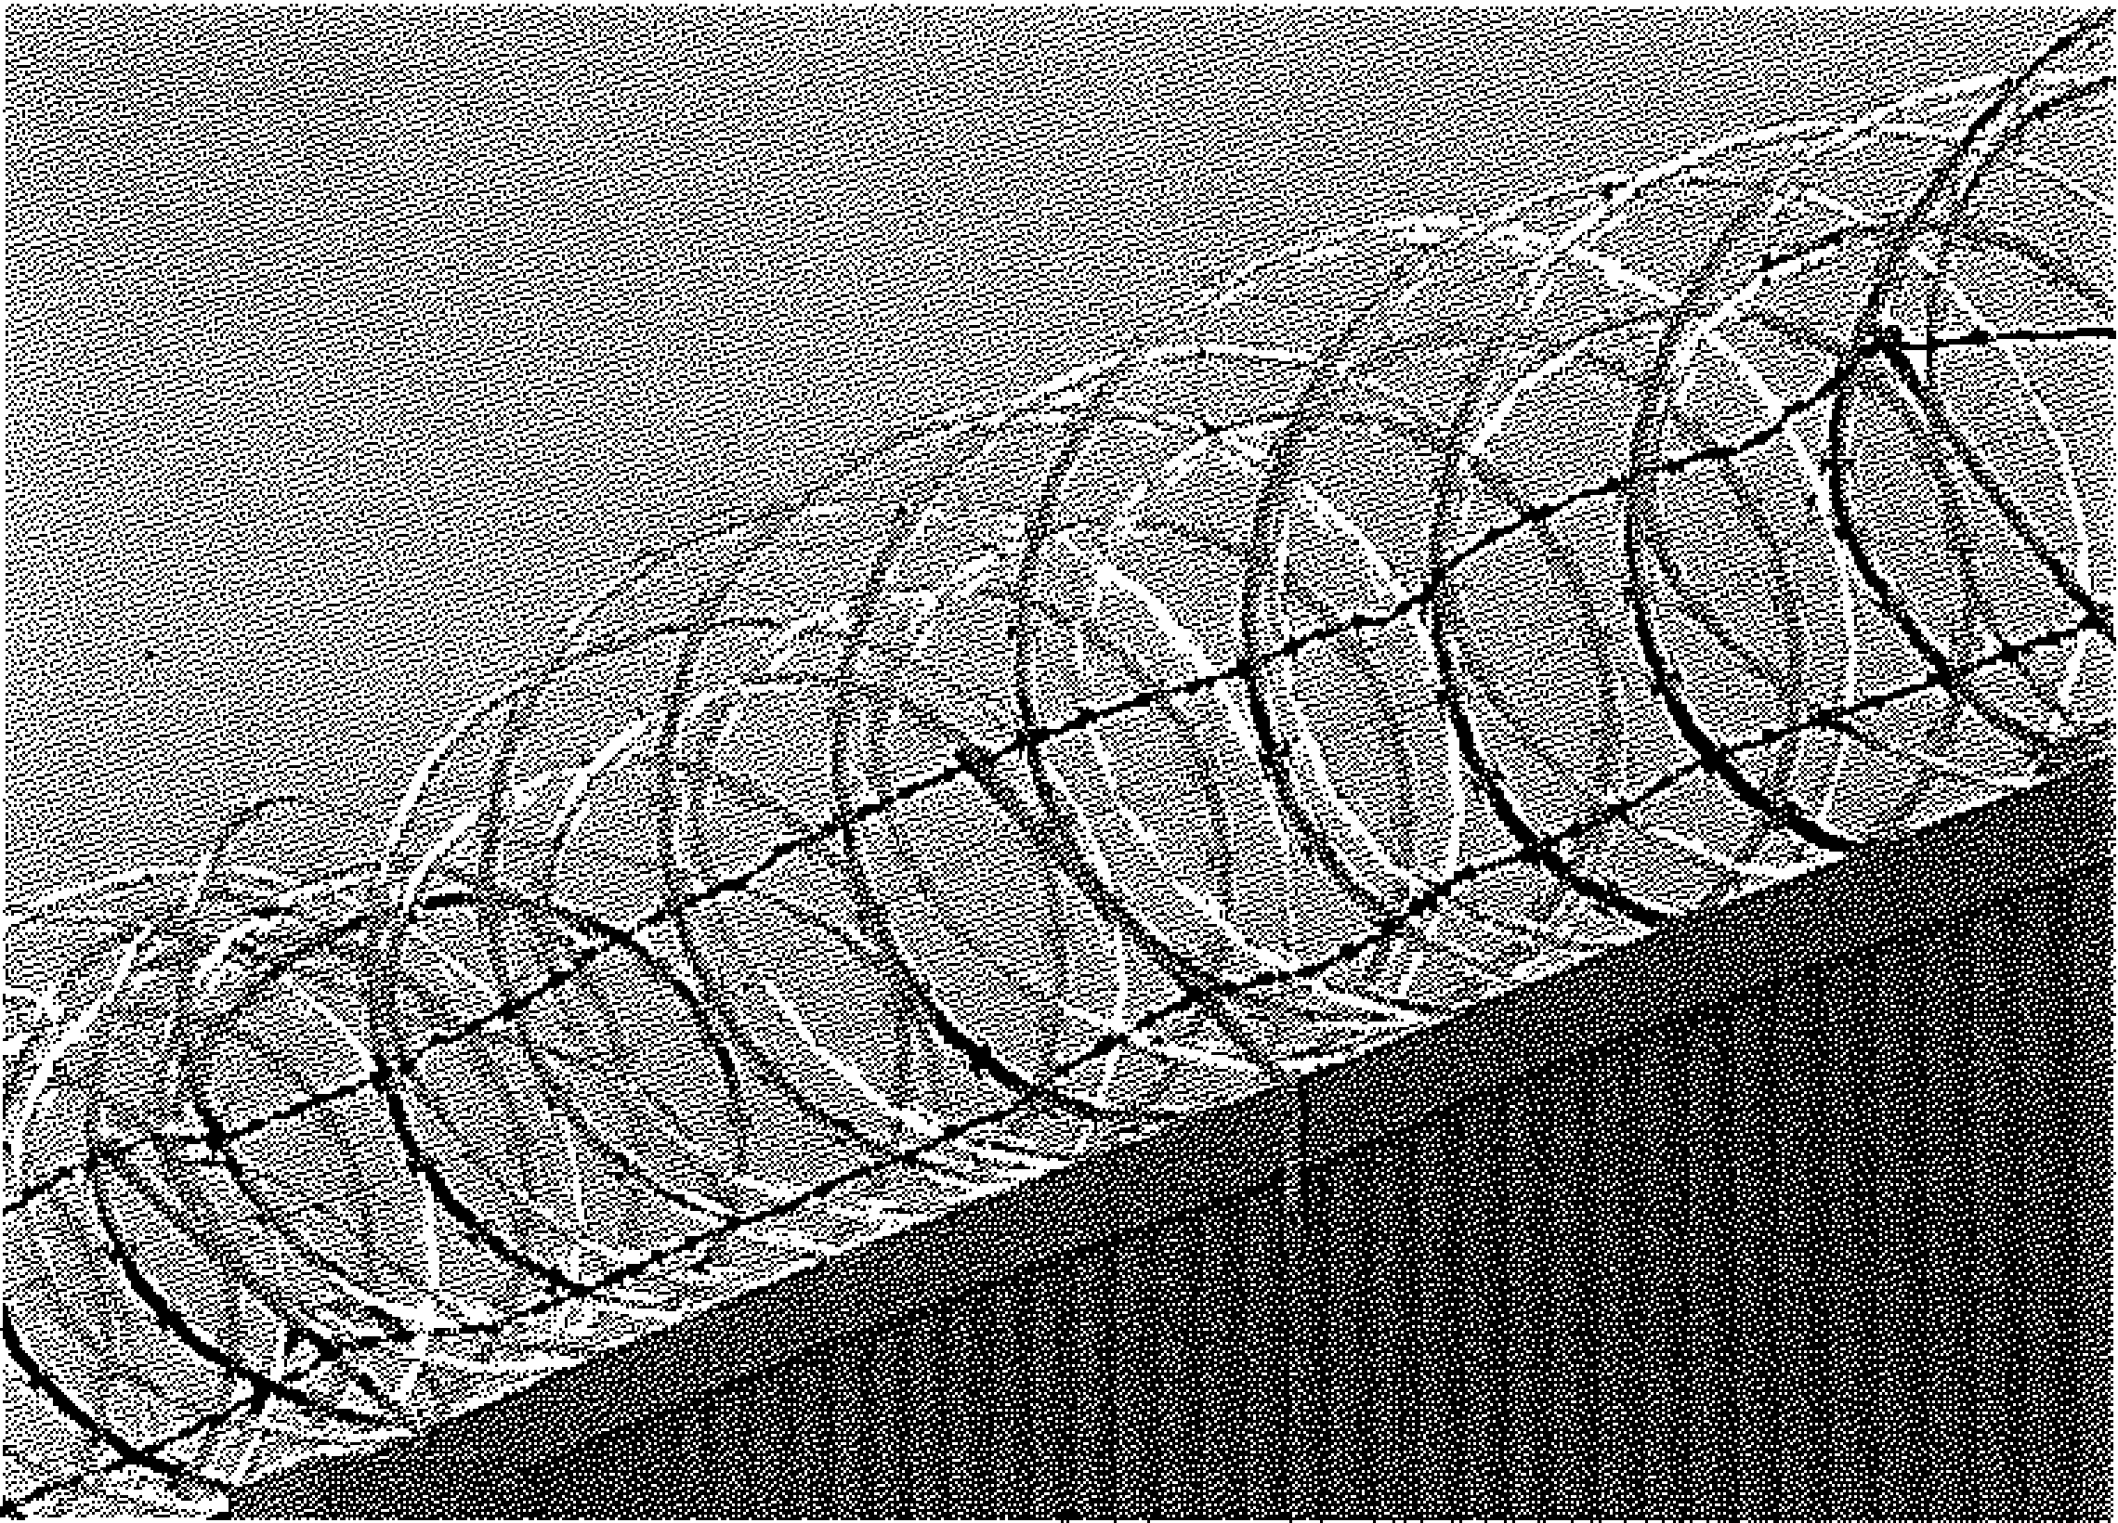

## Prohibited Carry Areas

* Educational Property (Vehicle Exception)
* Courthouses, State Buildings, and Federal Property (Vehicle Exception)
* After having consumed alcohol or illegal controlled substances
* Demonstrations at Private Health Care Facilities and Pickett Lines (unless posted)
* Law Enforcement or Correctional Facility
* Anywhere a conspicuous sign has been posted, or where prohibited by the owner

NC Private Protective

Services Firearms Training



MODULE II SAFETY

Title: Firearms Safety

Lesson Purpose: To introduce to the participant the importance of safe gun handling and storage of the firearm.

Student Performance Objectives: At the end of this block of instruction, the

student will be able to perform the following objectives in accordance with information received during the instructional period:

* 1. Discuss the provisions of North Carolina General Statute 14-315.1 Storage of firearms to protect minors.
  2. List the Four Cardinal Rules of Safe Gun Handling.
  3. Demonstrate how to safely store a handgun.

Hours: One (1)

Instructional Method Lecture/Demonstration

Materials Required: Pen/Pencil Handgun

Locking Devices (i.e., trigger lock, breech lock padlock, etc.)

References: See Bibliography

Prepared by: R. Steven Johnson Instructor/Coordinator

North Carolina Justice Academy

Date Prepared: Spring, 1998

Revised By: R. Steven Johnson Adjunct Instructor

North Carolina Justice Academy

Date Revised: December 2017

Title: Firearms Safety

1. Introduction
   1. Opening Statement

Anyone who is in possession of a firearm has the responsibility to always think and act in a safe manner. Safety deals not only with the handling of the weapon but also with the storage of the weapon.

Armed security officers should remember that mechanical safeties may fail so it is important that the officer understand the aspects of safe muzzle direction and the Four Cardinal Rules of Safe Gun Handling.

* 1. Student Performance Objectives

C. Reasons

Many times, we read or hear in the news of an accidental discharge of a deadly weapon that has taken the life of some individual. Weapons can be dangerous if mishandled or if in the hands of someone who is not adequately trained in the use and operational characteristics of the weapon. Safety is everyone's responsibility, and it starts with the basic education in safe gun handling practices and the safe storage of handguns.

1. Body
   1. Safety Issues for the Armed Security Officer
      1. Everyone must learn one basic rule at the outset of firearms training and never forget it! That rule is to always think safety and always practice safety. The rule must become so ingrained in thinking that every time a firearm is seen, the word "firearm" is read or heard, the officer becomes safety conscious. As one becomes more familiar with a firearm there is a tendency to relax, to let the guard down, to take chances, to approach its use in a more routine fashion. The officer should always maintain a healthy respect for the firearm.
      2. Always make certain that the weapon to be fired is in good working order.
      3. Four Cardinal Rules of Safe Gun Handling 1
         1. Treat all weapons as loaded until you have personally inspected it.
         2. Always point the muzzle in a safe direction.
         3. Keep your finger off the trigger and on the frame until you are ON TARGET, have the legal right to fire, and HAVE DECIDED TO FIRE.
         4. Be sure of your target and what is around and beyond it.
      4. Safety in general
         1. The officer should treat every gun as if it were loaded. Never point the weapon, loaded or unloaded, at anyone unless there is the intention to shoot.
         2. Always keep a weapon pointed in a safe direction. If all else fails and the muzzle is pointed in a safe direction, the chance of injury is greatly reduced.
         3. Only routine cleaning and maintenance should be performed. All service work on a weapon should be done by a factory trained armorer.
         4. Never use the weapon as a club or hammer.
         5. Do not throw a weapon around!
         6. Never hand a loaded weapon to anyone. Unload it first.
         7. If someone hands over a weapon and states that it is unloaded, do not take their word for it. Check it.
         8. Never carry the firearms in a pants pocket or waist­ band.

i. A firearm should remain in the officer's holster unless there is a need to use it. Unnecessary handling of any weapon increases the possibility of an accident.

J. Do not be lulled into over-confidence and take the weapon for granted.

1. While using the restroom when on duty, do not take your weapon from its holster. Unbuckle the gun belt and hang it on the hook usually located on the inside of the closed door. If there is no hook available, either hang the belt around the neck, or put the entire gun belt inside the crotch of the pulled-down trousers. Do not

put the weapon on the tank lid as it could fall. Do not put the gun belt on the floor because a person outside or in the next stall could reach under the partition and take the weapon. An officer's weapon must always be under control, regardless of what the officer is doing.

* 1. An officer should protect the weapon so that it is not lost or taken away. By losing the weapon, the officer and

the public become endangered. The officer should use only top-quality holsters with adequate (fastened) safety straps, i.e., top straps, etc., that ensure that the weapon cannot fall out or be taken easily yet can be drawn quickly.

1. Alcohol and gunpowder do not mix!
2. Warning shots

Warning shots should never be fired if the circumstances do not justify the use of deadly force. Warning shots should never be fired for the purpose of frightening or halting a suspect running away from an officer.

Any discharge of a firearm is dangerous to life and can be justified only if the need to shoot is clear and un­ avoidable. Every officer is responsible for the consequences of shooting, from the time the trigger is pulled until the bullet reaches its terminal resting point.

* + 1. Safety at home
       1. A security officer with a family, especially if there are small children, has a much greater concern for firearms safety than an officer living alone. However, all officers should do whatever is necessary to ensure safety and prevent accidental shootings.
       2. One problem with children is they observe guns being used in television and movies and they are allowed toy guns; yet they are unable to differentiate between their toy and a real gun. In addition, a child's curiosity may cause them to disregard a direct order not to touch a firearm.
       3. Do not be fooled by thinking that small children cannot pull the trigger of a double-action weapon. .
       4. Safety devices such as trigger locks are available commercially. Also, handcuffs can be applied to revolvers to render them safe.
       5. One commercial invention now available for securing handguns is a kit with serrated plastic strips, similar to flex-cuffs. One advantage of these strips is they break with 60 pounds of pressure. Tests have shown that young children lack the strength to break it, ·yet in an emergency the officer should have that capability.

f. Firearms should be secured in some fashion. There is no such thing as a good hiding place.

1. G. S. 14-315.1 storage of firearms to protect minors.

According to G.S. 14-315.1, storage of firearms to protect minors:

Any person who resides in the same premises as a minor, owns or possesses a firearm, and stores or leaves the firearm (1) in a condition that the firearm can be discharged and (2) in a manner that the person knew or should have known that an unsupervised minor would be able to gain access to the firearm is guilty of a Class 1misdemeanor if a minor gains access to the firearm without the lawful permission of the minor=s parents or a person having charge of the minor and the minor:

* 1. Possesses it in violation of G.S. 14-269.2(b) [Educational Property];
  2. Exhibits it in a public place in a careless, angry, or threatening manner;
  3. Causes personal injury or death with it not in self-defense; or
  4. Uses it in the commission of a crime.

Lead Poisoning

1. Lead poisoning may pose a serious health hazard to individuals constantly exposed to this by-product of firearms training.

Lead can come from the primer, power, and projectile. Residue is found on the weapon and on shell casings as well as the dust on the range.

1. Symptoms of lead poisoning are:
   1. Abdominal pain
   2. Fatigue
   3. Nausea
   4. Headaches
   5. Constipation
   6. Subtle mood changes
   7. Irritability
   8. Depression

Increased lead levels in the body may also result in muscle pain and weakness, weight loss, anemia, impotence, convulsions and renal failure.

1. Once the primer ignites, the powder lead particles are expelled into the air. Particles also shear off the projectile as it travels down the barrel and are expelled. Particles may be found on shell casings as well as the projectile itself.
2. To aid in decreasing the exposure to lead poisoning, observe the following suggestions:
   1. Do not smoke or eat on the range.
   2. Do not place shell casings in the cap or hat while policing the range.
   3. Wear a mask when sweeping a hard surface or paved range. Do not dry sweep a range.
   4. Wash hands prior to eating.
   5. Remember that clothing, arms, face, hair, etc. will contain lead particles.
3. Conclusion
   1. Summary

Safety is everyone's concern. Safety starts with learning about a weapon, how it works, how to handle it, how to use it, and how to store it. Learn all these things and become proficient at always being safe.

1. Questions from Class
2. Closing Statement

Always think safety. Always act in a safe manner. Remember that others watch you and may act accordingly. Be a good example to cohorts, friends and family. Be safe.

***N. C. Private Protective Services Firearms Training***

**END NOTES**

1. International Association of Law Enforcement Firearms Instructors, IALEFI Standards and Practices Guide (Laconia, NH: International Association of Law Enforcement Firearms Instructors, 1995), p. 76.

Firearms Safety

Think Safe! Act Safe!

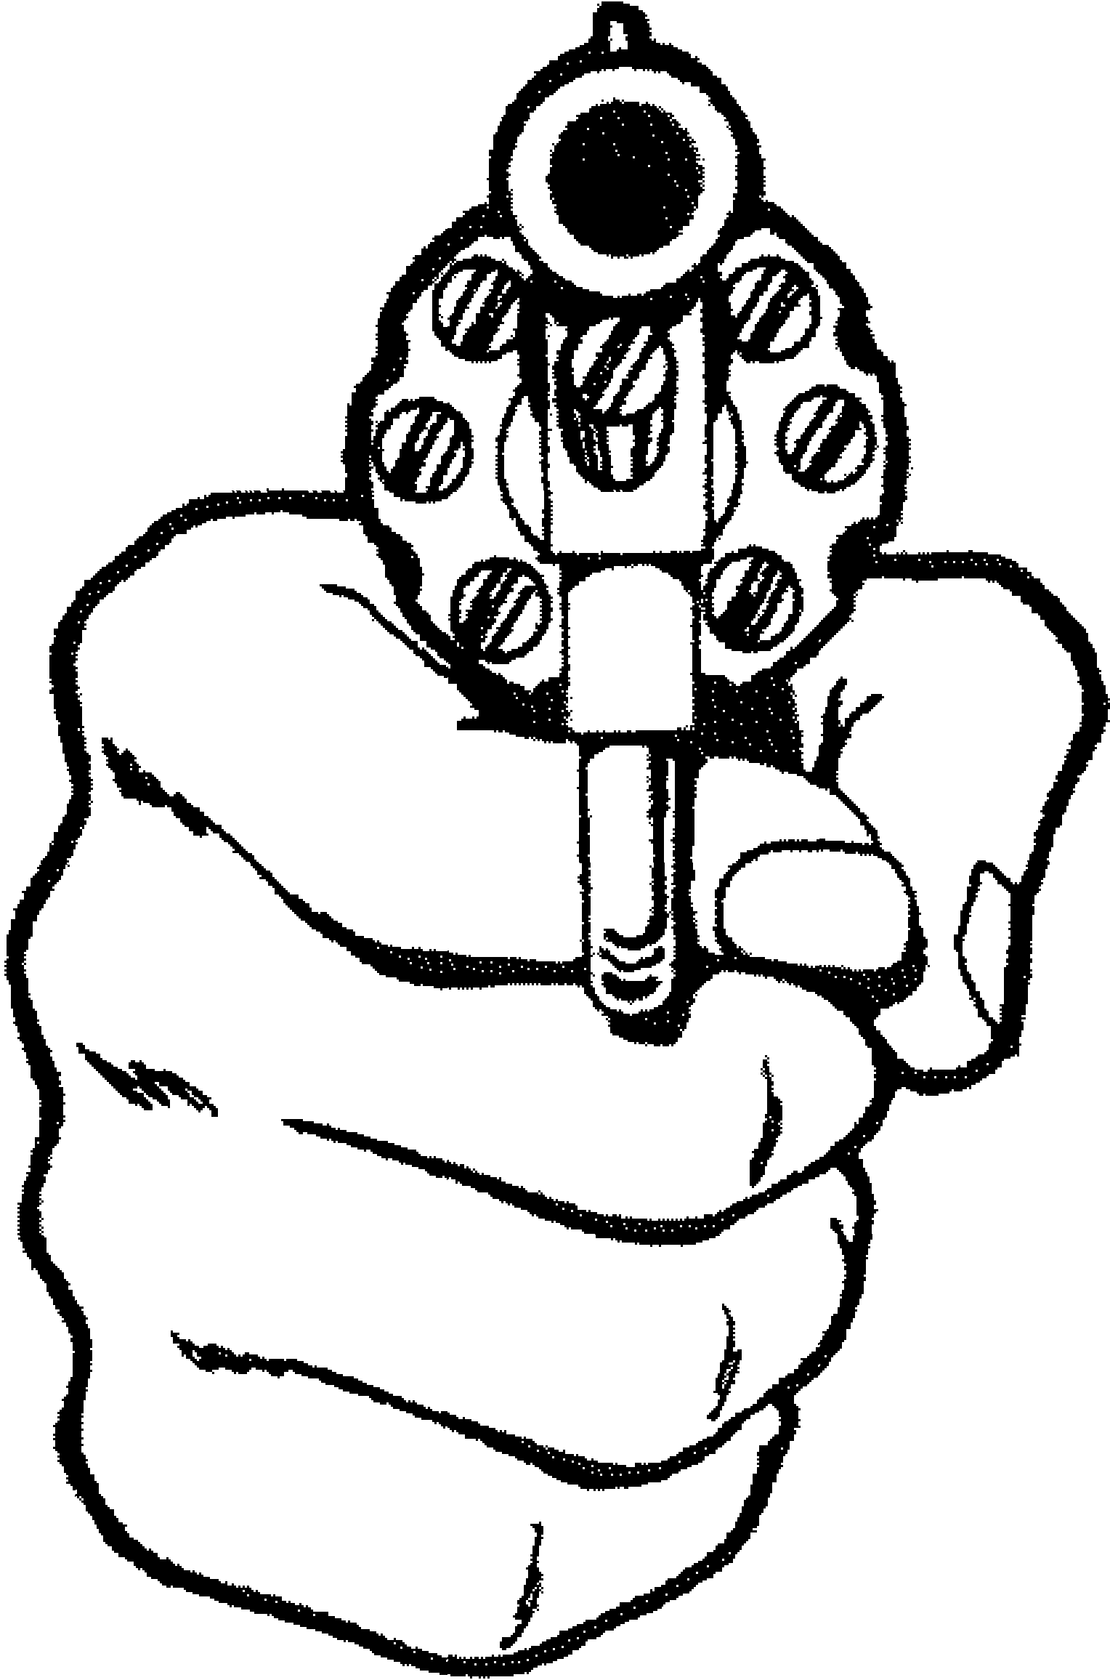Be Safe!

Remember to always check the Weapon!



## Four Cardinal Rules

for Safe Gun Handling

1. Treat every weapon as if it were loaded, until you have personally inspected it.
2. Always keep a weapon pointed in a safe direction.
3. Be sure of your target and what is around it and beyond it.
4. Keep your finger off the trigger, out of the trigger guard and on the frame, until you are on target, have the legal right to, and have decided to fire!



NC Private Protective

Services Firearms Training



MODULE Ill HANDGUN OPERATION &

MAINTENANCE

Title: Handgun Operation and Maintenance

Lesson Purpose: To provide the participant with the knowledge of the operational characteristics of the revolver and the semiautomatic and the nomenclature of each.

Student Performance Objectives: At the end of this block of instruction, the

participant will be able to achieve the following objectives in accordance with information received during the instructional period.

* 1. Describe the nomenclature of the revolver.

1. Describe the nomenclature of the semiautomatic handgun.
2. Demonstrate how to safely load and unload the revolver and semiautomatic handgun.
3. Describe the cycle of operation of the semiautomatic handgun.
4. Demonstrate how to clean and inspect the handgun.

Hours: Four (4)

Instructional Method: Lecture/Demonstration

Materials Required: Revolver

References: See Bibliography

Prepared By: R. Steven Johnson

Instructor Coordinator

North Carolina Justice Academy

Date Prepared: Spring, 1998

Date Revised: Summer 2001

Revised By: R. Steven Johnson

Adjunct Instructor

North Carolina Justice Academy

Date Reviewed: February 2014

Title: Handgun Operation and Maintenance

I. Introduction

A. Opening Statement

The service handgun must be maintained properly to function properly. The armed security officer should be familiar with the correct nomenclature of the handgun and well as how it operates and how best to care for it.

1. Student Performance Objectives
2. Reasons

While detailed disassembly should be left to a factory trained armorer, the armed security officer should be familiar with the operational characteristics with the handgun that they carry as well as how to adequately clean and care for the weapon to ensure that the weapon will function properly if needed.

1. Body

A Revolver

* 1. The principle of the revolver is that a cylinder with separately loaded chambers (usually six) revolves as the weapon is cocked or the action is pulled through, thereby aligning each chamber with the barrel and firing pin in succession. 1
  2. Nomenclature 2

To properly use and understand the service revolver one must first be familiar with the nomenclature.

* + 1. Rear sight
    2. Front sight
    3. Barrel
    4. Trigger
    5. Trigger guard
    6. Hammer
    7. Hammer spur
    8. Top strap

1. Cylinder

J. Extractor/ejector rod

1. Backstrap
   1. Frontstrap
2. Grips
3. Thumb latch

0. Cylinder star

p. Extractor rod shroud

* 1. There are single-action and double-action revolvers.
     1. For a single-action revolver to fire, the hammer must be pulled back with the thumb into a cocked position and the trigger squeezed.
     2. The double-action revolver can be fired in the manner described above and can also be fired by squeezing the trigger only, making the hammer pull back and fall all in one motion.
     3. In both actions, as the hammer falls it drives the hammer nose forward to the firing pin well and detonates the cartridge primer.
  2. The cylinders of various makes of revolvers do not all revolve in the same direction. For example, the cylinders of Smith and Wesson and Ruger revolvers rotate *counterclockwise,* while the cylinders of Colt revolvers rotate *clockwise.*
  3. The cylinder latches of various makes of revolvers do not all work the same. For example, the cylinder latch on a Smith and Wesson must be pushed forward, while on a Colt the latch

must be pulled back, and on the Ruger, it is pushed into the frame.

* 1. The revolver has built-in safety features.
     1. For a single-action revolver to fire, it must first be cocked.
     2. Double-action firing requires a heavy trigger pull and the action must be "pulled through" completely.
     3. In addition, many modern revolvers are equipped with a · hammer block to prevent firing if the hammer is struck accidentally or slips during the cocking phase. The

safety of the hammer block can be tested by almost cocking the hammer and letting it fall while the cylinder is out. The firing pin should not protrude through the breech.

* 1. Uncocking a loaded and cocked revolver3
     1. To lower the hammer on a live round in a revolver, first make sure the finger is off the trigger and the gun is pointing in a safe direction. Place the thumb of the

non-shooting hand between the cocked hammer assembly and frame, with the thumb nail directly under the firing pin. ·

* + 1. Place the thumb of the shooting hand firmly on the hammer spur.
    2. Then place the index finger of the shooting hand on the trigger. Apply slight pressure on the trigger until you sense forward motion of the hammer.
    3. Next, immediately release the trigger and remove the index finger from the trigger to the outside of the trigger guard.
    4. Guide the hammer down slowly with the thumb of the shooting hand until the firing pin touches the thumb of the non-shooting hand. Remove the thumb of the

non-shooting hand from contact with the gun and guide the hammer slowly down the remainder of the way with . the thumb of the shooting hand. ·

1. Loading and unloading 4
   1. During practice and qualification, the shooter should always load in the manner that is used in an actual

***Module Ill: Handgun Operation and Maintenance (Student) Page 5 .***

combat situation. If speed loaders are used on duty, they should also be used during range activity.

* 1. The officer should utilize combat procedures for unloading and loading during both practice and qualification. For a right-handed shooter the method is as follows.
     1. The weapon should be brought to the belt buckle with the muzzle pointed down at least 45 degrees. The thumb of the right hand works the cylinder release latch or button while the two middle fingers of the left hand push the cylinder out and clear of the frame. The index and little fingers hold onto the top of the top strap. The weapon can now be loaded.
     2. To unload the weapon turn it so that the barrel is pointing upward. The thumb of the left hand can now be used to work the extractor rod to empty the weapon. Unloaded brass should not be

caught in the hand. It should be dumped on the ground. While the left hand clears the cylinder, the right hand can be reaching for the additional ammunition.

* + 1. For left-handed shooters, the weapon can be loaded the same as for right-handed shooters or, the right thumb operates the cylinder release or button, then the right thumb grasps the cylinder as the cylinder is opened and is held with the four fingers. The index finger operates the extractor rod ejecting any shell casings or live rounds. The left hand can then grasp speed loaders or ammunition to load or reload the weapon.

In reloading, the officer usually gets additional rounds from one of four sources: belt loops, dump pouches, speed strips, or speed loaders.5

* + - 1. Loading from loops can be faster if the shooter practices grasping and loading two rounds at a time.
      2. Speed strips enhance loading in that all the rounds are pointed in the right direction and should also be loaded two at a time.
      3. Dump pouches should be loose and "broken in" so that when released the rounds fall easily into the shooter's cupped hand. The officer must be careful, however, that rounds do not come out of the pouch prematurely before the shooter's hand is cupped and ready.
      4. The fastest method for fully reloading the revolver is by use of the speed loader, a device that allows all six rounds to be loaded at the same time.

1. After being emptied, the weapon, still held by the left hand, is brought into the proximity of the

belt buckle with the barrel pointed at a downward angle (about 45E) and downrange. A left-handed shooter may elect to hold the weapon with the right hand at this point by holding the cylinder with the thumb and index finger.

1. With the index and little finger still on the top strap, the palm of the weak hand should form a cup under the cylinder to catch any rounds if dropped. The thumb and middle finger should be used to rotate the cylinder and should contact

the cylinder at the cylinder flutes bordering each chamber to be loaded. This will enhance the ability to load by feel!

1. Live rounds are loaded with the strong hand; the cylinder is then closed, and the weapon is ready to fire.
2. Cleaning and inspecting the revolver6
   1. Unload the weapon in the proper manner before cleaning. Visually and physically inspect the weapon to make sure that it is unloaded.
   2. Read manufacturer's instructions prior to cleaning.
   3. With the cylinder open, the barrel should be thoroughly scrubbed with the proper caliber brush. Use a dry brush initially to remove as much dirt and residue as possible prior to using solvents. The area around the firing pin hole and hand slot should be covered to prevent debris from entering the interior of the frame. The brush should clear the bore at the end of each stroke as attempts to reverse the brush while in the bore will bind the bristles and can eventually cause damage to the lands and grooves. ONLY use stainless steel brushes on stainless steel weapons.
   4. The barrel throat or forcing cone can be cleaned more effectively by utilizing a commercial device such as the Lewis Lead Remover or a .45 cal. brush. With the handle bent at a right angle, both can be useful in cleaning this area.
   5. Use a bristle brush or toothbrush with solvent to clean the interior surfaces of the frame, the crane assembly, and the flat surfaces of the cylinder including the extractor star and the area behind the extractor star.

f. Push the extractor rod back and forth. It should operate freely. Clean the remainder of the extractor rod assembly and place a drop of oil on the extractor rod. Again, push the rod back and forth and wipe off the excess oil.

1. Clean the individual chambers of the cylinder.
2. Pass a solvent moistened patch through the bore until clean. Then pass a lightly oiled patch through the bore. Repeat the process for the individual cylinders.

1. If necessary, clean debris from the firing pin well with a toothpick or similar device.

1. Officers should periodically inspect service revolvers to determine if they are in good working order. The weapon should always be inspected while it is being cleaned.
   1. Screws ·The officer should check all visible screws to make sure they have not worked loose.

***Module Ill: Handgun Operation and Maintenance (Student) Page 8***

* 1. The extractor rod should be checked to determine · if it is bent or loose. If the extractor rod becomes loose, the cylinder may be difficult to open, or the entire cylinder assembly can fail to rotate when

the hammer is cocked, or the trigger is pulled.

* 1. The firing pin should be checked for looseness and penetration. ·
  2. Cylinder alignment - After the weapon is cocked, the cylinder should align with the barrel and there should be no excessive play in the cylinder, as it should be locked at that point.
  3. Hammer push-off ·Verify that when the hammer is in the cocked position it cannot be "pushed off ' with the thumb.
  4. Double-action trigger pull - Verify that there is no binding or sticking and the pull is smooth.
  5. Cylinder opening and closing - Cylinder should open and close freely without binding.
  6. Trigger return - Verify that the trigger returns to the forward position sharply and smoothly.
  7. Verify that the forcing cone and barrel is free from excessive lead and powder build-up.
  8. Verify that the underside of the extractor star is free from excessive lead and powder build-up.

k. If repair or disassembly is required, the weapon should be taken to a factory trained armorer. If any of the conditions above exist, carry the weapon to a qualified armorer.

1. Semiautomatic Operation and Maintenance L Semiautomatic
   1. Semiautomatics have gained increased popularity in the last few years. These weapons have great potential, especially when one considers their accuracy, firepower, and speed in reloading. Semiautomatics, like revolvers, are also single-action or double-action, and with some variation generally function in the same manner.
2. Nomenclature
   1. Rear sight

(2) Front sight

1. Ejection port
2. Grip
3. Trigger
4. Trigger guard
5. Magazine
6. Slide
7. Slide stop notch

(10) Receiver/Frame

(11) Magazine release or catch

(12) Barrel

1. Ejector
2. Extractor
3. Front strap
4. Back strap
5. Magazine well
6. Slide stop lever
7. Takedown lever (some models)
8. Safety (some models)
9. Hammer (some models)
10. Decocking lever (some models)
11. Cycle of operation
    1. **Feeding** - Takes place when a cartridge is placed in the path of the slide ready for chambering. The magazine is used for this purpose.
    2. **Chambering** - Takes place when the cartridge is seated in the chamber. This action occurs when the slide moves forward under pressure provided by the recoil spring.
    3. **Locking** - Occurs when the locking ribs on the barrel are engaged with the locking recesses in the slide and the slide is as far forward as it will go. Locking prevents the loss of gas pressure until after the bullet has left the muzzle of the weapon.
    4. **Firing** - The trigger is pulled and the firing pin impacts, firing the round.
    5. **Unlocking** - Takes place after the firing of a round. Gases from the fired cartridge force the slide and barrel rearward.
    6. **Extracting** - Extracting cartridge from the chamber by means of the extractor located on the slide which engages with the rim of the cartridge during chambering.
    7. **Ejecting** - Throwing the expended casing out of the weapon by way of the ejection port.
    8. **Cocking** - When the slide moves rearward, it forces the hammer rearward and downward com­ pressing the mainspring.

***Module 111: Handgun Operation and Maintenance (Student) Page 11***

1. Safety devices
   1. Safety (SA)
   2. Safety/Decocking Lever (DNSA)
   3. Grip Safety
2. Firing Pin Block
3. Magazine Disconnectors

(6) Trigger Safety (Glock, Springfield XD)

1. Loading
   1. Hold the weapon properly with a firm single hand grip. The muzzle of the weapon should be pointed away from the body.
   2. Insert magazine and ensure the magazine is "seated. Magazine should be held between the thumb and middle and ring fingers. The index finger should be positioned straight along the front of the magazine. The floor plate of the magazine should be in the palm of the hand.
   3. If the slide is locked to the rear pull the slide to the rear and release to chamber a round.
   4. If the slide is forward, pull the slide rearward and release to chamber a round.
   5. Place safety on if carried in this manner.
   6. The finger should remain off the trigger.
2. Unloading - with weapon pointed in a safe direction8
   1. Depress the magazine release button and remove the magazine.
   2. The finger should remain off the trigger.
   3. Hold the weapon in the strong hand.



* 1. With the support hand, grasp the slide on ser­ rations and pull to the rear ejecting round in the chamber.
  2. Lock the slide open.
  3. Inspect the weapon visually and physically-­ make sure no round remains in the chamber.

1. Reloading

There are two types of reloading, with the slide back or with the slide forward.

* 1. Slide Back or Emergency Reload

Drop the empty magazine, insert a new magazine and pull the slide rearward and release to chamber a round.

* 1. Slide Forward Reload
     1. Magazine Change

Drop the magazine currently in the weapon, insert a new magazine. If the shooter feels that they need to rack the slide to ensure that a round is chambered they should do so.

* + 1. Magazine Save or Tactical Reload

Secure a new magazine and bring it to the base of the grip, remove the old magazine capturing it with the support hand, insert the new magazine; OR remove the old magazine and secure it then insert a new magazine. The old magazines are always secured versus dropped on the ground.

1. Some of the more commonly used semiautomatics are the Colt model 1911 .45 ACP, the various Smith and Wesson models, the Beretta, the Sig Sauer, the Glock, H&K USP, and the Ruger models.
   1. The Colt 1911 model or government models are single-action semiautomatics. If a round is chambered and the hammer is carried down, the hammer must be cocked before the pistol can be fired. Cocking is performed by pulling back the hammer.
      1. The Colt .45 has two excellent safety features. The first is the grip safety which prevents firing unless it is de­

pressed as the pistol butt is grasped in the shooter's hand.

* + 1. The second safety is the manual thumb safety on the left side of the frame. When activated the safety prevents the hammer from falling.
    2. Beca use these safeties work as they do, most experts recommend that the .45 be carried, cocked, and locked hammer back and the manual safety on. Thumbing of the safety becomes a conditioned response with training so that as the muzzle moves toward the target, the officer may fire almost instantly.
  1. Most Smith and Wesson models, Beretta, Ruger,

H&K USP, and the Sig Sauer models are double-action semiautomatics and function like the revolver for the first shot. It is carried with the trigger forward and the hammer down. By

pulling the trigger, the shooter cocks the weapon and fires all in one motion. After firing the first round, the weapon cocks itself, the hammer remaining rearward. Subsequent rounds are fired by pulling the trigger single-action.

* + 1. The safety lever is located at the rear of the slide and controls the "rolling bloc" safety system. With the hammer down and the lever in the up position, the weapon may be fired double-action. Many of the newer models have ambidextrous safeties.
    2. If the pistol is cocked, it may be placed in a safe condition by rotating the lever down causing a block of steel to come between the hammer and the firing pin base. The hammer is tripped but strikes the rolling bloc and the weapon does not fire. ·
    3. If the Smith & Wesson or Beretta are carried with the safety lever down, it cannot be cocked or fired. The trigger is dis­ connected and can be pulled without the weapon becoming cocked. Many officers like this feature from the standpoint of the weapon getting into the hands of a mental patient or an adversary while struggling. Without prior knowledge, the weapon would probably be inoperative in their hands.
    4. The Sig Sauer and Smith-Wesson frame decockers do not have safety/decockers but have a "decocking lever" located on the left side of the frame slightly above the trigger.
  1. The Glock, Smith & Wesson double-action models, Springfield XD, Smith & Wesson M&P, and Beretta double-action models are semiautomatic weapons with a double action trigger pull on each shot. The weapon has a trigger pull that ranges from 5-12 lbs. The weapons may not have a hammer and will not have a decocking device even if the weapon does have a hammer as the hammer will never remain in the single action position.

1. Cleaning and inspecting the semiautomatic.
   1. Unload the weapon in the proper manner before cleaning. Magazine is removed, then the chamber is cleared. Visually and physically inspect the weapon to ensure that it is unloaded.
   2. Field strip the weapon according to the manufacturer's recommendations. The weapon will normally be separated into five components: frame, slide, barrel, recoil spring and guide rod, and magazine. The magazine may also be dis­ assembled for cleaning and should be cleaned whenever the weapon is cleaned.
   3. Use a bristle brush or toothbrush to remove residue and dirt from the frame and slide. Use the proper bore brush to clean the barrel. Use a dry brush initially to remove as much dirt and residue as possible prior to using any type of solvent. When cleaning the barrel, the bore brush should be inserted from the chamber end of the barrel.
   4. When cleaning the frame and slide, make sure that the rails are cleaned and that the slide moves freely on the rails when assembled. The recoil spring and guide rod should be wiped off then lightly lubricated.
   5. Check manufacturer’s recommendations on solvents. Use a solvent that is safe to the user and one that leaves no residue.
   6. Lubricate according to manufacturer=s recommendations. Usually, 6 to 8 drops of oil are all that is needed. Remember that excessive oils attract dirt. Do not use excessive oil on the magazine. Oils are penetrates and can penetrate the primer of a round of ammunition causing it not to fire.
   7. Once the weapon has been reassembled perform a "function check". This check is done to make sure that the weapon has been assembled properly and will function as required. Some simple checks are: dry fire the weapon double­ action and single-action; lock the slide to the rear, depress the slide release allowing the slide to go forward; release the magazine, insert the magazine, pull the slide to the rear with the magazine in the weapon, the slide should lock

back on most weapons; check manual safeties or decocking levers to make sure that they function properly.

1. Conclusion
   1. Summary

Armed security officers should be adequately trained in the loading, unloading, making safe of the handgun that they carry. In addition, a thorough working knowledge of how the weapon functions and the proper name for the parts of the weapon is necessary to be well versed in the weapons system.

* 1. Questions from Class

1. Closing Statement

Each time a weapon is used it should be properly cleaned and serviced to ensure that the weapon will function properly. Armed officers should be thoroughly versed in cleaning the weapon and making the weapon safe.

END NOTES

* 1. International Association of Law Enforcement Firearms Instructors, 1995), p. 76.
  2. Parts List Manual (Springfield, MA: Smith & Wesson), p. 4.
  3. The Basics of Pistol Shooting (Washington, DC: NRA, 1991), p. 39. 4. Ibid., pp. 37-38, 40-41.

1. Brian A Felter, Police Defensive Handgun Use and Encounter Techniques (Englewood Cliffs, NJ: Prentice-Hall, Inc., 1988), pp. 271-278.
2. Parts List Manual, pp. 5, 24.
3. Gregory Boyce Morrison, The Modern Technique of the Pistol (Paulden, AZ: Gunsite Press, 1991), pp. 32-33.

8. Ibid., pp. 35-36.

*Mod ule III: Handgun Operation and Maintenance (Student) Page 18*

REVOLVER NOMENTCLATURE

Barrel Front Sight Rear Sight Top Strap

Hammer spur

Cylinder/thumb latch

Extractor Rod Trigger Guard

Grips

Front Strap Back Strap Cylinder Cylinder Star

**Semiautomatic Handgun**

***Nomenclature***

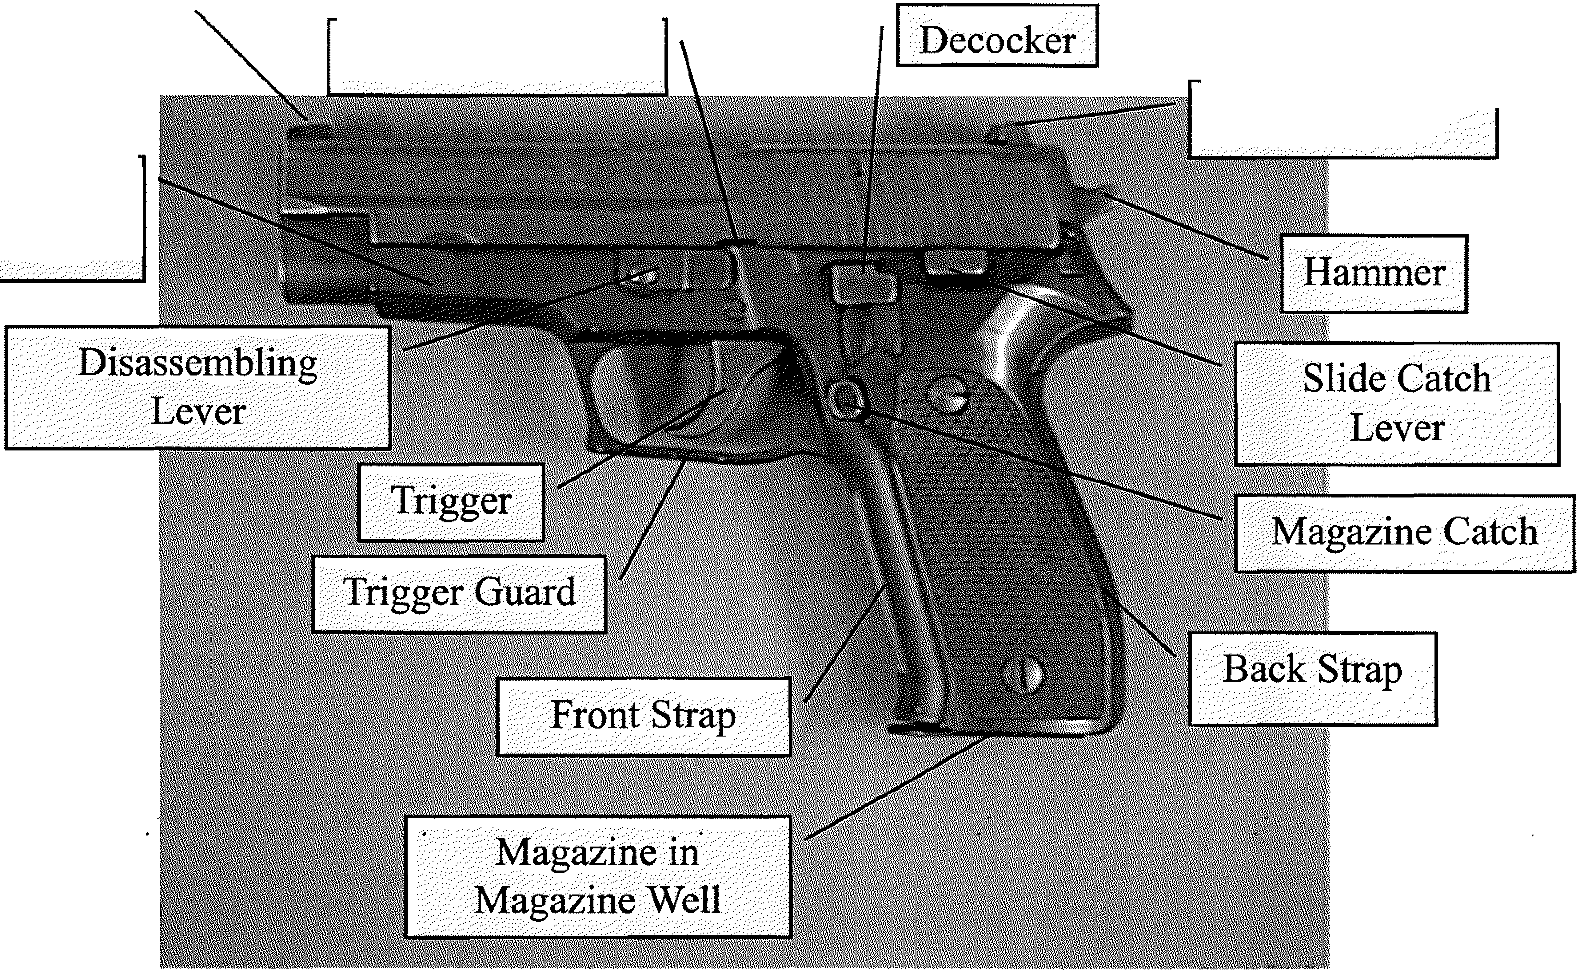

Frame

Slide Stop Notch

Rear Sight

NC Private Protective

Services Firearms Training



MODULE IV

MARKSMANSHIP FUNDAMENTALS

Title: Marksmanship Fundamentals

Lesson Purpose: To familiarize the participant with the basic elements of marksmanship fundamentals and how they may enhance the performance with the handgun.

Student Performance Objectives: At the end of this block of instruction, the

student will be able to achieve the following objectives in accordance with information received during the instructional period.

* 1. List the four steps of the draw.
  2. Demonstrate the proper one-hand and two-hand grip.
  3. Demonstrate two stances.
  4. Define Sight Alignment.
  5. Define Sight Picture.
  6. Describe in writing how to perform a malfunction drill.

Hours: Eight (8)

Instructional Method: Lecture/Demonstration

Materials Required Handgun

Belt with holster Ammunition Targets

Hearing and eye protection

Range equipment (i.e., staple guns with staples, PA system, chalk, etc.)

References: See Bibliography

Prepared by: R. Steven Johnson Instructor/Coordinator

North Carolina Justice Academy

Date prepared: Spring, 1998

Revised By: R. Steven Johnson Adjunct Instructor

North Carolina Justice Academy

Date Revised: February 2014

Title: Marksmanship Fundamentals

1. Introduction
   1. Opening Statement

Learning to effectively fire a handgun using the proper fundamentals should be done to save one's own life or the life of others, not merely to meet a qualification standard. Armed officers should be concerned with learning the basic marksmanship fundamentals to increase not only their ability to use the weapon, but also their confidence is using the handgun.

* 1. Student Performance Objectives
  2. Reasons

1. Body

A Drawing the weapon

When drawing the weapon from the holster, the trigger finger should stay outside the trigger guard and should not engage the trigger until the barrel is in the direction of the intended target.

* 1. Four steps to draw.
     1. Establish the master grip.
     2. Clear the holster.
     3. Weapon is brought to the center line of the body as two hands come together.
     4. Extend to target.

1. For good shooting, your draw should be one continuous motion. Smoothness is more important than an attempt at speed alone.
2. The snap or strap of a holster, if so equipped, should always be fastened, even in practice and qualification.
3. The weapon should be drawn and moved upward towards the target as if the officer is throwing a punch!
   * 1. Marksmanship Fundamentals
        1. The grip2 3
           1. The stock should be gripped with the last three fingers and the heel of the hand, thumb placed lightly against the support side of the frame, index finger outside the trigger guard.
           2. The grip should always be high on the stock or backstrap. This will cause the barrel to point straight so that the shooting finger and the barrel will be an extension of the arm. Grip firmly, but not so tight that the hand trembles or the muscles are too tense. Pressure should be exerted from the front of the weapon to the rear and not side to side.
           3. When using the one-handed grip, the weapon

may be canted approximately 10 degrees towards the body. This is a more natural position than holding the weapon straight up.

Think of how a punch is thrown and the arm naturally rotates in towards the body.

* + - * 1. To set the two-hand grip, place the heel of the non-gun hand between the fingertips and the heel of the gun hand. Try to cover as much as of the grips of the weapon as possible. Curl the support hand fingers around the fingers of the gun hand. The thumb of the support hand should be parallel or nearly parallel with the thumb of the gun hand. The index finger of the support hand should NOT be placed on the trigger guard. Pressure should be applied from the frontstrap to the backstrap of the weapon and not from the fingertips applying pressure to the sides of the weapon.
      1. Sighting (alignment and picture)4 5
         1. The front sight of a handgun is usually a blade, and the rear sight is a notch. The top of the front blade should be level with the top of the notch of the rear sight and centered in the rear, i.e., the space appearing on each side of the front sight in the notch of the rear should be the same on both sides. Care should be taken in focusing on the front sight to ensure that the alignment is correct. A .01" error in sight alignment can

cause an error of 3 feet at 50 yards. This lines the barrel of the gun in a straight line with the line

of sight. Maintain this alignment and line it with the point where you want the bullet to strike. The eyes can focus on only one object at a time, and this should be the front sight. The target and rear sight will be somewhat blurred.

* + - * 1. The shooter should sight with both eyes open. This method may be difficult at first but improves with practice. The master eye is dominant when sighting with both eyes.
      1. Breath control6

The breath should be held during the time of sighting and firing. This does not mean that a deep breath should be taken before starting to align the sights and held with perhaps considerable strain until the shot is fired. Normal breathing should take place until the gun is brought into position and the trigger squeeze is begun. The breath is released to a comfortable point and held while the round is fired. During rapid fire the breath is usually held for several shots. ·

* + - 1. Trigger manipulation 7
         1. Correct placement of the trigger finger is the first step in trigger manipulation. The two areas of the trigger finger that are used are the first joint and the pad. The first joint position places the first joint on the outside edge of the trigger. This position is more commonly used for double-action firing. The pad places the center of the finger between the first joint and the tip of the finger squarely on the trigger. The pad position is generally used for single-action firing.
         2. The pressure on the trigger is applied straight back in a line parallel to the bore and is applied gradually without jerks. The fact that the

pressure is gradually increasing does not mean that the increases are applied slowly, but that they are applied smoothly, and in such a manner that the shooter will not know the exact instant that the pistol will fire. Firing should not be anticipated. During the application of pressure on the trigger there should be little if any increase in the pressure applied by the last three fingers of the hand grasping the stock. The thumb, which is extended along the frame, is held against the side of the frame in a relaxed condition.

* + - * 1. One of the most common faults of the novice shooter is that of anticipating the recoil or attempting to meet the recoil of the gun. What this does is push the gun away the instant before it fires. In that short time, the inexperienced shooter pulls the aim astray in the act of pulling the trigger. Through proper training, errors such as these can be avoided or corrected.
        2. Dry firings

"Dry firing" is all-important. Itis the shortest cut to good marksmanship. One technique is to paste a small bull's eye on a mirror and stand before this, align the sights, watch the position, and squeeze the trigger with great care to be

sure that the gun is held so that the falling of the hammer will not disturb the sight alignment.

Any slight error can be detected.

* + - 1. Stance
         1. The officer must be able to move instinctively into a position that will enable him/her to draw, aim, cover, or fire. Instinctive positions are accomplished only by repetition and are instinctive only in the sense that they are learned responses and are programmed through repetition.
         2. Four of the more popular stances now taught are the Isosceles, the Modified Isosceles, the Weaver,

***Modul e IV. · Marksmanship Fund amental s (Student) Page 6***

" -

and the Modified Weaver. The term stance is somewhat of a misnomer in that the arm position is as different as the foot placement.

Isosceles

In the isosceles stance, the feet are about or a little more than shoulder width apart, the knees are slightly bent, the weight evenly distributed, and the body faces the target. The weapon is drawn and is brought to shoulder level as the two-hand grip is gained. The arms are straight forward from the shoulder and the elbows and wrists are locked. (Recoil should be felt at the shoulder.) The arms and chest appear to create an isosceles triangle, the weapon being at the tip.

Modified Isosceles 10

Just as in the isosceles stance, the arms are straight forward from the shoulder and the upper body faces the target. The dominant side foot is brought slightly back, about one-half of its length. The

toes of the dominant foot are positioned at the instep of the support side foot. This slight movement of the feet increases balance and mobility.

Weaver 11 12

In the Weaver stance, named for its California inventor, the shooter stands with the feet about shoulder width apart, the support side foot forward so that the body is turned at a slight angle (no more than 45 degrees) toward the intended target. The shooting arm is held straight forward at shoulder level and may be flexed slightly. A two-hand grip is gained with the weak arm providing support and is bent sharply at the elbow from about thirty to forty-five degrees. The support hand then pulls rearward while the gun

hand pushes forward, thereby creating an isometric tension that reduces recoil and aids in steadying the weapon. The Weaver may feel uncomfortable at first, especially if an officer is used to the Isosceles. However, with practice, the shooter can instinctively move into this position.

Modified Weaver

The Modified Weaver is identical to the Weaver stance except the strong or gun arm is extended straight out rather than having a bent elbow.

Other positions13 14

Single Knee Kneeling - Supported

Single Knee Kneeling -

Unsupported

Both Knees Kneeling High

Both Knees Kneeling Low

Prone - Rollover

1. Malfunctions is
   1. Revolver - Continue to pull trigger only if weapon failed to fire. This will rotate cylinder to new round. If cylinder will not rotate, check ammunition, extractor rod, or extractor star. Ensure that ammunition is serviceable, extractor rod is tight, and there is no debris behind extractor star. Have weapon checked by factory trained armorer if problems persist.
   2. Semiautomatic - Perform **TAP, RACK, READY.**

**TAP** the magazine to ensure that it is properly inserted in the magazine well.

**RACK** the slide to chamber a round of ammunition.



**READY** to engage or fire the weapon if necessary.

If this fails to work, seek cover then perform **LOCK, DROP, RACK, INSERT, RACK, READY.** If the

weapon continues to malfunction, have it checked by a factory trained armorer.

**LOCK** the slide to the rear.

**DROP** the magazine from the weapon.

**RACK** the slide to clear any rounds in the chamber.

**INSERT** a new magazine into the weapon.

**RACK** the slide to chamber a new round of ammunition.

**READY** to engage or fire the weapon if necessary.

1. Holsters, Gear and Accessories
   1. Holsters should be selected based upon safety, security, and availability provided for the weapon.
      1. The selection must be based on the assignment of the officer.
      2. The holster should protect against accidental dropping, accidental discharge when drawing or re-holstering, and unauthorized removal under service conditions.
2. The holster, belt, and all other gear should be made of top-quality materials and must be always maintained in good condition.
3. Many accessories are available for revolvers but are not recommended and are usually undesirable for security officer use.
   1. Broad triggers may snag on clothing while trigger shoes may work loose and cause malfunctions.
   2. Special grips may make drawing and handling the weapon more difficult and interfere with loading and unloading.
4. Conclusion
   1. Summary

Basic marksmanship fundamentals are the building blocks for all phases of handgun training. Learning these fundamentals does not always require ammunition. Many of the skills necessary to learn how to safely and effectively handle a handgun come from simply practicing with an empty weapon. Learning to draw the weapon, grip the weapon, align the sights etc. do not require ammunition, merely the time and resolve to learn to do it right.

* 1. Questions from Class

1. Closing Statement

The ability to fire a handgun safely and accurately is important, not only for qualification purposes, but more importantly for reasons of self-defense.

END NOTES

* 1. Felter, Police Defensive Handgun, p. 73.

1. Morrison, The Modern Technique of the Pistol. pp. 71-74.
2. Felter, Police Defensive Handgun, p. 74.
3. Morrison, The Modern Technique of the Pistol, pp. 87-88.
4. Duke Roberts and Allen P. Bristow, An Introduction to Modern Police Firearms (Beverly Hills, CA: Glencoe Press, 1974), pp. 42-43.

6. Ibid., pp. 41-42.

7. Felter, Police Defensive Handgun, pp. 94-105.

8. International Association of Law Enforcement Firearms Instructors, IALEFI Standards and Practices Guide (Laconia NH: International Association of Law Enforcement Firearms Instructors, 1995), p. 236.

1. Felter, Police Defensive Handgun, p. 78.
2. Bruce K. Siddle, Sharpening the Warrior’s Edge (Millstadt, IL: PPCT Research Publications, 1995).
3. Morrison, The Modern Technique of the Pistol, pp. 69-70.
4. Felter, Police Defensive Handgun, p. 78. 13. Ibid., pp. 300-305.

14. Morrison, The Modern Technique of the Pistol, pp. 117-120. 15. Ibid., pp. 41-52.

# Marksmanship

Fundamentals

1. Grip 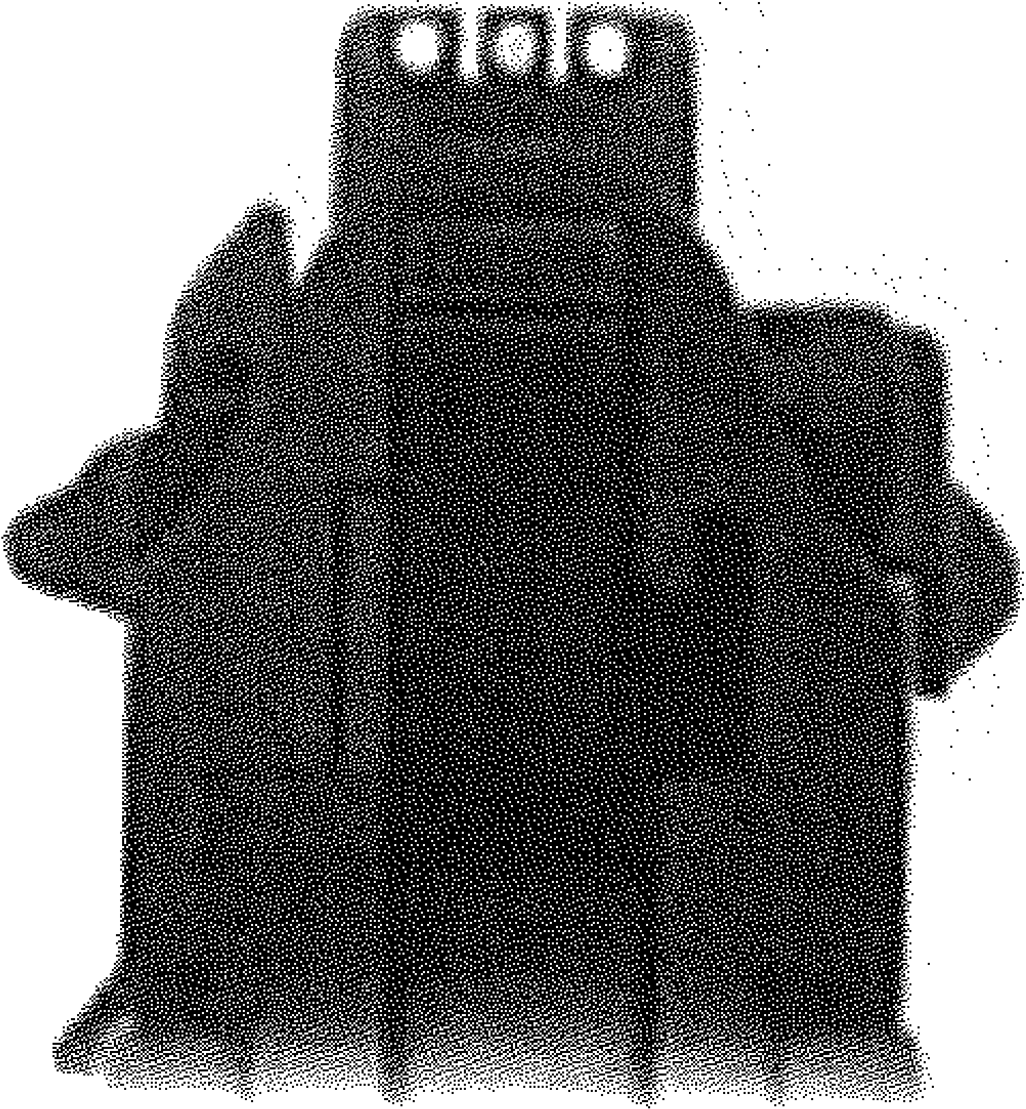
2. Sighting (Alignment & Picture)
3. Breath Control
4. Trigger Manipulation
5. Stance
6. Follow through

Four Steps to Drawing

the Weapon

1. Establish the master grip.
2. Clear the holster.
3. Weapon is brought to the centerline of the body. Two hands can come together at this point to establish a good two-handed grip.
4. Extend towards the target.

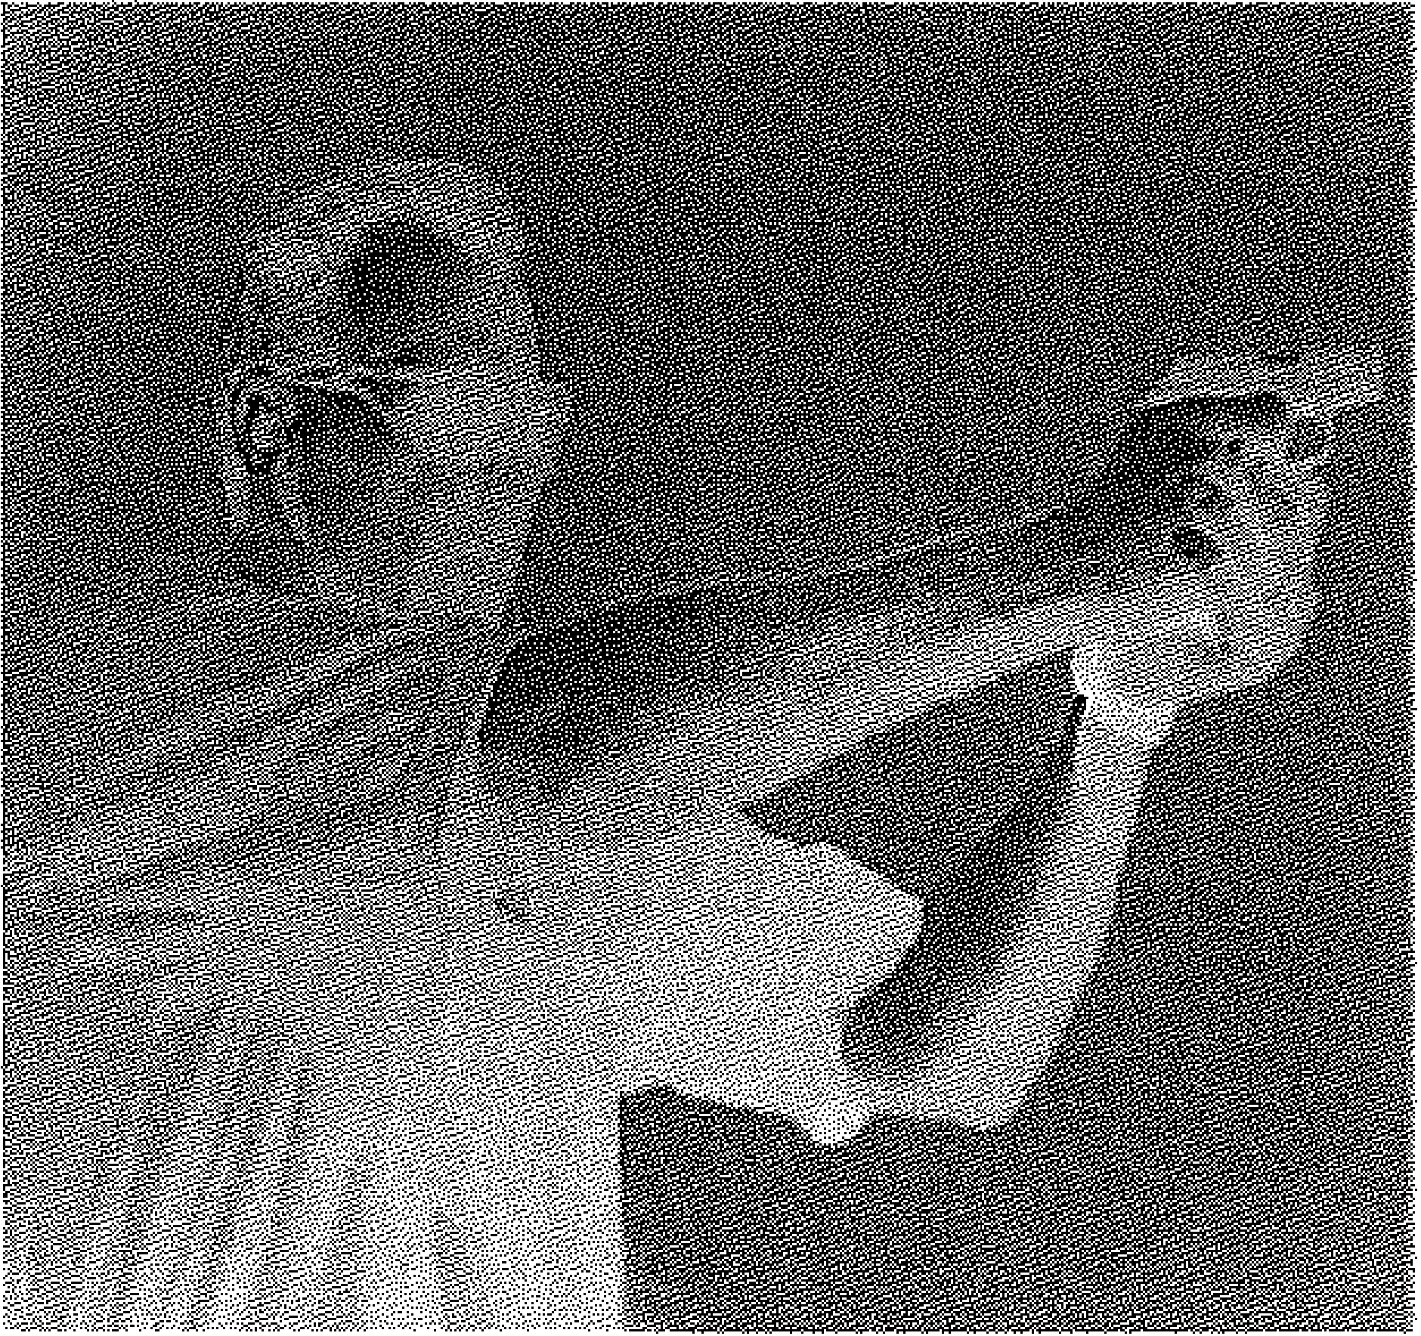

NC Private Protective

Services Firearms Training



MODULE V

NIGHT FIRING

· ... .

Title: Night Firing

Lesson Purpose: To provide the participant with the skills required to successfully engage a target in a reduced light situation with or without the use of a flashlight.

Student Performance Objectives: At the end of this block of instruction the

participant will be able to achieve the following objectives in accordance with information received during the instructional period.

* 1. Describe in writing the Reduced Light Operational Philosophy of night firing.
  2. Demonstrate two methods of employing the flashlight while firing the handgun.
  3. Successfully complete a night

qualification course with a score of 80% or better.

Hours: Four (4)

Instructional Method: Lecture/Demonstration

Materials Required: Handgun

Belt with holster Flashlight Targets

Range equipment (i.e., staple guns with staples, chalk, PA system, etc.)

Prepared by: R. Steven Johnson Instructor/Coordinator

North Carolina Justice Academy

Date prepared: Spring, 1998

Revised By: Darrell Wayne Ayers Deputy Director

North Carolina Justice Academy

Date Revised: February 2014

Title: Night Firing

1. Introduction
   1. Opening Statement

Night firing does not necessarily mean that we only fire at night. The philosophy of night firing really refers to learning to fire in reduced light situations. Warehouses, basements, and attics may be significantly darker than the outside area, therefore requiring an armed security officer to be familiar with firing under reduced light conditions or even firing with the use of a flashlight.

* 1. Student Performance Objectives
  2. Reasons

The reasons for learning flashlight or night fire techniques are quite simple. First, the officer may be required to work in an environment of reduced light. Second, the officer may carry a flashlight is such situations and therefore needs to know what to do with it or how to use it to his/her advantage.

IL Body

1. Reduced Light Operational Philosophy
   1. It is only logical that officers train under low-light and no-light conditions. Consideration must be given to the fact that security officers not only work at night but also in job environments where lighting is greatly reduced such as new construction sites or warehouses where lighting is either nonexistent or minimal. During conditions of reduced light, the officer must have the ability to perform the following functional tasks:
      1. Navigate
      2. Locate
      3. Identify
      4. Engage armed threats.
2. Techniques

* 1. Loading and reloading

Loading and reloading should always be by feel. This method always allows the officer to watch the surroundings, and this is certainly necessary when firing at night.

1. Instinctive shooting

Instinctive shooting is the relating of firing position to target rather than pure aiming. This is because the reduced light lessens the ability to utilize sight picture. This technique is instinctive only because it is a learned response from repetitive drawing and firing. The stance, grip, draw, firing stroke, etc., is the same regardless of available light.

1. Muzzle flash technique 1

This technique, using burst firing, expounds the limited use of a sight picture utilizing the muzzle flash as a light source. The first round must be fired instinctively in darkness, but subsequent rounds are fired with the limited sight pictures from the flash lighting.

1. Flashlight discipline

The flashlight can show the adversary an officer's location and should be left on for only brief periods. The flashlight, if used, should be switched "half-on" so that it is necessary to depress the small button on the switch to activate the light. Should the officer drop or lose control of the light for any reason, the light would then be extinguished, saving the officer from being unnecessarily illuminated. Two methods are now being taught for firing with a flashlight.

* 1. Non-supported Methods
     1. Traditional or FBI Technique

In this position the flashlight is held in the support hand and is held straight out to the side and slightly forward at shoulder level. It is then turned on, illuminating the target. The weapon is held with the

strong hand only.

(2) Puckett Technique

In this position, the flashlight is held in the support hand and placed on the shoulder against the neck.

* 1. Supported methods2

The flashlight is held in the support hand with the support hand supporting the firing hand in some manner. Listed below are some of the supported flashlight techniques available:

Harries Technique

Modified Harries Technique

Ayoob Technique

Chapman Technique

Overhand or Keller

Stacked Support

1. Conclusion
   1. Summary

In this block of instruction information was given on operational philosophy and just how to hold the flashlight should the need to use deadly force occur. Students should adopt a method of utilizing the flashlight in conjunction with the handgun with which they are most comfortable.

B. Questions from Class

C. Closing Statement

Utilization of the flashlight along with the handgun is a practical matter. If you are carrying the flashlight as part of your duties and you are placed in a position that the use of a firearm is necessary, the trained security officer should be able to utilize both at the same time rather than throwing the light down and attempting to use the handgun.

Harries Technique

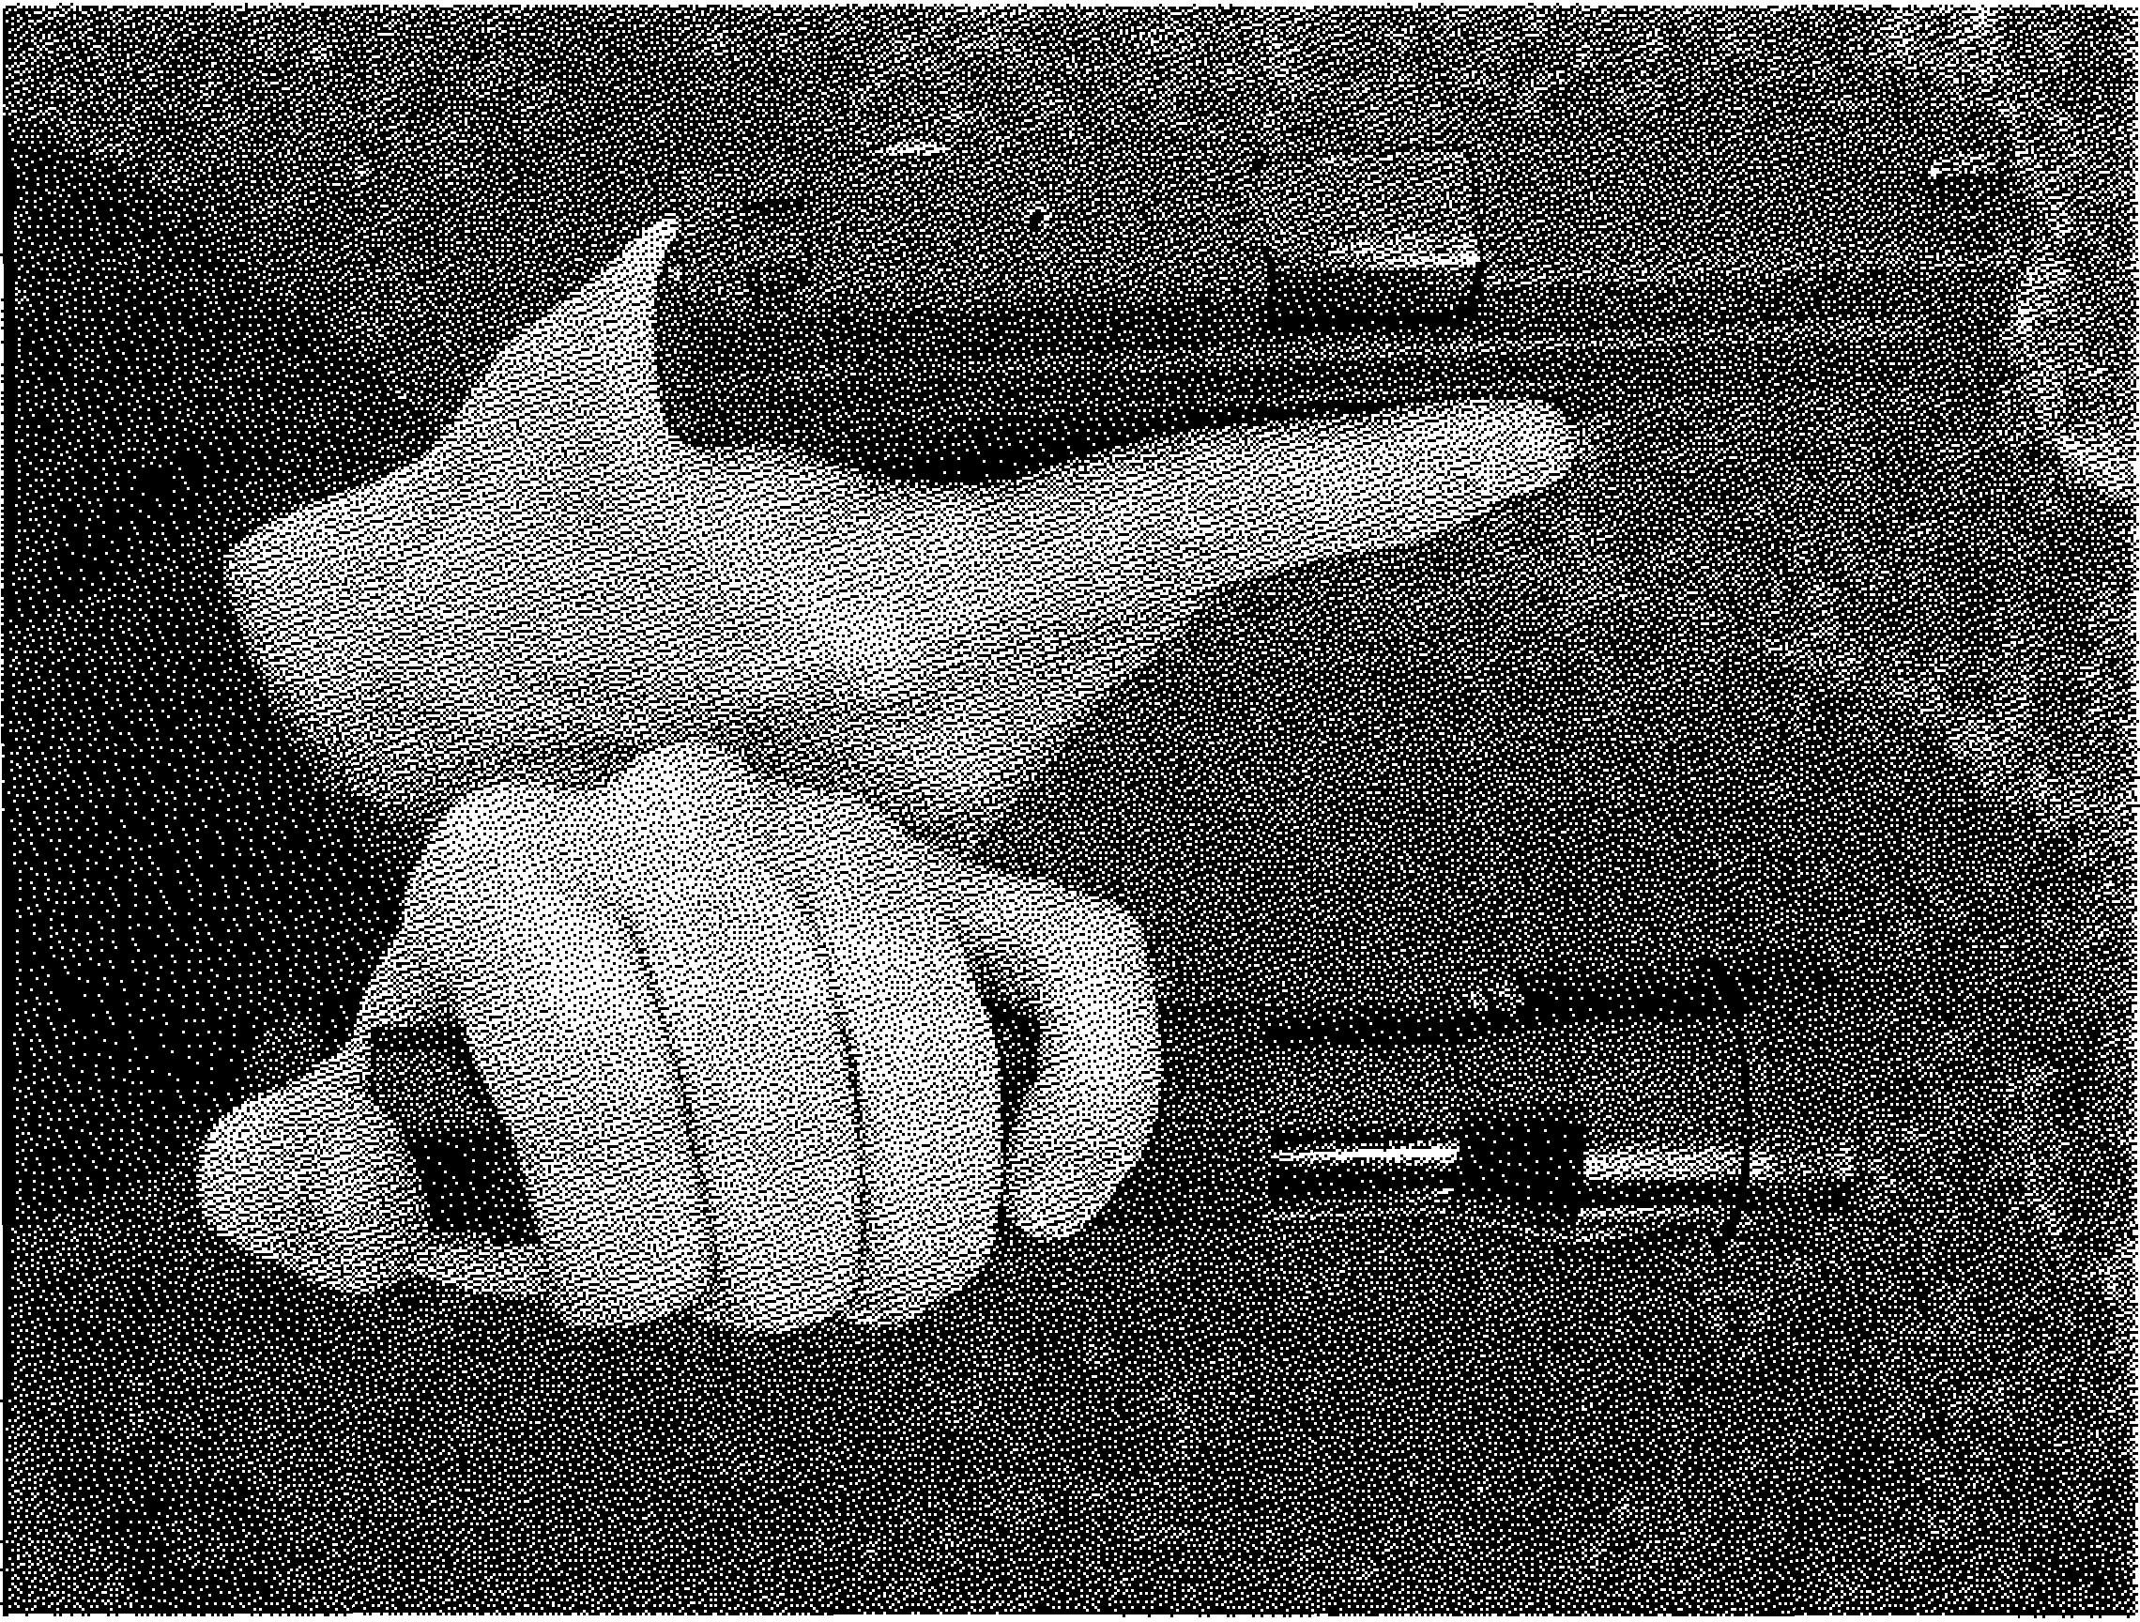

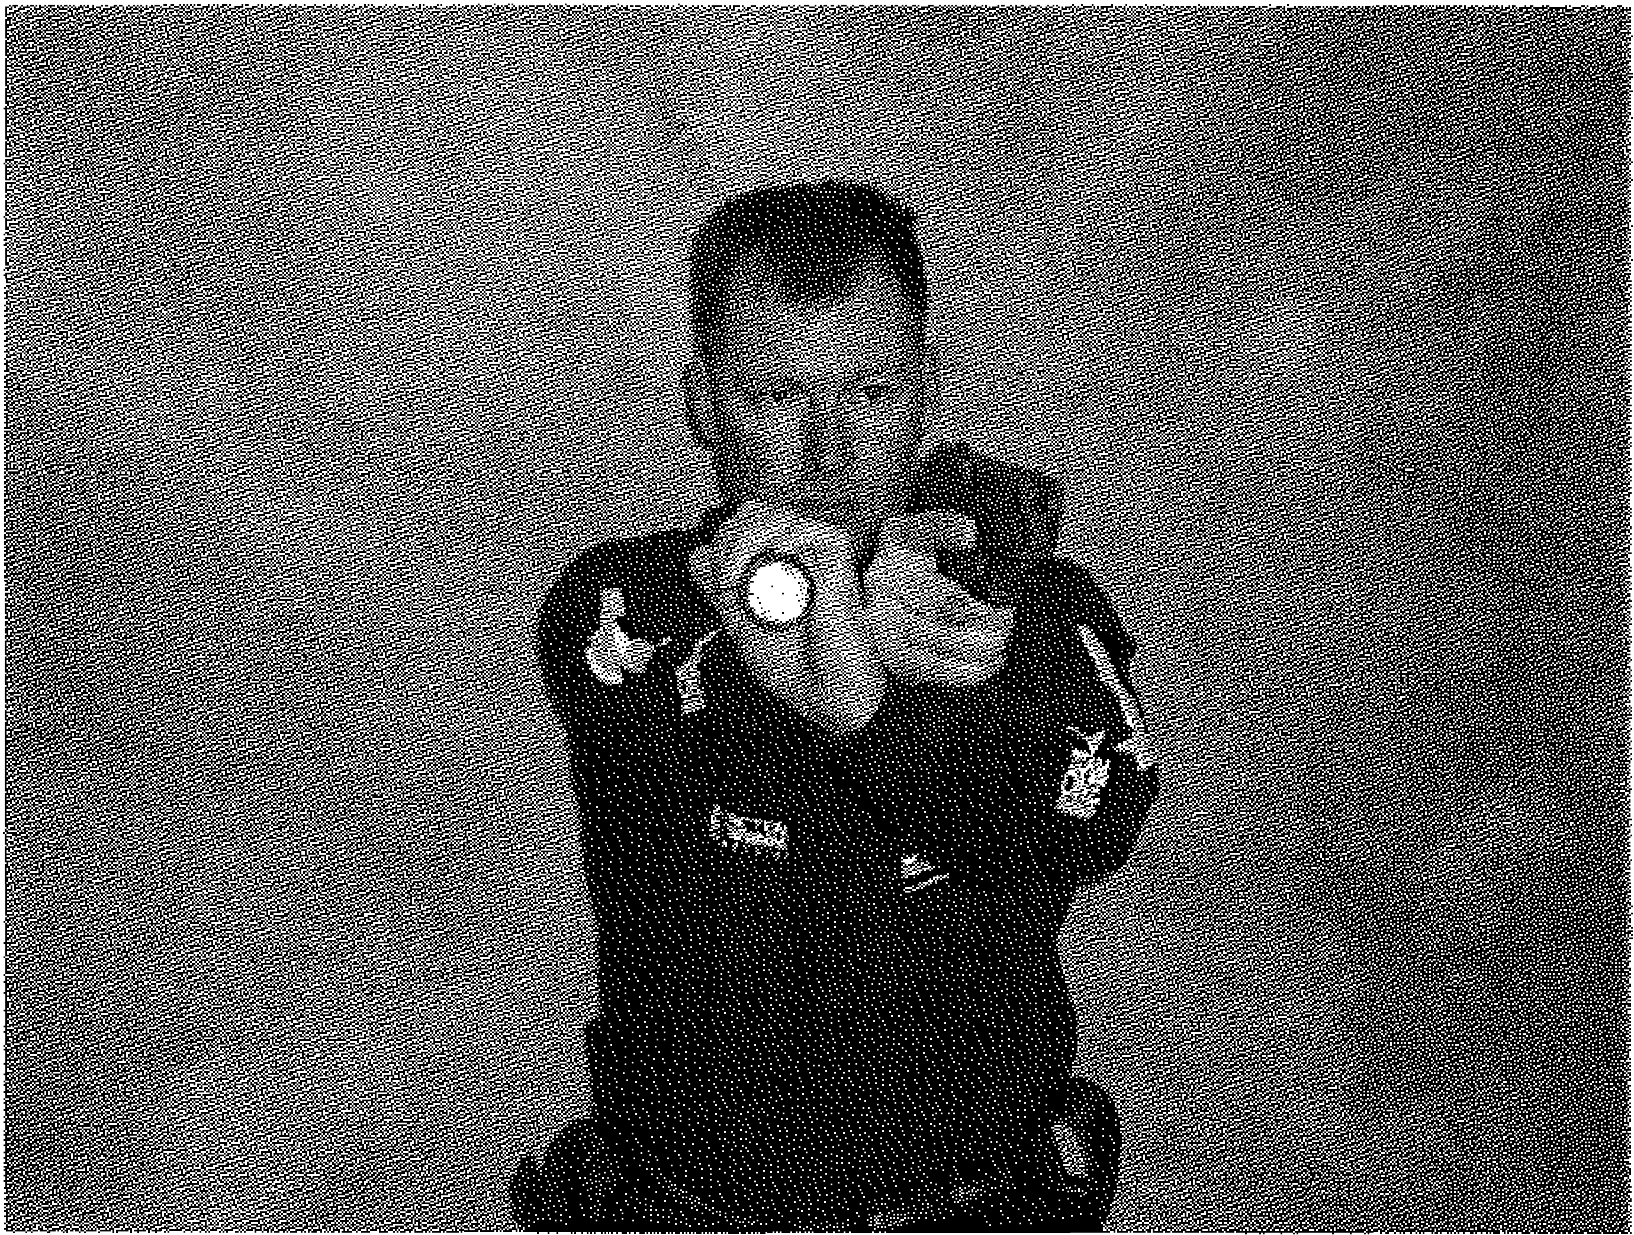

Modified Harries Technique

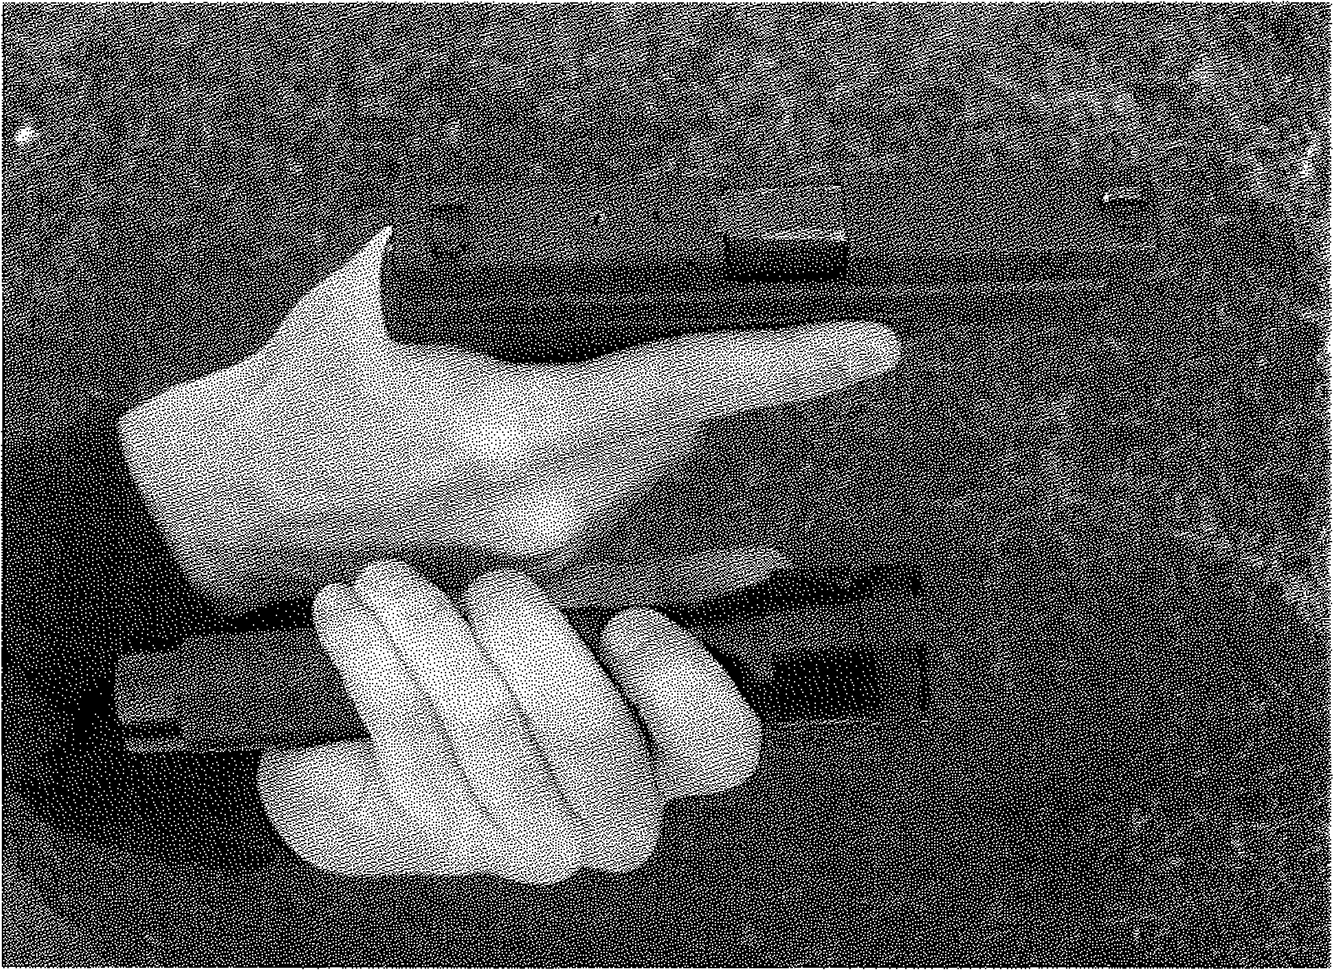

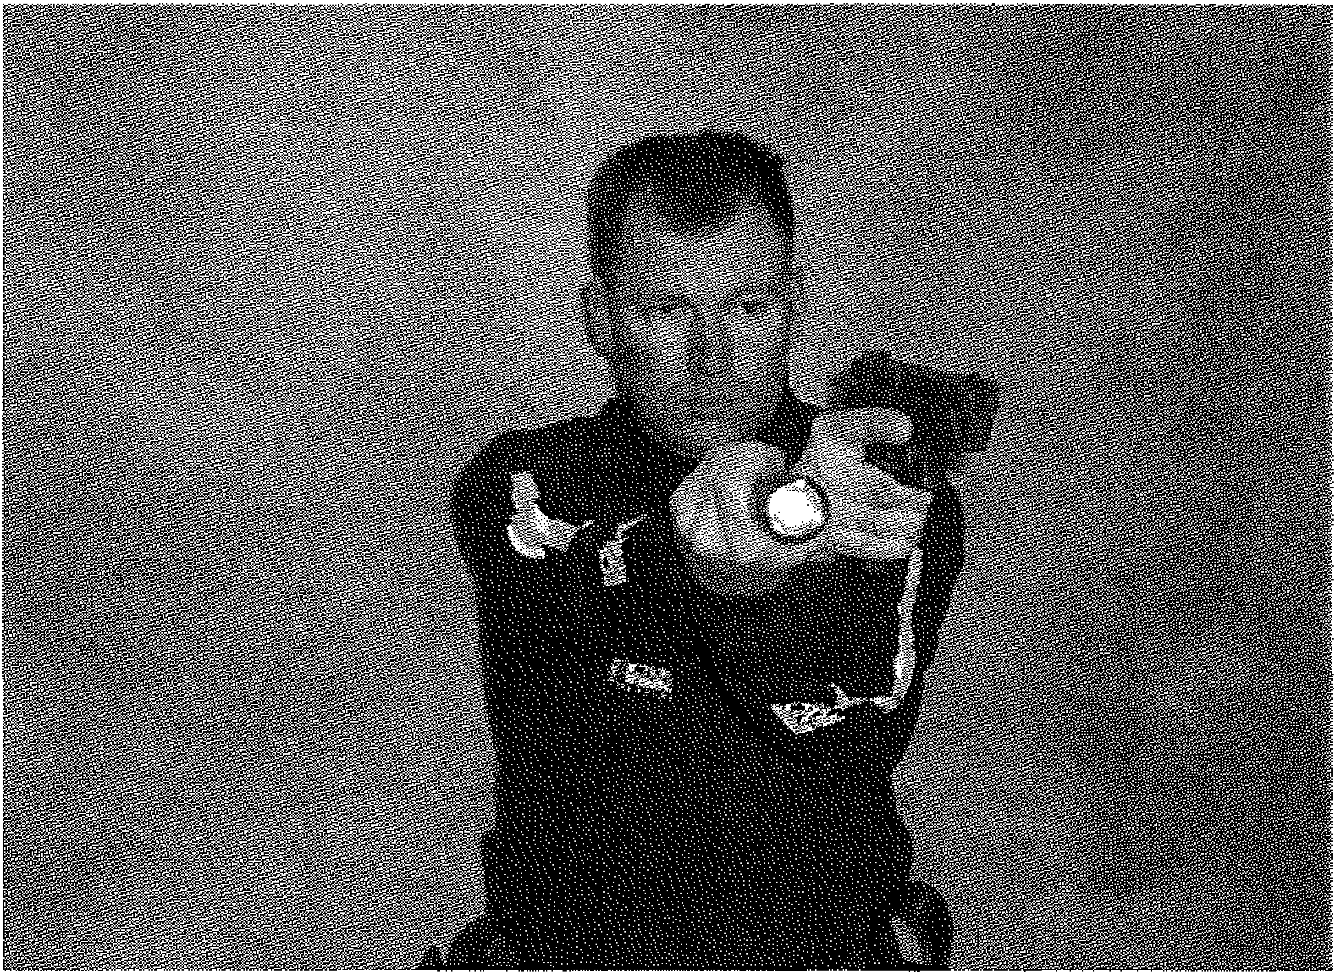

Flashlight Techniques

Ayoob Technique

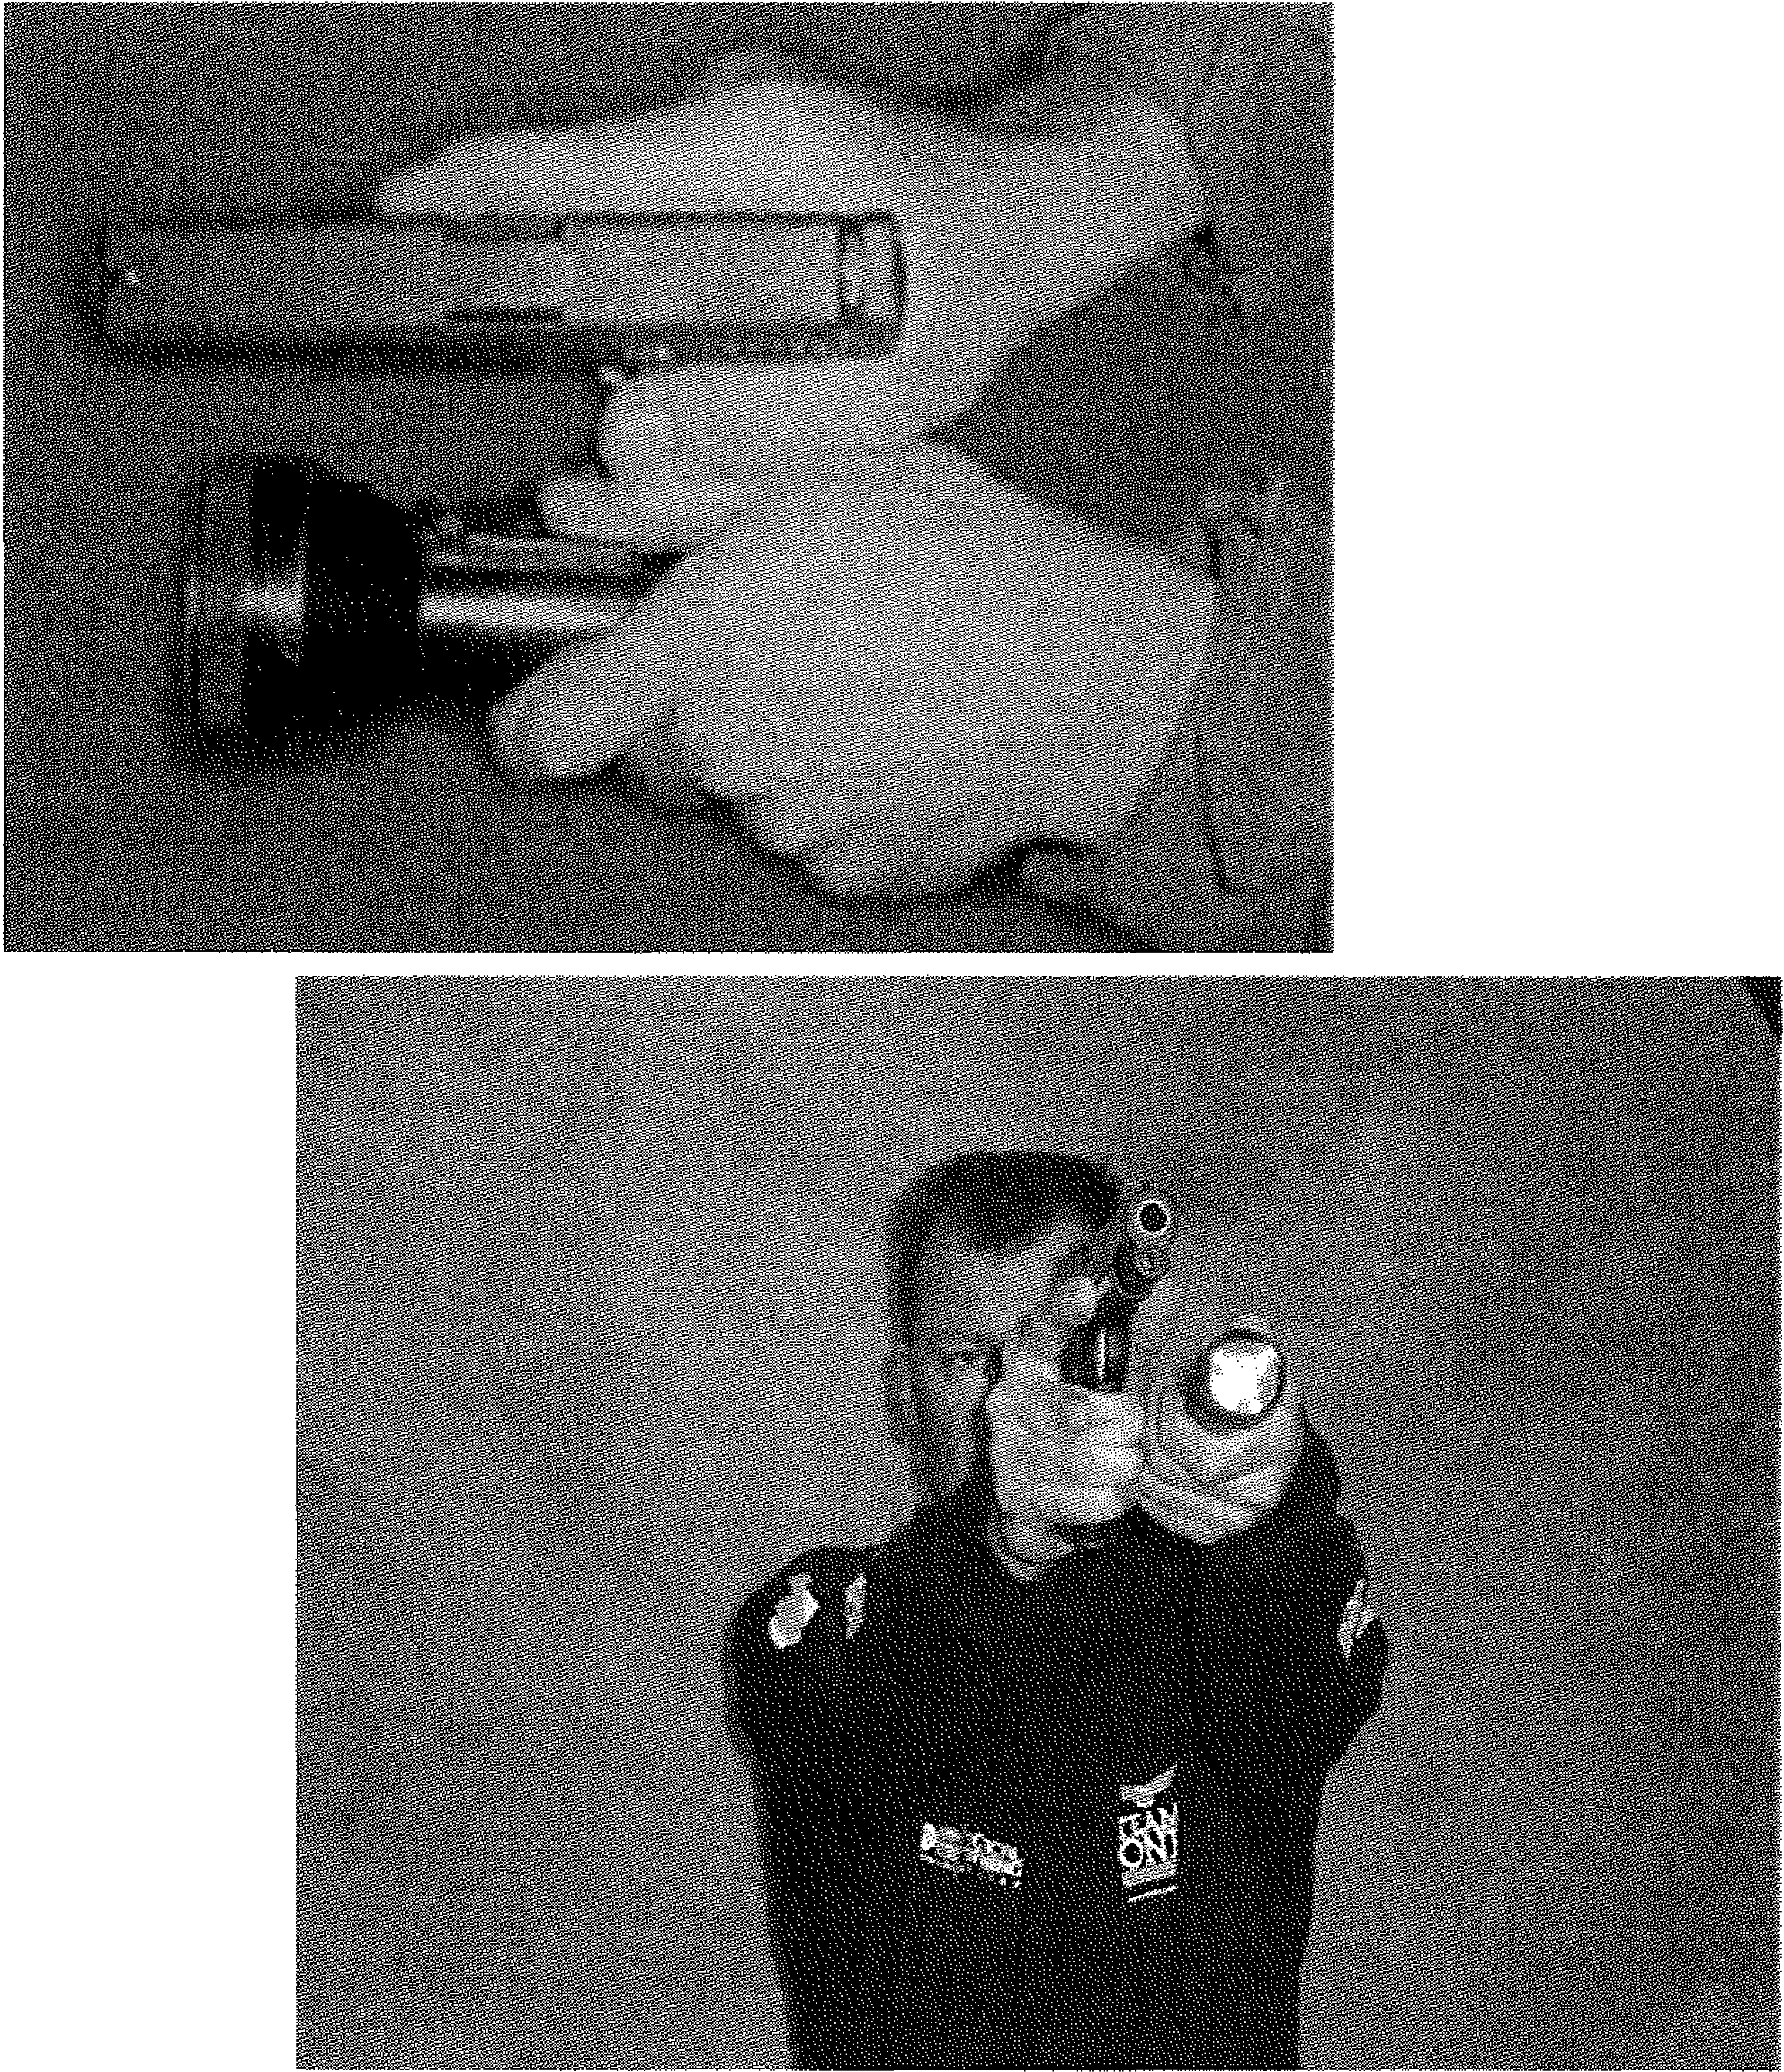

Flashlight Techniques

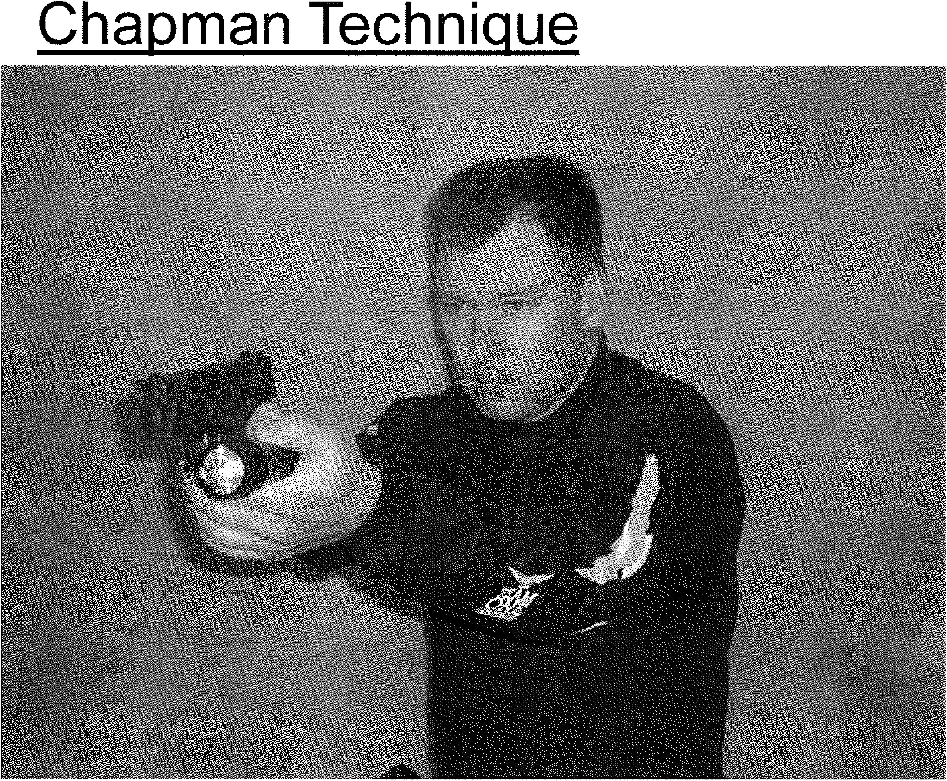

NC Private Protective

Services Firearms Training



MODULE VI THE SHOTGUN

For Long Gun Training Only

Title: The Shotgun

Lesson Purpose: To provide the participant with the skills and knowledge to safely handle and operate the pump or semiautomatic shotgun.

Student Performance Objectives: At the end of the block of instruction, the

student will be able to perform the following objectives in accordance with the information presented in the instructional period.

* 1. List the major parts of the pump or semiautomatic shotgun.

2. Demonstrate how to properly mount the shotgun.

1. Demonstrate how to combat load the shotgun.

4. Demonstrate four carry positions for the shotgun.

Hours: Eight (8)

Instructional Method: Lecture/Demonstration

Materials Required: Pump Shotgun Semiautomatic Shotgun Dummy Ammunition Targets

Range equipment (i.e., staple guns with staples, PA System, chalk, etc.)

References: See Bibliography

Prepared by: R. Steven Johnson Instructor/Coordinator

North Carolina Justice Academy

Date Prepared: Spring 1998

Revised by: R. Steven Johnson

Instructor/Coordinator

North Carolina Justice Academy

Date Revised: Summer 2001

Reviewed By: R. Steven Johnson Adjunct Instructor

North Carolina Justice Academy

Date Reviewed: February 2014

Date Reviewed December 2017

Title: The Shotgun

* 1. Introduction

A. Opening Statement

The shotgun is one of the most effective personal protection weapons available. Because of its devastating capability, the shotgun could create a danger if placed in the hands of an untrained security officer. The purpose of this instruction is to train the officer of the workings of the shotgun and how to safely and effectively handle and fire the shotgun.

1. Student Performance Objectives
2. Reasons

Because of the vast capabilities of the shotgun, it is extremely important that the armed security officer be completely familiar with the nomenclature of the shotgun as well as the operational cycle and all aspects of fundamentals in handling and firing the shotgun.

1. Body

A Use of the Shotgun

* 1. The shotgun is one of the most effective and versatile weapons. In addition to its use as a shotgun, the weapon can be used like a rifle. The weapon often gives a great psychological advantage to the officer. Even the sound of a round being chambered has quite an impact on the adversary.
  2. The shotgun is comparatively inexpensive and with proper care should give many years of service.
  3. Shotguns are usually classified as single-shot single-barrel, double-barrel (either over-and-under or side-by-side), semi­ automatic, or pump action.
  4. Most shotguns used for security or enforcement are either pump action or semiautomatic.
  5. Semiautomatic shotguns are normally gas operated, such as the Remington 11-87 or recoil operated such as the Beretta 1200 or inertia delayed blowback such as the Benelli model.
  6. The pump action riot gun is usually a modification of the sport or hunting shotgun. The barrel of a riot gun is usually 18 or 20 inches in length with no choke.

1. These shotguns are normally carried in a Cruiser Safe condition. Cruiser safe refers to having the magazine loaded, nothing in the chamber, and the safety on. When the shotgun is taken out, the officer must work the action of the weapon to place the first round in the chamber.
2. It is important that officers understand the nomenclature and operation of the shotgun including the "safety" locations unique to a particular make of weapon. For example, on some shotguns the safety is atop the receiver, while on others it is at the front or back of the trigger guard. The slide release button is in different places also. The officer should be able to understand and locate the following nomenclature of the pump shotgun:
   1. Pump or Slide Action
      1. Stock
         1. Pistol grip
         2. Comb
         3. Recoil pad
         4. Toe
      2. Receiver
      3. Breech
      4. Barrel
      5. Front sight (rifle or bead)
      6. Magazine cap
      7. Forearm
      8. Magazine tube
      9. Ejection port
3. Loading port
4. Safety
5. Carrier

(13) Muzzle

1. Extractor
2. Ejector
3. Slide release
4. Semiautomatic
   1. Stock
      1. Pistol grip
5. Comb
6. Recoil pad

(d) Toe

1. Receiver
2. Breech

(4) Barrel

1. Front sight (rifle or bead)
2. Magazine cap

(7) Forearm

1. Magazine tube
2. Ejection port

(10) Loading port

(11) Safety

1. Carrier
2. Muzzle
3. Extractor
4. Ejector
5. Carrier control button or bolt release button
6. Cartridge drop lever carrier stop button or carrier release button.
7. Cocking handle or lever
8. Cleaning and operating the shotgun.

Officers should read the manufacturer's operators manual prior to cleaning, disassembling, or operating the shotgun. This manual should be read thoroughly to become familiar with the operational characteristics of that particular make

and model shotgun.

1. Operating cycle
   1. Pump or Slide Action

The cycle consists of moving the slide rearward to open the action, extract and eject a fired shell, and cock the hammer, returning the slide forward to chamber a loaded shell and close the action.

* + 1. Remington, Smith & Wesson, High Standard, and Winchester shotguns have an ejection port on the right side of the receiver and a loading port on the bottom of the receiver.
    2. Ithaca and Browning shotguns have both the ejection and loading port at the same location on the bottom side of the receiver.
    3. The safety on the Smith & Wesson, Remington, and Ithaca are located on the rear of the trigger guard, and the safety on the Winchester and High Standard are located on the front portion of the trigger guard. The safety of the Mossberg

and Browning shotguns are located on top of the receiver.

* + 1. The slide release button on the Smith & Wesson, Remington, and Ithaca are on the front portion of the trigger guard and on the Winchester and High Standard it is located on the rear portion of the trigger guard.
    2. The smooth operation of the slide action is based upon a vigorous movement of the slide.
    3. During the time the action is worked, the trigger should not be pressed.
  1. Semiautomatic Shotgun
     1. Benelli, Beretta, and Remington semiautomatic shotgun models have an ejector port on the right side of the receiver and a loading port on the bottom of the receiver.
     2. The safety on all three of the above-mentioned semiautomatic shotguns is located to the rear of the trigger guard.
     3. The cocking lever and bolt release button or carrier control button is located on the right side of the receiver just below the ejection port.
     4. The Benelli and the Beretta operate on recoil inertia.
     5. The Remington 1187 is gas operated.

1. Loading the magazine
   1. Initial loading
      1. Move the action forward closing the breech block, or on the semiautomatic, depress the carrier control button to close the bolt.
      2. Place butt on strong hip and support with strong hand or brace stock of shotgun along forearm of the strong hand.
      3. Depress carrier and press round into magazine tube using weak hand.
      4. Be sure the round is pushed beyond shell latch to prevent jamming the loading port.
      5. The shotgun that has ammunition in the magazine, safety on, and an empty chamber is referred to as Cruiser Safe.
      6. To chamber a round with the pump shotgun, simply depress the slide release and work the forearm forcibly.
      7. To chamber a round with the semiautomatic shotgun, first depress the carrier stop button or cartridge drop lever (Benelli), then work the cocking handle.
   2. Combat loading2
      1. Strong hand is kept on the pistol grip of the butt stock with the barrel pointed at the target and trigger finger outside trigger guard.
      2. All combat loading is done with non-firing hand.
      3. With the bolt or action open, load the first round into the ejection port by taking the shell in the non-shooting hand and placing the hand underneath the action and roll the shell into the ejection port with the fingertips. The action is closed either by pushing the forearm forward with the same hand, or by depressing the carrier control button.

With the Remington 1187, as you place the second round in the chamber the round will activate the carrier stop button closing the bolt.

* + 1. All remaining shells are loaded into the magazine by taking each shell in the non-firing hand and pushing the shell into the loading port and into the magazine with the thumb.

Make sure the shell rim passes the shell stop and you hear the shell stop click.

* + 1. Combat loading an Ithaca Model 37 or Browning BPS
       1. Loading and ejection port are same on underside of action.
       2. Weapon is held same as in number 1 above.
       3. First round is loaded into magazine same as in number 4 above.
       4. After first round is loaded into the magazine, activate slide release button and operate forearm back and then forward, chambering the round.
       5. All remaining rounds are loaded into the magazine as described in number 4 above.

1. Unloading safety
   1. To unload the shotgun, push safety "on safe."
   2. Hold the weapon with the strong hand, with the butt against the strong hip, muzzle pointing slightly upward.
   3. Pump
      1. Depress slide release and bring forearm back slowly the round begins to eject from the ejection port.
      2. Remove the round from the ejection port with the support hand.
      3. Depress shell latch and control the round as it exits the magazine tube and loading port.
      4. When the first round has been extracted from the loading port, depress the shell latch again. This will release the second round from the magazine tube.
      5. Depress the left shell latch for each succeeding round to be extracted from the magazine tube.
      6. Visually inspect the weapon to ensure the weapon is indeed empty.
   4. Semiautomatic shotgun
      1. Pull back the cocking lever to remove round from the chamber.
      2. Depress shell latch and control the round as it exits the magazine tube and loading port.
      3. When the first round has been extracted from the loading port, depress the shell latch again. This will release the second round from the magazine tube.
      4. Depress the shell latch for each succeeding round to be extracted from the magazine tube.
      5. Visually inspect the weapon to ensure the weapon is indeed empty.
2. Some basic rules to remember in the use of the shotgun are:
   1. A shotgun should not be unloaded by ejecting the unused shells on the ground where they could become burred, dirty, and a source of malfunction.
   2. The officer must never gain a false sense of security that a shotgun may impart. An officer must be aware of the range, penetration, and spread of the various shotgun loads. An officer also must realize the danger and possible consequences of firing at a suspect who is near innocent bystanders and of possible occupancy of buildings or vehicles beyond the suspect.
   3. Shotguns should be inspected daily, and nothing should be dropped down the barrel, such as cigarette ashes or gum paper.
      1. Make sure the barrel retaining nut is tight.
      2. With the weapon unloaded, make sure the weapon is clean.
      3. With the weapon unloaded, check the action for smoothness.
      4. Check the sights for looseness or breakage.
      5. Check the action bars to make sure they are not warped.
      6. The firing pin may be checked by allowing it to impact upon a penny held against the block. (Of course, the weapon is unloaded.) The pin should dent the copper penny visibly.
   4. The shotgun should not be carried with a round in the chamber. The shotgun has a cross bolt safety that blocks the trigger but not the firing pin.

In a situation where the use of the shotgun is contemplated, the officer should pump a shell into the chamber, with the safety on.

1. Ammunitions
   1. In shotgun ammunition, the component parts are the primer, powder charge, and projectile(s). These parts function in the same manner as pistol ammunition.

All shotgun ammunition utilizes the center fire case. It may be made as rugged as necessary because the primer is contained in a separate cup which is loaded into a pocket in the center of the case head.

In shotgun ammunition, the projectile can be a single lead projectile or several lead, steel or copper shot pellets of varying size. In a shotgun cartridge, a wad is used to separate the powder and shot charges, also serving to prevent gas from escaping through the loose shot as it travels out the barrel.

* 1. Shotguns and the shot shells they fire are referred to by gauge, not caliber. The gauge terminology was developed in England and was determined by dropping round lead balls down the barrel of a weapon.

A shotgun was designated as 12 gauge when a round ball weighing 1/12th of a pound would pass through the barrel. A 12 gauge shotgun would in fact be .729

caliber. Shotguns used in security must always be 12 gauge. Shotgun ammunition commonly used in security are the rifled slug, #00 buckshot, or #4 buckshot.

* + 1. The 12 gauge rifled slug is a ball of lead approximately .72 caliber which has a muzzle velocity of 1600 feet per second. It has simulated lands and groove marks, and in effect, makes the shotgun a rifle. The average shooter should be able to center a man-size silhouette at 70 yards. The initial penetration of the slug is very good, but then its energy dissipates rapidly.
    2. The shot size most commonly used is #00 Buck. Firing this load is equal to firing **nine** .33 **caliber projectiles.** Its reputation as a man stopper is legendary. The area of shot spread increases with distance and the maximum range recommended for use is 40 yards. A

rule of thumb in allowing for shot spread is 1" of spread for each yard of distance up to 30 yards. Thus, an officer must be extremely careful that stray pellets do not injure innocent bystanders. This is especially true when considering the projectile's penetrating power. In one test con­ ducted, #00 Buck was fired at four double plasterboard partitions. Of the nine pellets, nine passed through the first partition (2 sheets), nine through the second (4 sheets), seven through the third (6 sheets), and two through the fourth (8 sheets).

* + 1. The #4 Buckshot load contains 27 projectiles approximately 24 cal. in size. The shot spread of this load is even greater than that of buckshot.
    2. Several less than lethal munitions include bean bag rounds, rubber slugs and buckshot, plastic birdshot, and CS, CN, and QC projectiles.

1. Shotgun marksmanship fundamentals
   1. Mounting the shotgun4
      1. The shotgun is held by the pistol grip with the strong hand while the forearm is held lightly with the support hand.
2. The muzzle is at eye level.
3. The butt of the shotgun is moved up into the shoulder pocket while the muzzle remains at eye level and is extended outward. Do not move the head toward the weapon. Raise the strong arm elbow as the butt of the weapon is raised.
4. The toe of the stock should be placed firmly in the shoulder pocket. Pull the weapon straight back into the shoulder with the strong hand.
5. When properly mounted, the top or comb of the stock should be approximately 1to 1 *Y2* inches above the shoulder.
   1. Sight alignment
      1. The front sight bead should appear to sit on the flat sighting surface on top of the receiver.
      2. No surface of the barrel should be visible.
      3. The bead should be centered on the sighting surface.
      4. If the weapon is equipped with rifle sights, align as you would with a handgun.
   2. Sight picture

The placement of the sights on the target will be subject to the type of sights used, as well as the point of aim versus point of impact for that particular shotgun. With some bead sight weapons, it is necessary to aim lower when using #00 Buckshot. Rifle sights can normally be adjusted to achieve point of aim point of impact.

* 1. Breathing

There is no set pattern for breath control; however, it is recommended that the breath be held when the shot is fired.

* 1. Trigger control
     1. When firing rifle slugs, the pressure on the trig­ ger should be smooth and constant so as not to interrupt sight alignment at moment of discharge.

(2) Shooter can use trigger slap for rapid fire of #00 Buckshot or shot shell.5

1. Fundamentals in shooting at moving targets include:6
   1. Sight on the target.
   2. Swing through it.
   3. Swing the barrel past and fire.
   4. Follow through with the swing of the barrel.
2. Recoil
   1. When a shotgun fires, a great deal of force propels the projectiles toward the target. The opposite force, or recoil, is almost entirely absorbed by the weight of the weapon, the action in automatics, and by the weight and flexibility of the shooter's body.
3. Since any given amount of energy will perform only a specific amount of work before it is absorbed, the seeming violence of the explosion is reduced significantly by the time it reaches the shooter's shoulder.
4. Experienced shooters know that recoil can never be severe if the weapon is properly placed and held against the shoulder. Hold the butt of the weapon firmly to the shoulder and keep the elbow raised to the same level as the shoulder.
5. Carry positions
   1. High Port or Port Arms
   2. At Ease or Hip Carry
   3. Satterwhite or High Ready7
   4. Low Ready or Low Muzzles 17. Sling carry positions
6. American Carry9 (Strong Side - muzzle up)
7. African or Muzzle Down Carry10 (Support Side - muzzle down)
8. Muzzle Up Carry11 (Support Side - muzzle up)
9. Firing positions
   1. Standing - In this position, the officer stands erect with the knees bent, feet about shoulder width apart, and the weak foot forward. The body should be relaxed. The strong hand grips the stock just behind the trigger guard, and the butt of the weapon is placed firmly against the strong shoulder with the officer's cheek against the stock. The support hand holds the forearm or slide with the support arm bent at the elbow. The elbow of the strong hand is raised so the arm is on a horizontal plane with the ground. The weapon is held

just slightly below eye level. The officer should lean into the weapon but should keep both feet planted flat.

* 1. Kneeling - To reach the kneeling position (opposite procedure if left-handed), face the target, make half a turn to the right, place the left foot about 18 inches left forward, and drop to the right knee. The left knee supports the left arm. There are variations of these positions.

1. Conclusion

A Summary

Given that the shotgun is one of the most effective personal defense weapons available, it is imperative that the armed security officer who carries this weapon be thoroughly familiar with the safe operation and handling of this weapon.

B. Questions from Class

C. Closing Statement

The responsibility for carrying a deadly weapon and knowing how to effectively use this weapon under the correct circumstances is a tremendous one. Officers should become proficient with any weapon that they choose to carry. Many times, officers will spend a great deal of time with the handgun and choose to fire the shotgun very little.

To become completely competent with the weapon the officer must practice until the highest skill level is obtained.

**END NOTES**

1. Louis Awerbuck, The Defensive Shotgun, Techniques and Tactics (El Dorado, AR: Desert Publications, 1989), pp. 17-22.

2. Ibid., pp. 18-19.

3. Felter, Brian A, Police Shotguns and Carbines (Englewood Cliffs, NJ: Prentice-Hall, Inc., 1991), pp. 29-35.

4. Ibid., p. 121.

5. Bill Clede, Police Shotgun Manual (Harrisburg, PA; Stackpole Books, 1986), p. 66.

6. Ibid., pp. 67-68.

7. Felter, Police Shotguns and Carbines, pp. 116-117. 8. Ibid., pp. 114-115.

9. Awerbuck, The Defensive Shotgun, p. 50.

10. Ibid., p. 52.

1. Felter, Police Shotguns and Carbines, pp. 41-42.



NC Private Protective

Services Firearms Training



MODULE VII ENCOUNTER TECHNIQUES



Title: Encounter Techniques

Lesson Purpose: To familiarize the participant with the aspects of encounter shooting techniques as they apply to street encounters@ versus the sterile setting of range qualification.

Student Performance Objectives: At the end of this block of instruction, the

student will be able to perform the following objectives in accordance with the information obtained in the instructional period.

* 1. Describe in writing the difference between cover and concealment.
  2. List the four colors of the mental conditioning color code system.
  3. Demonstrate how to fire from behind a barricade.

Instructional Method: Lecture/Practical Exercises Materials Required: Handgun

Belt with Holster Targets

Range Props for Practical Exercises (i.e., barricades, objects that can be used for cover such as barrels, mailbox, fire hydrant, etc.) Range Equipment (i.e., staple guns, chalk, PA system)

References: See Bibliography

Prepared By: R. Steven Johnson

Adjunct Instructor

Reviewed By: R. Steven Johnson Adjunct Instructor

North Carolina Justice Academy

Date Reviewed: February 2014

Title: Encounter Techniques

* 1. Introduction

1. Opening Statement

Often, armed officers only fire in a very sterile or static environment such as firing a qualification course. In this environment, the officer is stationary during the shooting segments and the target is stationary. When training for encounter techniques, the object should be to increase the heart rate of the officer to simulate the increased heart rate caused by adrenalin during a stressful confrontation.

Officers should realize how their physical and mental capabilities may be diminished by this increased heart rate.

1. Student Performance Objectives

C. Reasons

* 1. Body

1. Encounter Techniques
   1. For years firearms training was not applicable to "the street"-­ to actual confrontations. Officers have merely qualified with their weapon and have never done training that required movement, moving targets, use of cover and concealment, and judgmental shooting.
   2. Encounter shooting is an aggressive, driving, demanding type of firearms training and should better prepare officers for the street.
      1. In this type of training, courses are run with varying distances, multiple targets, varying starting positions, different types of targets, and even multiple weapons.
      2. The courses are not announced ahead of time and are new to the officers. Naturally, the courses are changed from one time to the next. These types of courses help condition the officer to fire both fast and accurately.
      3. Some important points should be made at this time!
         1. Cover versus concealment - concealment hides the shooter - cover stops bullets. 1
         2. Bouncing bullets - if fired into a hard surface at less than a 45" angle, bullets may travel along that surface from 2 to 8 inches away from the surface. This depends on both the surface fired on and the type of round fired.
         3. Barricade positions - should be fired with some combat style grip. Support side may be fired with either the strong or support hand. Barricades should be used for cover and not to support the weapon. The weapon should not extend beyond the barricade or be supported by the barricade unless the shot will be a distance shot.
         4. When using the vehicle as cover, the engine block and wheels afford the best protection. Firing from behind an open door is very dangerous.2
         5. Ifa shotgun is emptied in a shooting situation, leave the action open and load the first round by dropping it into the ejection port (combat loading). Close the action and the weapon is ready to fire while the tubular magazine is being loaded.
         6. Shooting confrontations are usually at distances of seven yards and less, are usually outdoors, are over in 2 to 3 seconds, with no more than 3 rounds being fired. At least twenty-five percent of incidents involve more than one suspect.3
         7. Consider the types of cover normally available then consider the type of firing position that could be used that would afford the officer the most protection. Items to consider include vehicles, utility poles, buildings, fire hydrants, curbing, etc. In addition, consider items that

should not be used such as gas pumps, hazardous material containers, etc.

* + - 1. Use the muzzle flash from the adversary's fire in returning fire in darkness. Fire on both sides of the flash, with the first round going slightly to the right of the flash. Remember target identification prior to firing at someone.
      2. Challenges should be issued to suspects whenever time allows. This may help to eliminate a possible shooting situation. The trigger finger is always positioned outside the trigger guard during a challenge.
      3. Covering suspects
         1. With a handgun, lower the muzzle slightly below eye level to more easily visualize the suspect. The suspect's hands should be clearly visible. The trigger finger should be positioned OUTSIDE of the trigger guard.
         2. With a shotgun, lower the muzzle slightly below eye level to more easily visualize the suspect. The suspect=s hands should be clearly visible. The trigger finger should be positioned OUTSIDE of the trigger guard. If possible, the safety should be engaged. This will depend on the position of the safety and how easily the officer can access the safety.
      4. Three basics of survival shooting
         1. Weapon presented quickly.
         2. Weapon held the same way for each shot.
         3. Weapon held still while shot is fired.

Knowing how to shoot a weapon is only one of the skills associated with the ability to defend oneself or a third party.

Mental Conditioning

The mind's ability to be in some state of readiness is paramount in surviving a lethal encounter. Jeff Cooper has developed a color code system for mental conditioning defined as follows.

* 1. Condition White: normal, non-combative state of mind.
  2. Condition Yellow: state of relaxed alertness.
  3. Condition Orange: state of alarm.
  4. Condition Red: defensive combat.

The consideration and use of this mental conditioning system will afford the peace of mind of knowing how the officer may react when faced with a violent situation. The officer will have thought out situations and prepared possible solutions and alternatives so that the officer reacts without having to think about the response.

1. The Body Under Stress7

Under stress the heart rate begins to rise. Once the heart rate reaches approximately 115 beats per minute (BPM), fine motor skills begin to deteriorate. At 145 BPM complex motor shills begin to

deteriorate. How does this affect the armed security officer's ability to perform and to survive the encounter?

* 1. At 115 BPM precision and accuracy skills are lost. The ability to move the weapon in minute degrees to accurately align the sights is lost as this is a fine motor skill.
  2. At 145 BPM the visual system begins to narrow and there is a loss of complex motor skills such as using the Weaver Stance. Both eyes will remain open to receive as much information as possible for our internal computer, the brain. Because both eyes are open the body will face the target. The officer will more naturally assume an Isosceles or Modified Isosceles stance.

3. At 175 BPM there is a loss of peripheral vision as the field view may narrow to as little as 18 inches. Auditory exclusion is experienced; the officer may not hear his or her own shot. It is physically impossible to focus on the front sight of the firearm as the body suffers a loss of near vision. The ability to reason diminishes. This can lead to drastic increases in reaction time or doing what would seem to be irrational acts. An individual might remove themselves from cover thinking that they cannot see the threat clearly when they are suffering from the diminished field vision (tunnel vision)

To determine the officer's ability to survive an encounter, shooting courses should be fired that utilize decision making, use of various positions, use of available cover, and the use of light exercise to increase heart rate to simulate the heart rate increases induced by

stress. Decision making objectives should include shoot-no-shoot decisions, type of cover decisions, when to move, how to move, etc.

* 1. Conclusion

A. Summary

While basic qualification courses may be fun and can be somewhat stressful, these courses do not provide the realism of the armed encounter. It is important that armed security officers be exposed to this type of shooting where decision making is critical. The officer who carries a firearm must be competent with any weapon system

that they are required to carry. In addition, comes the responsibility of not only knowing how to use a weapon, but more importantly,

knowing when to use a weapon.

1. Questions from Class
2. Closing Statement

Firearms training is more than just marksmanship skills. It includes a thorough knowledge of the justifications for deadly force, concern for safety, weapon maintenance, and tactical considerations. But most importantly, it involves gaining confidence in ability, not false confidence, which is dangerous, but that confidence which comes from the knowledge and skills acquired in training.

* 1. *Private Protective Services Firearms Training*

END NOTES

* + 1. Felter, Police Defensive Shotgun, p. 145. 2. Ibid., p. 177.

3. Ibid., p. 190.

1. Jeff Cooper, Fireworks, A Gunsite Anthology (Rogue River, OR: The Janus Press, 1980), pp. 125-130.
2. Charles R. Skillen and Mason Williams, American Police Handgun Training (Springfield, IL: Charles C. Thomas Publisher, 1977), pp. 8-15.
3. Felter, Police Defensive Handgun, p. 138.
4. Siddle, Sharpening the Warrior's Edge, pp. 8, 43-44.

*Three Basics of Survival Shooting*

* 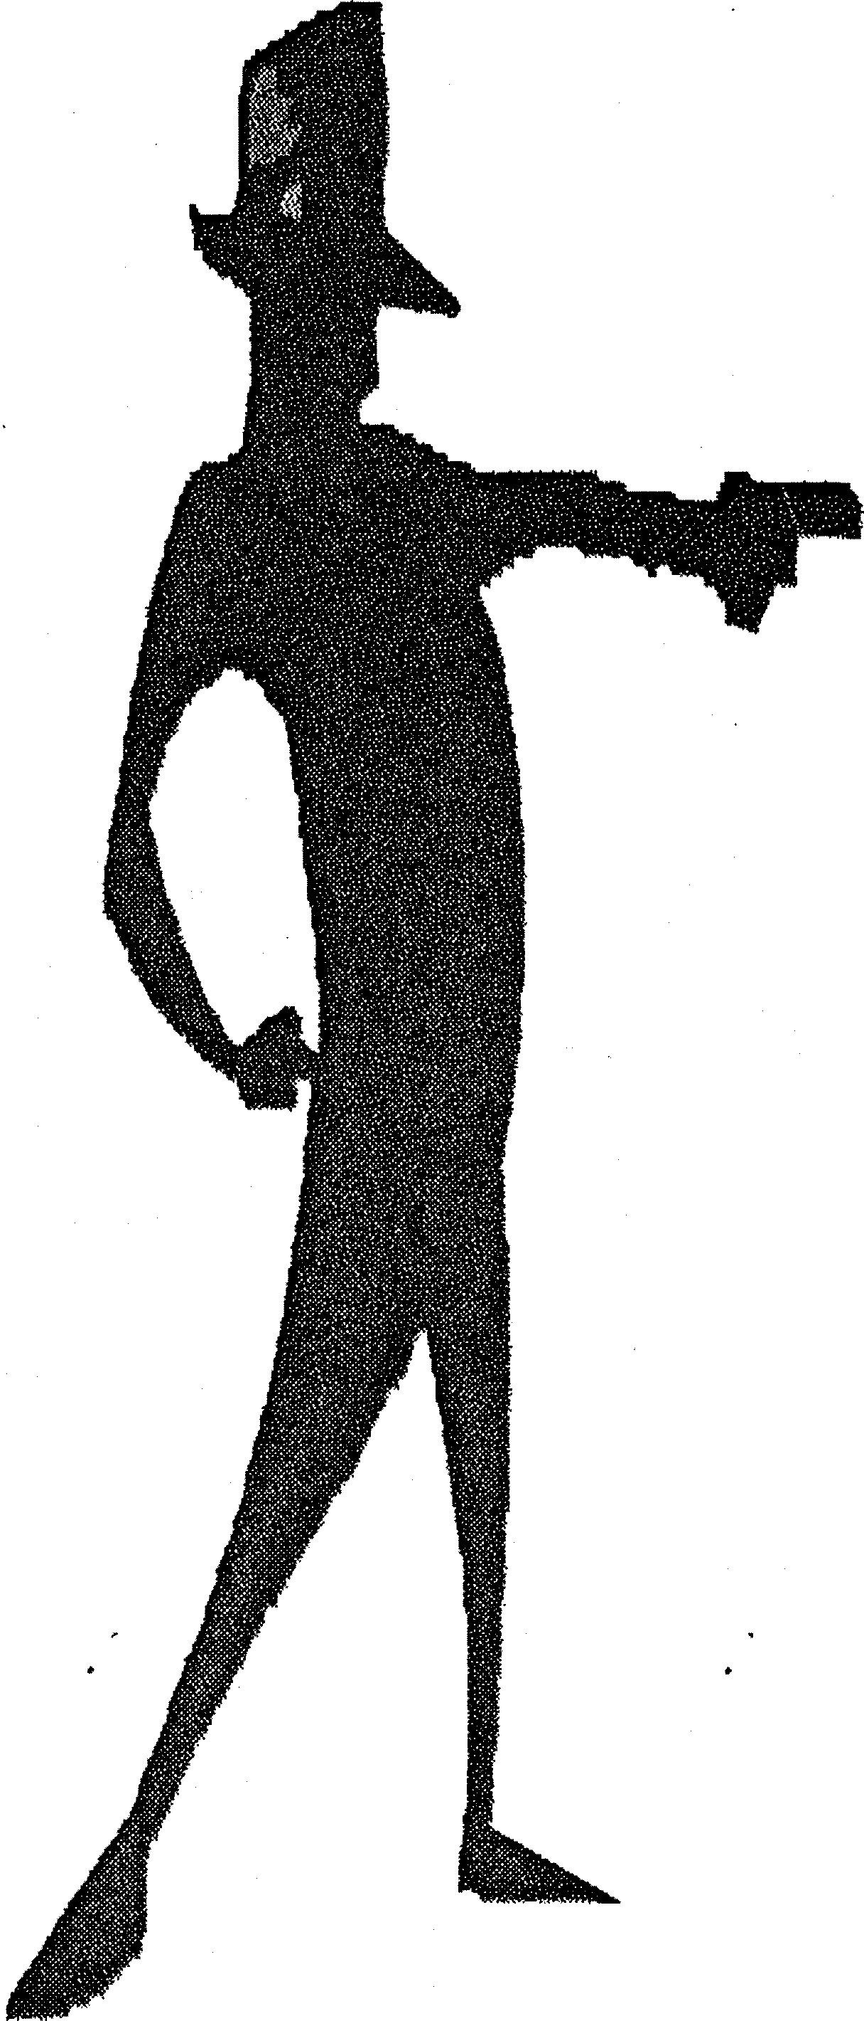*Weapon must be p r e s e n t e d quickly !*
* *Weapon must be held the same way after each shot!*
* *Weapon must be held still while the shot is being fired!*

*Mental Conditioning*

*Color Code System*

•Condition White - normal

*•Condition Yellow - state of relaxed alert*

*•Condition Orange state of alarm*

*•Condition Red - defensive combat*

*Physical Conditioning......*

*Physical Reactions Under Stress*

•*115 BPM* - *Loss of fine motor skills ability to use small muscle groups*

•*145 BPM* - *Loss of complex motor skills ability to use multiple muscle groups*

*•145 - 175 BPM - Gross motor skills enhanced*

-*but only for a short period of time.*

*•175 JJPM* – *auditory exclusion, loss of near vision, onset of tunnel vision, loss of cognitive reasoning.*

NC Private Protective

Services Firearms · Training



HANDGUN & SHOTGUN COURSES OF FIRE

PPS DAY HANDGUN QUALIFICATION COURSE - 50 ROUNDS

Stage 1

Stage 2

Stage 3

Three (3) Yard Line (6 Rounds) Load and holster

1. Draw and fire 2 rounds in 2 seconds using one hand only. Keep the target covered until given the command to holster.
2. Draw and fire 2 rounds in 2 seconds using one hand only. Keep the target covered until given the command to holster.
3. Draw and fire 2 rounds in 2 seconds using one hand only. Holster an empty weapon unless told to reload.

NOTE: All shooting is with the use of a single hand. Seven (7) Yard Line (20 Rounds)

Load and holster.

1. Draw and fire 3 rounds in 5 seconds, keep the target covered, on command fire 2 rounds in 3 seconds, keep the target covered, on command fire 1round, reload and fire two rounds with the support hand only in 15 seconds. (Clear and holster unless told to reload.)

NOTE: Semiautomatic users must load the first magazine with six rounds and the second magazine with two rounds. This will prompt an emergency reload (Slide locked to the rear).

Load and holster.

2. Draw and fire 12 rounds in:

Revolvers - 25 seconds

Semiautomatic - 20 seconds with a required magazine change.

Fifteen (15) Yard Line (12 Rounds) Load and holster

Draw and fire 6 rounds, go to the kneeling position and fire an additional 6 rounds. Revolver users have 35 seconds, semiautomatic users have 30 seconds with a required magazine change in the kneeling position.

Magazines may be loaded any way the student desires, as long as there are at least six rounds in the first magazine. ALL RELOADS WILL BE DONE IN THE KNEELING POSITION.

Stage 4 Twenty-five (25) Yard Line (12 Rounds)

NOTE: All firing is done from behind the barricade. The weapon cannot extend beyond the barricade, nor can the barricade be used for support. No part of the weapon or body should touch the barricade.

Load and holster.

Draw and fire 6 rounds from a prone position, and 6 rounds from a standing barricade position in 60 seconds. Semiautomatic pistol users are required to make a magazine change. Magazines may be loaded in any configuration.

Scoring: 50 rounds scored by use of a B-27 Target with the cumulative total multiplied by .4 to determine the percentile score. Total possible: 250 points = 100%. Eighty percent (80%) is required to

qualify (200 points).

Qualification: Students must score 80% once in three attempts using service or duty ammunition and service or duty equipment. Practice rounds cannot be used for qualification. Students must be notified as to which are the actual qualification attempts.

Administration: Students will fire the required number of rounds from each yard line. If all rounds are not fired from a given point, the student CANNOT fire additional rounds from another yard line to "catch up."

PPS NIGHT HANDGUN QUALIFICATION COURSE - 50 ROUNDS

Stage 1

Stage 2

Stage 3

Three (3) Yard Line (6 Rounds) - Total Darkness Load and holster

1. Draw and fire 2 rounds in 2 seconds using one hand only. Keep the target covered until given the command to holster.
2. Draw and fire 2 rounds in 2 seconds using one hand only. Keep the target covered until given the command to holster.
3. Draw and fire 2 rounds in 2 seconds using one hand only. Holster an empty weapon unless told to reload.

NOTE: All shooting is with the use of a single hand.

Five (5) Yard Line (8 Rounds) - Flashlight required for first six rounds.

Load and holster.

Draw and fire 3 rounds in 5 seconds, keep target covered, on command fire 2 rounds in 3 seconds, keep target covered, on command fire 1 round, reload with 2 rounds and fire 2 rounds with the support hand in 15 seconds. (Clear weapon when empty and holster.) (Semi-automatic users must change magazines and fire the last two rounds with the support hand.) SUPPORT HAND FIRING WILL BE ONE HAND ONLY.

NOTE: Semiautomatic users must load the first magazine with six rounds and the second magazine with two rounds. This will prompt an emergency reload (Slide locked to the rear). The flashlight must be turned off during the reload and may not be used for the remaining two rounds fired support hand only.

Seven (7) Yard Line (12 Rounds) - Vehicle Emergency Lights Only Load and holster

Draw and fire 12 rounds in: Revolvers - 25 seconds.

Semiautomatics - 20 seconds with a required magazine change. (Magazines may be loaded in any configuration.)

Stage 4 Ten (10) Yard Line (12 Rounds) - Vehicle Emergency Lights and Vehicle Headlights (low beam only) or a similar alternative light.

Load and holster.

* 1. Draw and fire 3 rounds in 5 seconds, keep target covered, on command fire 2 rounds in 3 seconds, keep target covered, on command fire 1 round in 1second.

Load and holster.

1. Draw and fire 2 rounds in 5 seconds from a kneeling position. (Student holsters and stands.)
2. Draw and fire 2 rounds in 5 seconds from a kneeling position. (Student holsters and stands.)
3. Draw and fire 2 rounds in 5 seconds from a kneeling position. (Clear weapon when empty, holster and stands.)

Stage 5 Fifteen (15) Yard Line (12 Rounds) - Vehicle Headlights (bright), Emergency Lights and/or All Available Light

Load and holster.

Draw and fire *6* rounds from the standing position, go to the kneeling position, and fire *6* rounds from the kneeling position. Revolver users will have 35 seconds, semiautomatic users will have 30 seconds with a required magazine change. All reloading will be done in the kneeling position. Clear weapon and holster.

Scoring: 50 rounds are scored by use of the B-27 Target with the cumulative total multiplied by .4 to determine score. Total

possible: 250 points = 100%. Eighty percent (80%) is required

to qualify (200 points).

Qualification: Students must score 80% once in three attempts using service or duty ammunition and service or duty equipment. Practice rounds cannot be used for qualification. Students must be notified as to which are the actual qualification attempts.

Administration: Students will fire the required number of rounds from each yard line. If all rounds are not fired from a given point, the student CANNOT fire additional rounds from another yard line to "catch up."

PPS SHOTGUN QUALIFICATION COURSE - 5 Slugs / 5 #OOBuckshot

#00 Buckshot

Stage 1 Fifteen (15) Yard Line (2 #00 Buckshot)

Combat load 1 round, load a second round and fire 2 rounds standing from the shoulder in 15 seconds (clear weapon when empty).

Load 3 rounds

Stage 2 Fifteen (15) Yard Line (3 #00 Buckshot)

Load 3 rounds into the magazine tube. Fire 3 rounds, 1 standing from the shoulder, 2 kneeling -15 seconds (clear weapon when empty).

*Score buckshot at this point.

Rifled Slugs

Stage 3 Twenty-five (25) Yard Line (3 Slugs)

Load 3 slugs into the magazine tube. Fire 3 rounds, 2 standing from the shoulder, 1 kneeling - 20 seconds (clear weapon when empty).

Stage 4 Twenty-five (25) Yard Line (2 Slugs)

Combat load 1 round, load a second round and fire 1 standing from the shoulder, 1 kneeling - 20 seconds (clear weapon when empty).

*Score slugs at this point.

NOTE: Stages 1and 4 begin with weapon empty, safety on, action open. Once the command to fire is given, student combat loads and fires. Stages 2 and 3 will start with shotgun in "cruiser safe" condition (magazine loaded, safety on, chamber empty). Once the command to fire is given, student chambers a round and fires. After

firing on all stages, weapon should have safety on, action open and be carried at high port.

Scoring:

Qualification:

# 00 Buckshot (45 Possible Points)

B-27 target, any hit in the silhouette, 1point for hit using 9 pellet #OO Buckshot and; .75 points for each hit using 12-pellet

#00 Buckshot.

Rifled Slug (55 Possible Points)

* 1. target, each hit within the 7 ring counts 11 points; any other hit on the silhouette but outside the 7 ring counts 6 points.

Totals for buckshot and slugs are added together for a total possible score - 100%. Eighty percent (80%) is required to qualify.

Students must score 80% once in three attempts. Practice rounds cannot be used for qualification. Students must be notified as to which are the actual qualification attempts.

PPS DAY FIVE SHOT REVOLVER COURSE - 50 ROUNDS

Stage I

Stage 2

Stage 3

Three (3) Yard Line (8 Rounds) Load with 5 rounds and holster

* + 1. Draw and fire 2 rounds in 2 seconds, one hand only. Keep target covered until given the command to holster.

1. Draw and fire 2 rounds in 2 seconds, one hand only. Keep target covered until given the command to holster.
2. Draw and fire 1 round one hand only reload with 3 rounds and fire 3 rounds one hand only in 15 seconds.

NOTE: All shooting is with the use of a single hand. Seven (7) Yard Line (22 Rounds)

Load with 5 rounds and holster, also load any loading device (speed loader, speed strip, etc.) if used with at least 2 rounds.

Draw and fire 3 rounds in 5 seconds, on a second command to fire, fire the remaining 2 rounds reload with 2 rounds and fire those 2 rounds with the support hand in 15 seconds.

Load with 5 rounds and holster.

Draw and fire 2 rounds in 3 seconds. Keep the target covered, on a second command to fire, fire 2 rounds in 3 seconds, on a third command to fire, fire 1 round in 1 second.

Load with 5 rounds and holster, also load any loading device (speed loader, speed strip, etc.) if used.

Draw and fire 5 rounds, reload and fire an additional 5 rounds in 25 seconds.

Fifteen (15) Yard Line (IO Rounds)

Load with 5 rounds and holster, also load any loading device (speed loader, speed strip, etc.) if used.

Draw and fire 5 rounds standing, go to a kneeling position, reload and fire 5 rounds kneeling in 35 seconds.

Stage 4 Twenty-five (25) Yard Line (10 Rounds)

Load with 5 rounds and holster, also load any loading device (speed loader, speed strip, etc.) if used.

Draw and fire 5 rounds from the prone position, reload and fire 5 rounds from the standing barricade position in 60 seconds.

NOTE: All firing is cone from behind the barricade. The weapon cannot extend beyond the barricade, nor can the barricade be used for support. No part of the weapon or body should touch the barricade.

Scoring: 50 rounds scored by use of a B-27 Target with the cumulative total multiplied by .4 to determine the percentile score. Total possible: 250 points = 100%. Eighty percent (80%) is required to qualify (200 points).

Qualification: Students must score 80% once in three attempts using service or duty ammunition and service or duty equipment. Practice rounds cannot be used for qualification. Students must be notified as to which are the actual qualification attempts.

Administration: In the event that not all rounds are fired from a given firing point, the student CANNOT fire additional rounds at another yard line to "catch up."

PPS NIGHT FIVE SHOT REVOLVER - 50 ROUNDS

Stage 1

Stage 2

Stage 3

Three (3) Yard Line (7 Rounds) - Total Darkness

Load with 5 rounds and holster, also load any loading device (speed loader, speed strip, etc.) if used with at least 2 rounds.

1. Draw and fire 2 rounds standing in 2 seconds, one hand only. Reload with 2 rounds.

1. Draw and fire 2 rounds standing in 2 seconds, one hand only.
2. Draw and fire 2 rounds standing in 2 seconds, one hand only.
3. Draw and fire 1 round standing in 2 seconds, one hand only.

NOTE: All shooting is with the use of a single hand. Five (5) Yard Line (5 Rounds) - Flashlight Optional Load with 5 rounds and holster.

1. Draw and fire 3 rounds in 5 seconds. Keep the target covered until given the command to holster.

2. Draw and fire 2 rounds in 4 seconds. Holster an empty weapon unless told to reload.

Seven (7) Yard Line (16 Rounds } - Emergency Lights Only

Load with 5 rounds and holster, also load any loading device (speed loader, speed strip, etc.) if used.

1. Draw and fire 5 rounds, reload with 5 rounds and fire in 25 seconds.

Load with 5 rounds, also load any loading device (speed loader, speed strip, etc. if used with at least 1round.

1. Draw and fire 3 rounds in 5 seconds, fire 2 rounds, reload with 1 round and fire the 1 round in 15 seconds.

Stage 4 Ten (10) Yard Line '12 Rounds) Emergency Lights and Vehicle Headlights (Low Beam) or Similar Alternative Light

Load with 5 rounds and holster.

* 1. Draw and fire 2 rounds standing in 5 seconds.
  2. Draw and fire 2 rounds standing in 5 seconds.
  3. Draw and fire 1round standing, in 3 seconds.

Load with 5 rounds and holster, also reload any loading device (speed loader, speed strip, etc.) if used, with at least 2 rounds.

* 1. Draw and fire 3 rounds kneeling in 7 seconds, on command fire 2 rounds, reload with 2 rounds and fire those 2 rounds in 20 seconds.

Stage 5 Fifteen (15) Yard Line (10 Rounds) - All Available Light

Load with 5 rounds and holster, also reload any loading device (speed loader, speed strip, etc.) if used.

1. Draw and fire 5 rounds standing, go to the kneeling position, reload and fire 5 rounds kneeling in 35 seconds.

Scoring: 50 rounds are scored by use of the B-27 Target with the cumulative total multiplied by .4 to determine the percentile score. Total possible: 250 points = 100%. Eighty percent (80%) is required to qualify (200 points).

Qualification: Students must score 80% once in three attempts using service or duty ammunition and service or duty equipment. Practice rounds cannot be used for qualification. Students must be notified as to which are the actual qualification attempts.

Administration: Students will fire the required number of rounds from each yard line. If all rounds are not fired from a given point, the student CANNOT fire additional rounds from another yard line to "catch up".